449/2
Drawing and design paper
Marking scheme

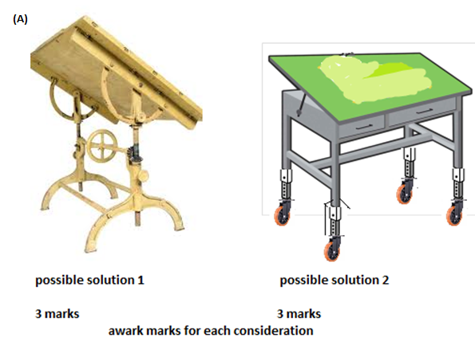

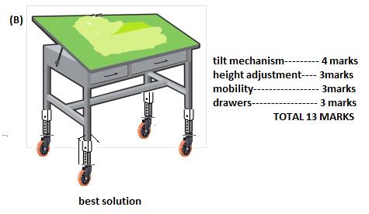
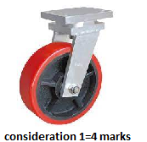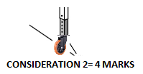
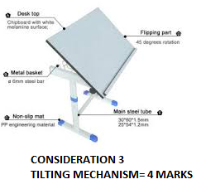OR 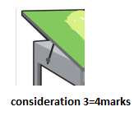
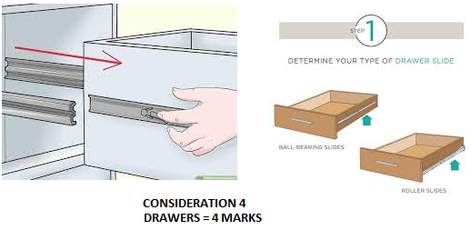
D)(i) materials. Various types of manufactured boards. Mild steel. Alluminium.etc.(any 3 marks)
(ii) Methods of joining
Bolts and nuts, screws,welding ,various wood joints (any 2 marks)

