DRAWING &DESIGN: [449/1]
FORM THREE
MARKING SCHEME
            - (a) List two uses of TEE Square (2mks)
- -drawing horizontal lines on a drafting table,
- it is also used to guide the triangle that is used to draw vertical lines.
(b) Why are different styles of lines used in drawing? (2 marks)
Line styles are used to graphically represent physical objects and each has its own meaning,
        - define a circle (2 marks)
A circle is a plane figure bounded by a curved line called the circumference, which is always equidistant from the Centre.
- List any three differences between first angle and third angle projection. (3 marks)
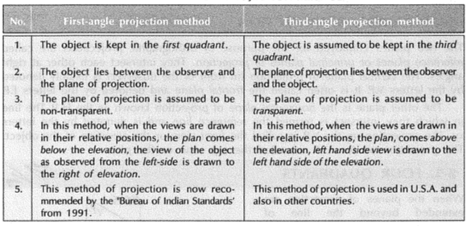
- Describe the duties the following personnel in engineering production Industries:
(a) Designer. (2 marks)
. A person who comes up with ideas and put them in form of sketches , analyses possible solutions and come up with the best solution in order to solve particular problems.
(b) Draughts person. (2 marks)
This is a trained practitioner in the production, reproduction and storing of technical drawings.

- Illustrate using sketches the difference between chain and datum dimensioning. (2marks)
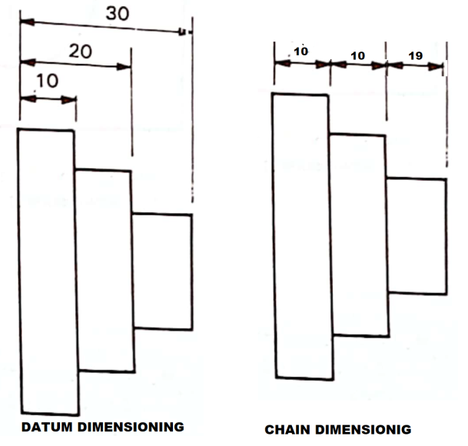
- Construct a regular octagon whose distance across the corners. ( 5 marks)
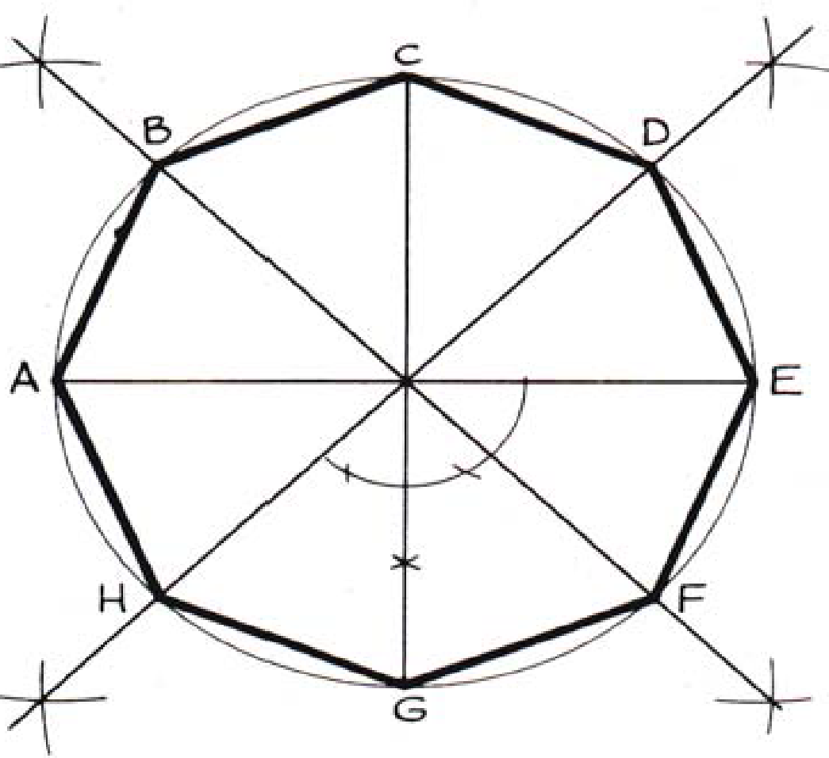
- Sketch the three views of the block shown below in third angle projection (6 marks)
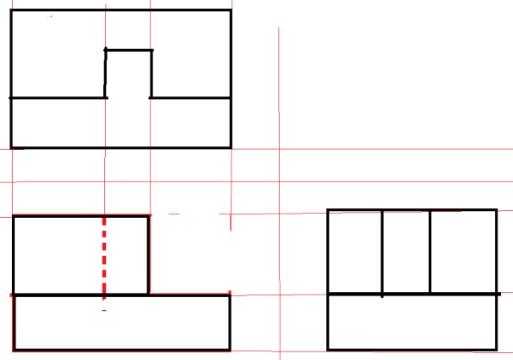

- Figure below shows two views of a truncated hexagonal pyramid. Complete the plan and draw an auxiliary view Q as projected through the elevation. (7 marks)

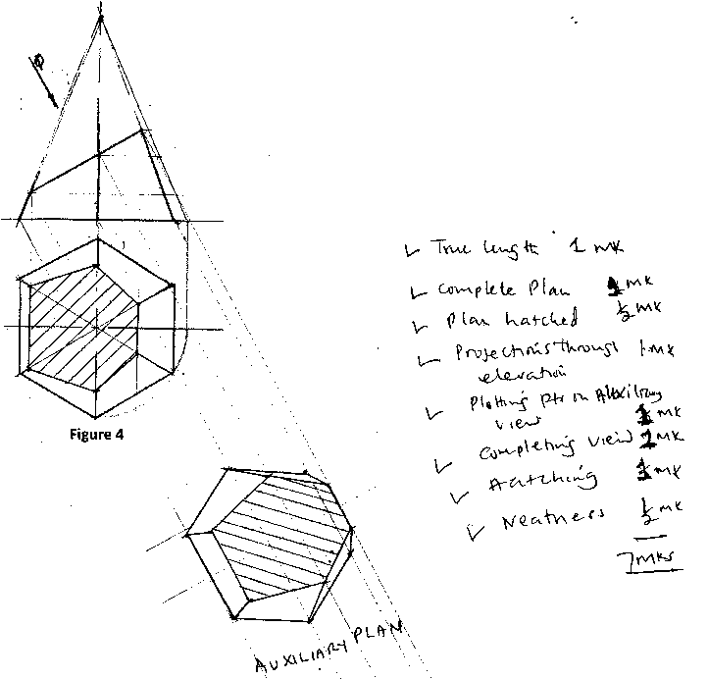
- Sketch the two views given below in isometric (7 marks)
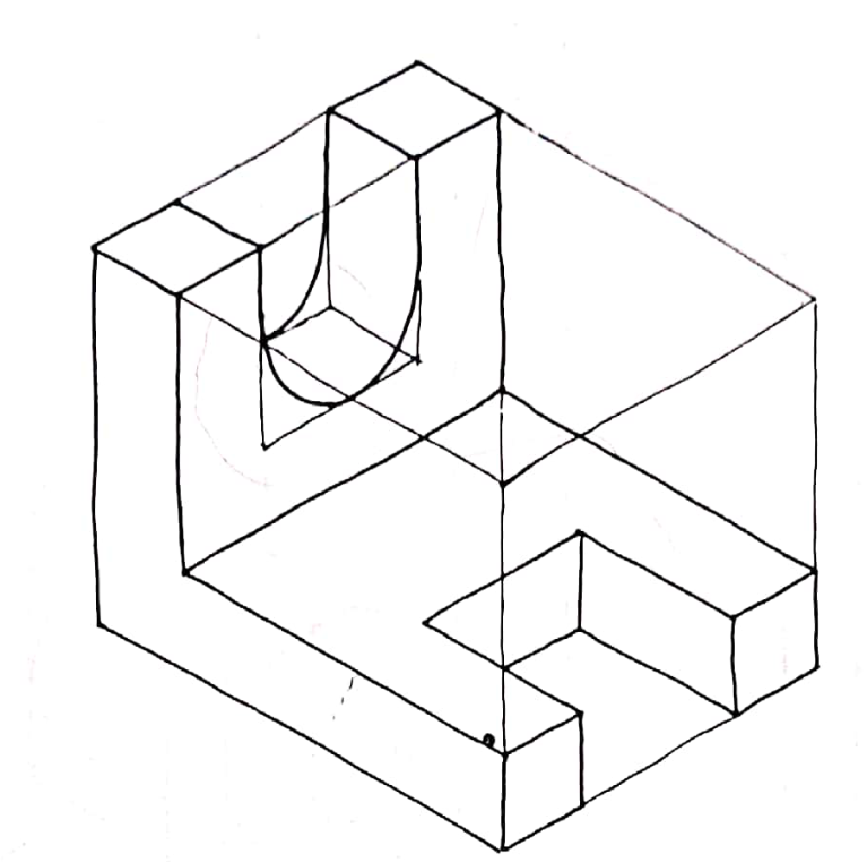

- Construct a diagonal scale 20:1, to read to 5 mm. and with an accuracy of 0.02 mm. Show a reading of 3.76 mm. on the scale. (5 marks)

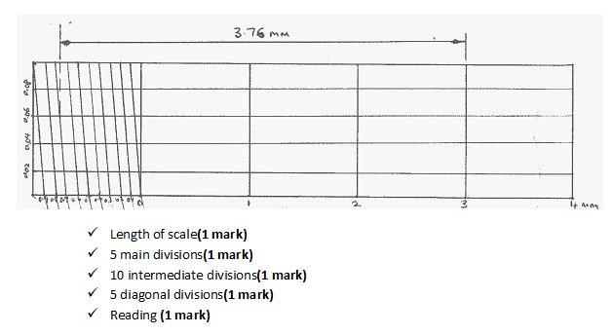

- Sketch views given below in oblique (5 marks)

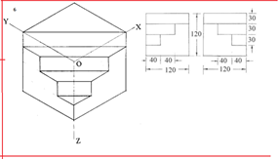

- … Figure 6 shows parts of a cable spool and its support bracket. Draw FULL SIZE in third angle projection, the following views of the assembly: (20 marks)
- Sectional front elevation along the cutting plane P-P.
- Plan.
Insert four leading dimensions. Do not show any hidden details.

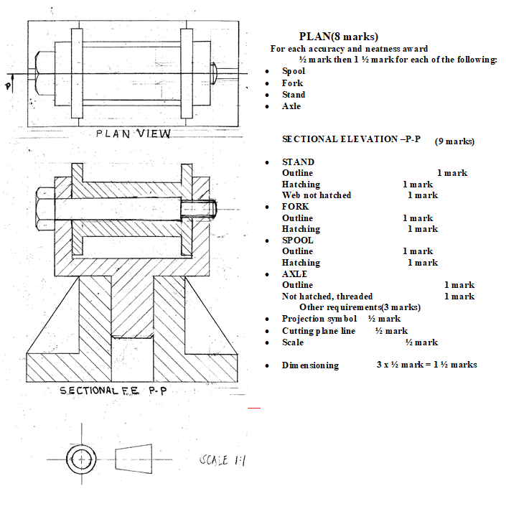
- Draw full size an isometric view of a shaped block whose two views are shown in Figure 7 taking A as the lowest point. (15 marks)
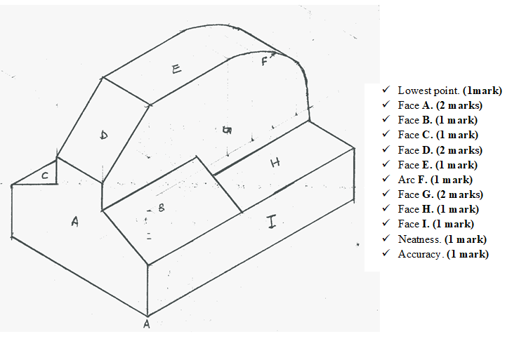
13

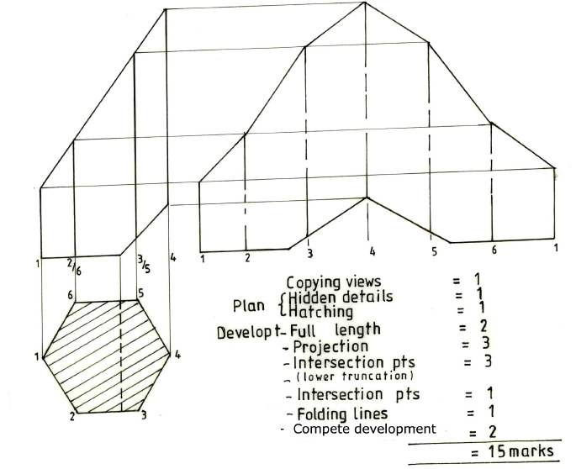
14
