**FORM 2 Marking Scheme**

**DRAWING AND DESIGN**

1. Define the term scale. (2 marks)

A scale is defined as the proportion by which we either reduce or increases the actual size of the object on a drawing. OR

• Scale means the proportion or ratio between the dimensions adopted for the drawing and the corresponding dimensions of the object.

1. Differentiate between plain and diagonal scale. (4 marks)
2. Plain Scale is used to measure up to two consecutive units, i.e. a unit and its immediate sub division.
3. Diagonal Scale is used to represent three consecutive units i.e. a unit and its immediate two sub divisions.
4. (a) Define an ellipse as a locus. (2 marks)

A regular oval shape, traced by a point moving in a plane so that the sum of its distances from two other points (the foci) is constant

(b) Construct an ellipse whose major and minor axes are 70mm and 50mm respective and indicate the two foci points. (7 marks)

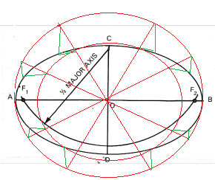

1. Illustrate the following terms as used in dimensioning. (4 marks)
2. Projection line

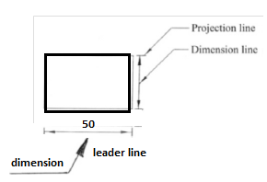

1. Dimension line
2. Leader line
3. Dimension

1. Draw a line 100mm long and sub-divide proportionally into nine equal portions. (5 marks)

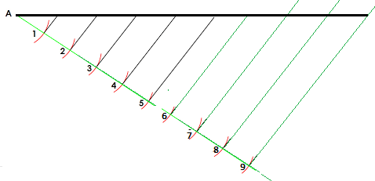

1. The mechanism shown below is a plan of a folding door . “K” and “L” are hinges while “M” slides vertically along KN. Plot the locus of the handle “H” as the door moves from fully opened to fully closed position.

(8 marks)

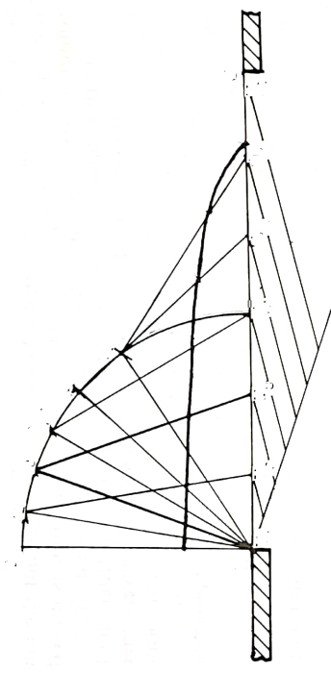

1. Construct a diagonal scale to read up to 1/100th of a metre and long enough to measure up to 6 metres. (6 marks)



1. Front elevation of pentagonal prism is shown in the figure below. Its slanting height and length of one side are given as 60mm and 20mm respectively. (6 marks)

Draw the following

1. Given front elevation
2. Surface development.
3. The plan

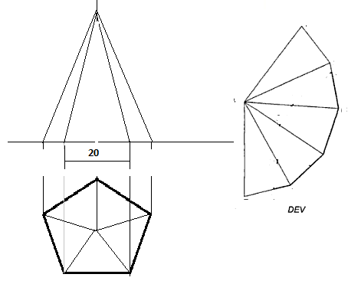

1. Sketch the three views in figure 3 below in two-point perspective. (5 marks)

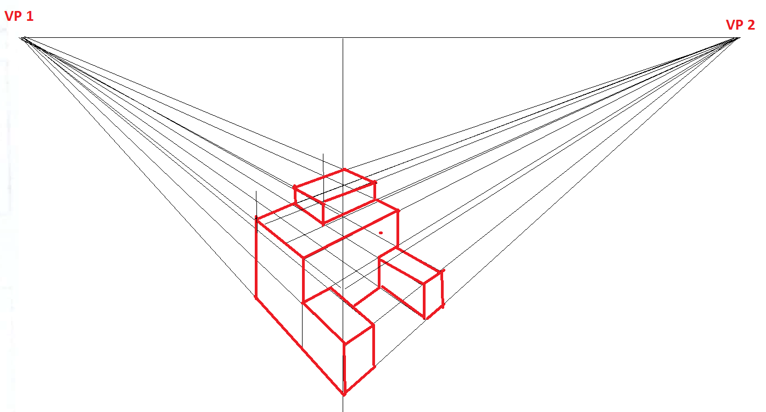

1. State four factors to be considered when choosing a material to used in design. (2marks)
2. Suitability
3. Availability
4. Cost
5. Size
6. Sketch the three views in figure 3 below in oblique taking A-A as the lowest point. (4 marks)

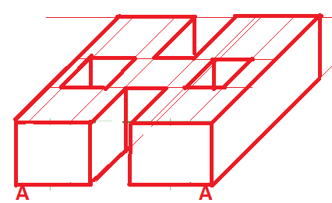

1. The isometric view of a machine part is shown below. Draw full size the following views in third angle projection. (15 marks)
2. Front elevation
3. The plan
4. End elevation

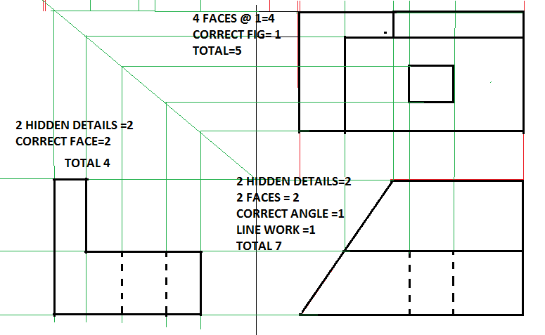

1. In the mechanism shown in figure **6**, the crank **EF** rotates about Centre **E** while **GH** oscillates about **G**.

Plot the locus of the point for one complete revolution of **EF.** (15 marks)

