**Term 1 – 2023 OPENER**

**DRAWING AND DESIGN (449/2)**

**PAPER 2**

**FORM FOUR (4)**

**Time: 2½ Hours**

MARKING SCHEME

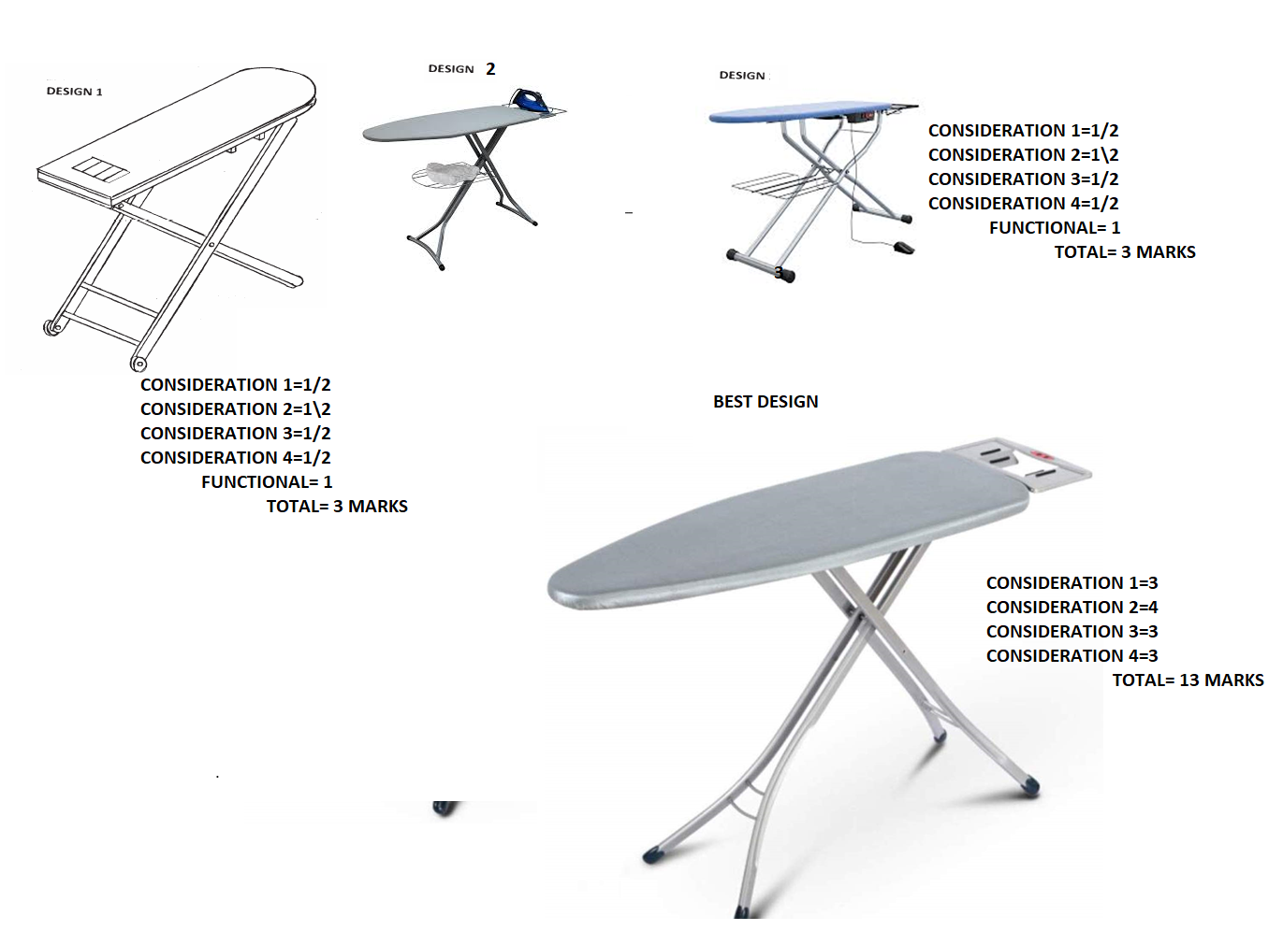

CONSIDERATION 1

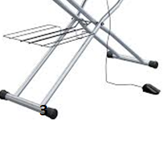

CONSIDERATION 2 AND 3



CONSIDERATION 4

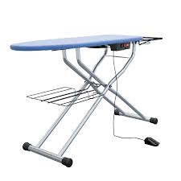

Top of Form

Bottom of Form

