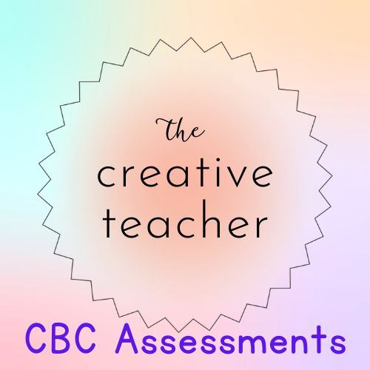

JUNIOR SECONDARY SCHOOL
COMPUTER SCIENCE
MID-TERM ONE 2023
GRADE 7

NAME…………………………………………………………ADM NO…………………………

INSTRUCTIONS TO CANDIDATES
Write your name, candidate number, class, and school in the space provided
You are given 10 minutes to read through the questions.
Read each question carefully
Answer all the questions
Write your answer, in either blue or black ink, in the space provided in the booklet

FOR OFFICIAL USE ONLY

 | Exceeding Expectations 27-30 | Meeting Expectations 21-26 | Approaching Expectations 11-20 | Below Expectations 0-10
Learners Score
Performance Level

- Name six parts of a computer. (6mks)
……………………………………………………………………………………………………
……………………………………………………………………………
…………………………………………………………………………………………………………………………………………………………………………………
…………………………………………………………………………………………………………………………………………………………………………………
…………………………………………………………………………………………………………………………………………………………………………………
…………………………………………………………………………………………………………………………………………………………………………………
………………………………………………………………………………………………………………………………………………………………………………….

- Write the three main components of the computer system. (3mks)
…………………………………………………………………………………………………………………………………………………………………………………
…………………………………………………………………………………………………………………………………………………………………………………
…………………………………………………………………………………………………………………………………………………………………………………
…………………………………………………………………………………………………………………………………………………………………………………

- Describe six characteristics of computers. (12mks)
…………………………………………………………………………………………………………………………………………………………………………………
…………………………………………………………………………………………………………………………………………………………………………………
………………………………………………………………………………………………………………………………………………………………………………..
………………………………………………………………………………………………………………………………………………………………………………..
………………………………………………………………………………………………………………………………………………………………………………..
………………………………………………………………………………………………………………………………………………………………………………..
………………………………………………………………………………………………………………………………………………………………………………..
…………………………………………………………………………………………………………………………………………………………………………………
………………………………………………………………………………………………………………………………………………………………………………….
………………………………………………………………………………………………………………………………………………………………………………….
…………………………………………………………………………………………………………………………………………………………………………………..
…………………………………………………………………………………………………………………………………………………………………………………….

- Define a computer. (2mks)
……………………………………………………………………………………………………………………………………………………………………………………
…………………………………………………………………………………………………………………………………………………………………………………….

- Give five examples of devices that operate like a computer in our society. (5mks)
…………………………………………………………………………………………………………………………………………………………………………………
…………………………………………………………………………………………………………………………………………………………………………………
…………………………………………………………………………………………………………………………………………………………………………………
…………………………………………………………………………………………………………………………………………………………………………………
………………………………………………………………………………………………………………………………………………………………………………….

- State two uses of computers in our daily life. (2mks)
…………………………………………………………………………………………………………………………………………………………………………………..
…………………………………………………………………………………………………………………………………………………………………………………..
…………………………………………………………………………………………………………………………………………………………………………………….
…………………………………………………………………………………………………………………………………………………………………………………….

