BUNAMFAN CLUSTER EXAMINATION - 2022

Kenya Certificate of Secondary Education
451/1– COMPUTER STUDIES – Paper 1
June 2022 - 2 ½ hours

Name…………………………………Adm No……
Class…………… Date……………………………
Instructions to Candidates
a) Write your name and admission number in the spaces provided at the top of this page.
b) Sign and write the date of examination in the spaces provided above.
c) This paper consists of TWO sections; A and B.
d) Answer ALL questions in section A.
e) Answer question 16 and any other THREE questions from section B.
f) All answers should be written in the spaces provided on the question paper.
g) This paper consists of 13 printed pages
h) Candidates should check the question paper to ascertain that all the pages are printed as indicated and that no questions are missing
For Official Use Only

SECTION | QUESTION | SCORE
A | 1 - 15
B | 16
 | TOTAL
This paper consists of 13 printed pages. Candidates should check the question paper to ascertain that all pages are printed as indicated and that no questions are missing
SECTION A (40 marks)
Answer ALL the questions in the section in the spaces provided.
1) Describe the following input/output terms as used in computer systems. Give an example for each (3marks)
a) Read
…………………………………………………………………………………………………………….
…………………………………………………………………………………………………………….
b) Write
…………………………………………………………………………………………………………….
…………………………………………………………………………………………………………….

2) Using relevant examples distinguish between a formula and function. (3marks)
…………………………………………………………………………………………………………………….
…………………………………………………………………………………………………………………….
…………………………………………………………………………………………………………………….
3) A publisher intends to use a desktop publishing programme to create a publication which is to have many graphics. State three ways in which the graphics may be acquired for this purpose. (3 marks)
…………………………………………………………………………………………………………………….
…………………………………………………………………………………………………………………….
…………………………………………………………………………………………………………………….
4. The management of an organisation intends to purchase a printer. State three factors that they should consider during the purchase (3 marks)
…………………………………………………………………………………………………………………….
…………………………………………………………………………………………………………………….
…………………………………………………………………………………………………………………….

5. State three reasons why it is important to define data types of fields in a database correctly. (3 marks)

…………………………………………………………………………………………………………………….
…………………………………………………………………………………………………………………….
…………………………………………………………………………………………………………………….
6. An engineering company requires a computer system to design roads and bridges. (2 marks)
Explain one suitable choice for:
(i) output device;
…………………………………………………………………………………………………………………….
…………………………………………………………………………………………………………………….
(ii) software. ​
…………………………………………………………………………………………………………………….
…………………………………………………………………………………………………………………….
7. State three circumstances under which the use of wireless communication would be preferred in data communication. (3 marks)
…………………………………………………………………………………………………………………….
…………………………………………………………………………………………………………………….
…………………………………………………………………………………………………………………….
…………………………………………………………………………………………………………………….
8. Headache, back and neck pain may result from the use of computers. State how each of them can be minimized (2 marks)
(a)Headache
…………………………………………………………………………………………………………………….
…………………………………………………………………………………………………………………….

(b) Back & Neck Pain
…………………………………………………………………………………………………………………….
…………………………………………………………………………………………………………………….
9. Explain the importance of each of the following in word processing:
(i) tab stops; (2 marks)
…………………………………………………………………………………………………………………….
…………………………………………………………………………………………………………………….
(ii) Section breaks. (2 marks)
…………………………………………………………………………………………………………………….
…………………………………………………………………………………………………………………….
10. State three problems associated with using e-mail technology for communication (3 marks)
…………………………………………………………………………………………………………………….
…………………………………………………………………………………………………………………….
…………………………………………………………………………………………………………………….
11. State two ways in which each of the following can be prevented
(a) Software errors (1 mark)
…………………………………………………………………………………………………………………….
…………………………………………………………………………………………………………………….
(b) Computer fraud (1 mark)
…………………………………………………………………………………………………………………….
…………………………………………………………………………………………………………………….

12. Differentiate between analogue data and digital data as used in computers (2 marks)
…………………………………………………………………………………………………………………….
…………………………………………………………………………………………………………………….
…………………………………………………………………………………………………………………….
13. State four properties that an operating system displays about a file (2 marks)
…………………………………………………………………………………………………………………….
…………………………………………………………………………………………………………………….
…………………………………………………………………………………………………………………….
…………………………………………………………………………………………………………………….
14. State the functions of each of the following keys on the computer keyboard (2 marks)
(a) backspace;
…………………………………………………………………………………………………………………….
…………………………………………………………………………………………………………………….
(b) insert (ins)
…………………………………………………………………………………………………………………….
…………………………………………………………………………………………………………………….
15. Give three file organization methods in a computer (3 marks)
…………………………………………………………………………………………………………………….
…………………………………………………………………………………………………………………….
…………………………………………………………………………………………………………………….

SECTION B (60 Marks)
Answer question 16 and any other THREE questions from this section in the spaces provided.
16.(a) State three ways in which a programmer can make program code easy to fol1ow (3 marks)
…………………………………………………………………………………………………………………….
…………………………………………………………………………………………………………………….
…………………………………………………………………………………………………………………….
…………………………………………………………………………………………………………………….
(b) Study the flowchart below and use it to answer the questions that follows;
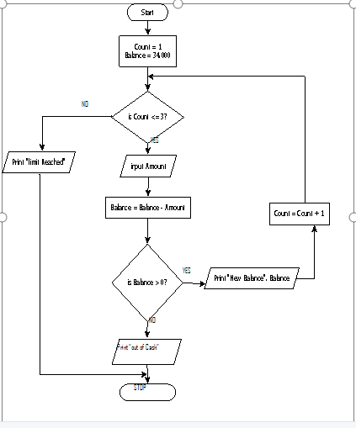

(i) State the output of the above program flowchart for the inputs given below (3 Marks)
Amount = 15,000, 14,000 and 23,000 respectively
………………………………………………………………………………………………………………………………………………………………………………………………………………………………………………………………………………………………………………………………………………………………………………………………………………………………………………………………………………………………………………………………………………………………………………………………………………………………………………………………………………………………………………………………………………………………………………………………………………………………………………………………………………………………………………………………
(ii) State the purpose of the flowchart (1 Mark)
……………………………………………………………………………………………………………
……………………………………………………………………………………….……………………
(iii) Write a pseudocode for the flowchart in question (16. c) above (8 Marks)
………………………………………………………………………………………………………………………………………………………………………………………………………………………………………………………………………………………………………………………………………………………………………………………………………………………………………………………………………………………………………………………………………………………………………………………………………………………………………………………………………………………………………………………………………………………………………………………………………………………………………………………………………………………………………………………………………………………………………………………………………………………………………………………………………………………………………………………………………………………………………………………………………………………………………………………………………………………………………………………………………………………………………………………………
17. (a) Interpret each of the following spreadsheet formula:
​(i) = countif(A2:A9, “>=E7”) (2 marks)
…………………………………………………………………………………………………………………….
…………………………………………………………………………………………………………………….
​(ii) =sumif(B2 :B10, “WP”, D3 :D11) (2 marks)
…………………………………………………………………………………………………………………….
…………………………………………………………………………………………………………………….

(b) The figure below shows relationships between tables in a database.
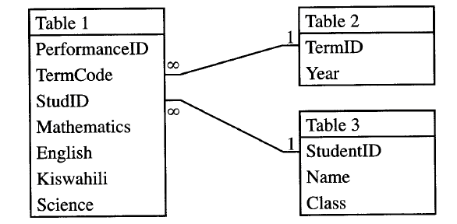
Identify two primary and two foreign keys used in the relationship. (4 marks)
…………………………………………………………………………………………………………………….
…………………………………………………………………………………………………………………….
…………………………………………………………………………………………………………………….
…………………………………………………………………………………………………………………….(c)(i) Convert the hexadecimal number C7D₁₆ to its equivalent decimal number (2 Marks)
…………………………………………………………………………………………………………………….
…………………………………………………………………………………………………………………….
(ii) Using the twos compliment and 8-bit notation subtract 27 from 12 leaving your answer in binary notation (5 Marks)
…………………………………………………………………………………………………………………….
…………………………………………………………………………………………………………………….
…………………………………………………………………………………………………………………….
…………………………………………………………………………………………………………………….
18. (a) Explain three circumstances under which observation method may be preferred during data
collection (6 marks)
…………………………………………………………………………………………………………………….
…………………………………………………………………………………………………………………….
…………………………………………………………………………………………………………………….
…………………………………………………………………………………………………………………….
…………………………………………………………………………………………………………………….
…………………………………………………………………………………………………………………….
(b) Describe each of the following types of maintenance
(i) Perfective; (2 marks)
…………………………………………………………………………………………………………………….
…………………………………………………………………………………………………………………….
(ii) Corrective; (2 marks)
…………………………………………………………………………………………………………………….
…………………………………………………………………………………………………………………….
(iii) Adaptive. (2 marks)
…………………………………………………………………………………………………………………….
…………………………………………………………………………………………………………………….
(c) Name three approaches that may be used to replace an old system with a new computerized system (3 marks)
…………………………………………………………………………………………………………………….
…………………………………………………………………………………………………………………….
…………………………………………………………………………………………………………………….
19. (a) With the aid of a diagram, describe the time sharing mode in computer data processing (5 marks)
…………………………………………………………………………………………………………………….
…………………………………………………………………………………………………………………….
…………………………………………………………………………………………………………………….
…………………………………………………………………………………………………………………….
…………………………………………………………………………………………………………………….
…………………………………………………………………………………………………………………….
…………………………………………………………………………………………………………………….
(b) A company’s management has opted to use computers to process data. State four factors that the management needs to consider when selecting the company data processing mode. (4 marks)
…………………………………………………………………………………………………………………….
…………………………………………………………………………………………………………………….
…………………………………………………………………………………………………………………….
…………………………………………………………………………………………………………………….
(c) Describe each of the following validation checks as used in data processing
(i) Preserve check (2 marks)
…………………………………………………………………………………………………………………….
…………………………………………………………………………………………………………………….
(ii) Data type check (2 marks)
…………………………………………………………………………………………………………………….
…………………………………………………………………………………………………………………….
(iii) Check digit (2 marks)
…………………………………………………………………………………………………………………….
20. (a)State the function of each of the following

(a) Network Interface Card (1 mark)
…………………………………………………………………………………………………………………….
…………………………………………………………………………………………………………………….

(b) Modem (1 mark)
…………………………………………………………………………………………………………………….
…………………………………………………………………………………………………………………….
(c) Repeater (1 mark)
…………………………………………………………………………………………………………………….
…………………………………………………………………………………………………………………….
(d) Crimping tool (1 mark)
…………………………………………………………………………………………………………………….
…………………………………………………………………………………………………………………….
(b) State any two reasons why the fibre optic cable is preferred for data transmission over the other cables (2 marks)

………………………………………………………………………………………………………………….
…………………………………………………………………………………………………………………….
…………………………………………………………………………………………………………………….

(c) State three functions of networking operating systems other than providing network security. (3 marks)

………………………………………………………………………………………………………………….
…………………………………………………………………………………………………………………….
…………………………………………………………………………………………………………………….
(d) A company has three branches X, Y and Z where X is the headquarter. The local area network (LAN) at X is directly connected to the LAN at Y and directly to the LAN at Z. Explain two benefits of having the LAN at Y also directly connected to the LAN at Z. (4 marks)
………………………………………………………………………………………………………………….
…………………………………………………………………………………………………………………….
…………………………………………………………………………………………………………………….
………………………………………………………………………………………………………………….
………………………………………………………………………………………………………………….
(e) The figure below shows a network topology . use it to answer the questions that follows:
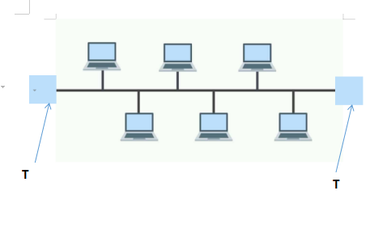
(i) What is the name of the topology? (1 mark)
………………………………………………………………………………………………………………….
…………………………………………………………………………………………………………………….
(ii) What is the work of the part labelled T. (1 mark)
………………………………………………………………………………………………………………….
…………………………………………………………………………………………………………………….
………………………………………………………………………………………………………………….
…………………………………………………………………………………………………………………….

THIS IS THE LAST PRINTED PAGE

