** MARANDA HIGH SCHOOL**

**Kenya Certificate of Secondary Education**

**MOCK EXAMINATIONS 2022**

**233/1 Chemistry (Theory) Paper 1**

**September, 2022 Time: 2 Hours**

**Name**: ………………………………………….…….…… **Adm** **No**: ………………

**Class**: ………………**Candidate’s** **Signature**: ………..…….. **Date: 6th September, 2022**

**Time: 10.45AM-12.45 PM**  ***Instructions to candidates***

*(a) Write your name, admission number, stream in the spaces provided above.*

*(b) Answer* ***ALL*** *the questions in the spaces provided and calculations* ***MUST*** *be clearly shown*

*(c)This paper consists of* ***15 printed pages****; please check the question paper to ascertain that all the pages are printed as indicated and that no questions are missing*

**FOR EXAMINER’S USE ONLY**

|  |  |  |
| --- | --- | --- |
| **Question** | **Maximum score** | **Candidate’s score** |
| **1-27** | **80** |  |

1a). State two reasons why most laboratory apparatus are made of glass (2marks)

………………………………………………………………………………………………………………………………………………………………………………………………………………………………………………………………………………………………………………….................................

b) How can one increase the luminosity of a flame? (1marks)

………………………………………………………………………………………………………………………………………………………………………………………………………………………..

2. The set – up below was used by a student to try to prevent the rusting of an Iron rod.

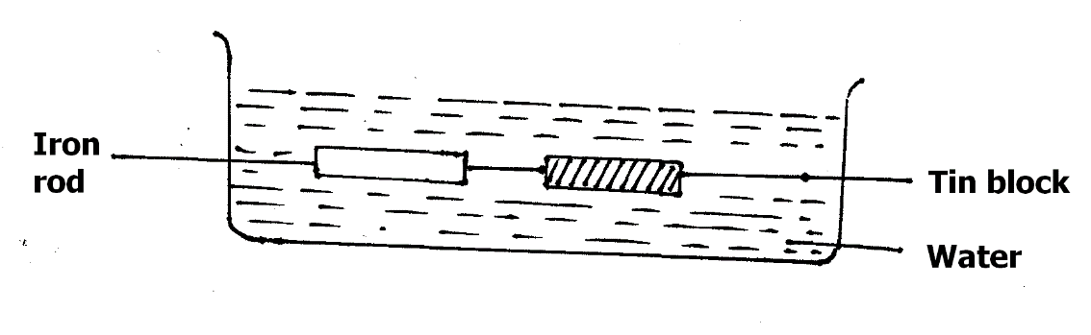

a) Did the student succeed in preventing the rusting of Iron using the set – up above?

Explain (2marks)

………………………………………………………………………………………………………………………………………………………………………………………………………………………………………………………………………………………………………………………………………

b) Which method of rust prevention was the student investigating? (1mark)

…………………………………………………………………………………………………………….

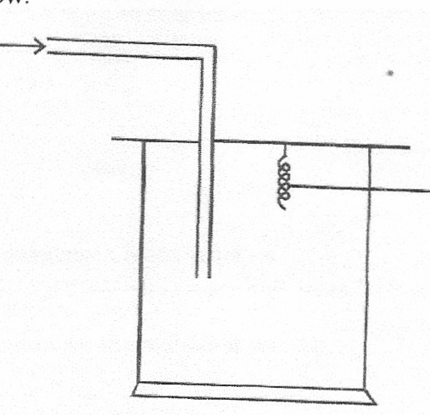3. The apparatus below was set up to show the catalytic oxidation of ammonia. Study the diagram and answer the questions that follow

Dry NH3(g)

**Hot platinum wire**

i) Write an equation for the reaction that takes place in the gas jar (1mark)

…………………………………………………………………………………………………………………………………………………………………………………………………………………………

ii) What is the role of hot platinum wire? 1marks)

…………………………………………………………………………………………………………………………………………………………………………………………………………………………

…………………………………………………………………………………………………………….

iii) Write the formula of the complex ion formed when excess ammonia gas is passed through a solution containing Zn2+ ions. (1mark)

……………………………………………………………………………………………………………………………………………………………………………………………………………………………………………………………………………………………………………………………………….

4. The atomic number of sulphur is 16. By calculating the of oxidation number of sulphur, state the electron configuration of sulphur in the sulphate ion (SO42-) (2marks)

……………………………………………………………………………………………………………………………………………………………………………………………………………………………………………………………………………………………………………………..…………………………………………………………………………………………..………………………………

5. Explain the following trends

i) Atomic radius of alkaline earth metals increase down the group (1mark)

…………………………………………………………………………………………………………………………………………………………………………………………………………………………………………………………………………………………………………………………………………………………………………………………………………………………………………………….

ii) Melting and boiling points of halogens increase down the group VII (1mark)

……………………………………………………………………………………………………………………………………………………………………………………………………………………………………………………………………………………………………………………………………………………………………………………………………………………………………………………

iii) Aluminium metal is a better conductor than sodium metal (1mark)

……………………………………………………………………………………………………………………………………………………………………………………………………………………………………………………………………………………………………………………………………….

6 a) State Le Chatelier’s Principle (1mark)

……………………………………………………………………………………………………………………………………………………………………………………………………………………………………………………………………………………………………………………………………..

b) A dynamic equilibrium between dichromate and chromate ions is established as shown in the equation below.

Cr2O72- (aq) + 2OH- (aq) 2CrO72- (aq) + H2O(l)

Orange Yellow

State and explain the observation made if a few drops of sodium hydroxide are added to the equilibrium mixture. (2marks)

……………………………………………………………………………………………………………………………………………………………………………………………………………………………………………………………………………………………………………………..………………………………………………………………………………………………………………………………………………………………………………………………………………………………………….

7 a) Complete the nuclear equation below. (1mark)

24

24

Q R +

12

11

b) A radioactive element of mass 50g has a half-life of 10 seconds. Sketch a graph of mass against time to show how the element mass varies with time (1mark)

**0**

**10**

**20**

**30**

**40**

**10**

**20**

**30**

**40**

**50**

**Time (sec)**

**Mass (g)**

c) Give one use of radioactive isotopes in medicine (1mark)

……………………………………………………………………………………………………………………………………………………………………………………………………………………………………………………………………………………………………………………………………….

8. The set-up below was used to investigate reaction between copper (II) oxide and hydrogen gas

Combustion tube

Copper (II) oxide

Hydrogen gas

heat

heat

**Liquid T**

a) Identify liquid T (1mark)

…………………………………………………………………………………………………………………………………………………………………………………………………………………………

b) Write an equation for the reaction that took place in the combustion tube. (1mark)

…………………………………………………………………………………………………………………………………………………………………………………………………………………………

c) State an observation made in the combustion tube. (1mark)

…………………………………………………………………………………………………………………………………………………………………………………………………………………………

9. The table below shows PH values of some solutions

|  |  |  |  |  |
| --- | --- | --- | --- | --- |
| Solution | A | B | C | D |
| PH values | 13 | 7 | 1 | 6.5 |

a) Which solution reacts vigorously with Magnesium metal? (1mark)

………………………………………………………………………………………………………………………………………………………………………………………………………………………….

b) Which solution is likely to be that of Lemon juice? (1mark)

………………………………………………………………………………………………………………………………………………………………………………………………………………………….

c) Select any two solutions that are likely to react with aluminium hydroxide (1mark)

……………………………………………………………………………………………………………………………………………………………………………………………………………………………………………………………………………………………………………………………………………………………………………………………………………………………………………………

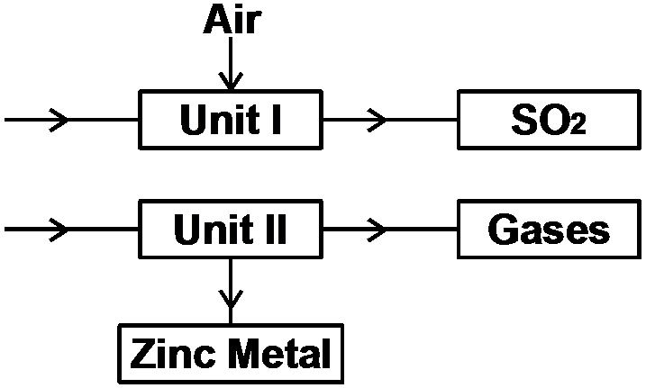10. The flow chart below shows some processes involved in the industrial extraction of zinc metal.

a) Name one ore from which zinc is extracted. (1mark)

………………………………………………………………………………………………………………………………………………………………………………………………………………………….

b) Write the equation for the reaction taking place in unit I. (1mark)

………………………………………………………………………………………………………………………………………………………………………………………………………………………….

c) State any one use of zinc metal. (1mark)

………………………………………………………………………………………………………………………………………………………………………………………………………………………….

11. Chlorine gas was bubbled through water for some time. The pale yellow solution formed was poured into a long glass tube and placed in the sun as shown in the diagram below.

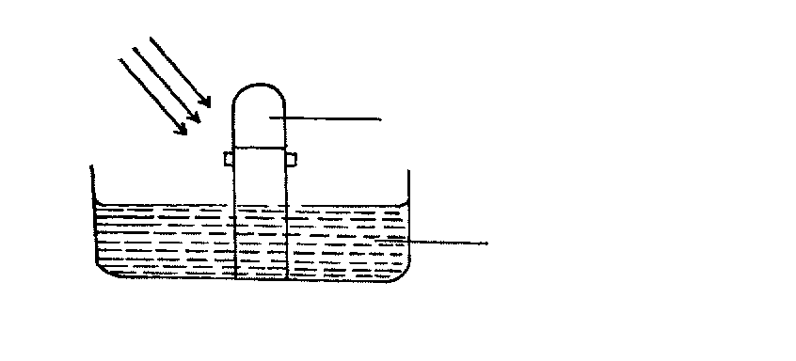

**Gas T**

**Sun rays**

**Green yellow solution**

a) Give the chemical composition in the pale yellow solution? (1mark)

i) ………………………………………………………………………………………………………….

ii) …………………………………………………………………………………………………………

b) Write an equation to show how gas T is formed (1mark)

……………………………………………………………………………………………………………………………………………………………………………………………………………………………………………………………………………………………………………………………………….

c) Give one use of chlorine (1mark)

………………………………………………………………………………………………………………………………………………………………………………………………………………………….

12. The solubility of potassium nitrate in water at 70OC is 155g/100g H2O while at 20oC, the solubility is 31g/100g water. 50g of a saturated solution of potassium nitrate at 70oC was cooled to 20oC, calculate the mass that crystallized out. (3marks)

……………………………………………………………………………………………………………………………………………………………………………………………………………………………………………………………………………………………………………………..………………………………………………………………………………………………………………………………………………………………………………………………………………………………………….

13. Substance L, M, N and P have the following properties.

|  |  |  |  |  |
| --- | --- | --- | --- | --- |
| Substance | M.P. | Solubility in water | Electrical conductivity | |
| Solid state | Liquid state |
| L | Low | Soluble | Does not | Does not |
| M | High | Soluble | Does not | Conducts |
| N | High | Soluble | Conducts | Conducts |
| P | High | Insoluble | Does not | Does not |

a) Select the letter which represents a substance which is suitable for making kettle handles. (1mark)

………………………………………………………………………………………………………………………………………………………………………………………………………………………….

b) Which letter represents a substance which is likely to be sodium chloride? (1mark)

………………………………………………………………………………………………………………………………………………………………………………………………………………………….

c) Name the bond structure and bond type likely to be in L. (1mark)

i) Bond structure…………………………………………………………………………………………

ii) Bond type……………………………………………………………………………………………

14. The diagram below represents a set-up used to prepare oxygen gas.

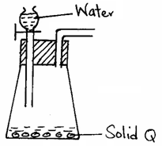

a) Name substance Q. (1mark)

………………………………………………………………………………………………………………………………………………………………………………………………………………………….

b) Complete the set-up given, to show how DRY oxygen gas is collected. (2marks)

15. Explain why a reaction between sodium carbonates powder with hydrogen chloride solution in in water produces effervescence while the same reaction with hydrogen chloride solution in methylbenzene does not produce effervescence (2marks)

………………………………………………………………………………………………………………………………………………………………………………………………………………………………………………………………………………………………………………………………………………………………………………………………………………………………………………………………………………………………………………………………………………………………….

16.A hydrocarbon S contains 3.6g carbon by mass and 0.8g hydrogen. Given that 3dm³ of the compound at s.t.p has a mass of 5.89g. Calculate the molecular formula (Molar gas volume at s.t.p = 22.4dm³, C=12, H=1) (3marks)

……………………………..……………………………………………………………………….……………………………………………………………………………………………………………………………………………………………………………………………………………………………………………..……………………………………………………………………….………………………………………………………………………………………………………………..………………

17.Name the following processes.

a) When anhydrous calcium chloride is left in an open beaker overnight a solution was formed (1mark)

………………………………………………………………………………………………………………………………………………………………………………………………………………………….

b) White sugar changes to black solid when mixed with excess concentrated sulphuric (VI) acid. (1mark)

………………………………………………………………………………………………………………………………………………………………………………………………………………………….

c) Sodium deca-hydrate crystals change to anhydrous sodium carbonate (powder) (1mark)

………………………………………………………………………………………………………………………………………………………………………………………………………………………….

18. Chlorine has two isotopes with mass number 35 and 37. If the relative atomic mass of chlorine is 35.5. Determine the percentage abundance of each isotope of chlorine. (3marks)

……………………………………………………………………………………………….………………………………………………………………………………………………………………………………………………………………………………………………………..……………………………………………………………………………………………….…………………………………………………………………………………………………………………………………………………………………………………………………………………………………………………………………….

19 a) Explain why water containing some traces of common salt is considered to be hard water (1mark)

………………………………………………………………………………………………………………………………………………………………………………………………………………………….

b) i) State one method used to remove permanent hardness (1mark)

………………………………………………………………………………………………………………………………………………………………………………………………………………………….

ii) Give one advantage of using hard water for domestic purpose. (1mark)

………………………………………………………………………………………………………

………………………………………………………………………………………………………

20. Study the flow chart below and use it to answer the questions that follow.



a) Identify the cation and anion in solution (R) (1mark)

Cation..........................................................................................................................................................

Anion...........................................................................................................................................................

b) Write an ionic equation for the formation of compound S (1mark)

…………………………………………………………………………………………………………….

…………………………………………………………………………………………………………….

c) Write the formula for complex ion in solution Q. (1mark)

…………………………………………………………………………………………………………….

21. The graph below shows the amount of calcium carbonate and calcium chloride varying with time in the reaction.

CaCO3(s) + 2HCl(aq)  CaCl2(aq) + H2O + CO2(g)

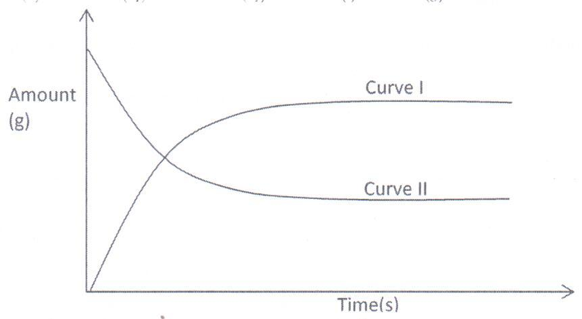

a) Which curve shows the amount of calcium chloride formed varying with time? (1mark)

…………………………………………………………………………………………………………………………………………………………………………………………………………………………

b) Explain why the two curves become horizontal after a given period of time. (1mark)

……………………………………………………………………………………………………………………………………………………………………………………………………………………………………………………………………………………………………………………………………….

c) Sketch on the graph, how curve I would appear if the experiment was repeated using a more dilute hydrochloric acid solution. (1mark)

22 a) State Graham’s law of diffusion. (1mark)

……………………………………………………………………………………………………………………………………………………………………………………………………………………………………………………………………………………………………………………..……………………………………………………………………………………………………………………………………………………………………………………………………………………………………………………………………………………………………………………………………………………….

b) 60cm3 of oxygen diffused through a porous plate in 20 seconds. How long will it take 120cm3 of carbon (iv) oxide gas to diffuse through the same plate under the same conditions? (C=12 , O=16)

(2marks) ……………………………………………………………………………………………………………………………………………………………………………………………………………………………………………………………………………………………………………………………………………………………………………………………………………………………………………………………………………………………………………………………………………………………………………………………………………………………………………………………………………………………………………………………………………………………………………………………

23. Methane undergoes combustion in oxygen as shown by the equation below.

CH4(g) + 2O2(g) CO2(g) + 2H2O(g)

a) Calculate the heat change for the reaction using bond energies in the table (3marks)

**Bond**  **Bond energy (KJ/mol)**

C – H 413

O = O 497

C = O 740

O - H 463

………………………………………………………………………………………………………………………………………………………………………………………………………………………………………………………………………………………………………………………………………………………………………………………………………………………………………………………………………………………………………………………………………………………………………………………………………………………………………………………………………………

24. Describe how a DRY,PURE sample of Lead (II) chloride can be prepared using the following reagents; dilute nitric (V) acid, dilute hydrochloric acid and lead carbonate (3marks)

……………………………………………………………………………………………….…………………………………………………………………………………………………………………………………………………………………………………………………………………………………………………………………………………………………………………………………………………….

25. Hydrogen sulphide gas was passed through a solution of iron (III) chloride

i) State and explain the two observations made (2marks)

……………………………………………………………………………………………………………………………………………………………………………………………………………………………………………………………………………………………………………………………………………………………………………………………………………………………………………………

ii) Write an ionic equation for the reaction taking place in (i) above (1mark)

……………………………………………………………………………………………………………

26. Study the diagram below and answer the questions that follow.

NH4Cl(s)

Energy

Reaction co-ordinate

ΔH1

ΔH2

ΔH3

NH4 +(g) + Cl-(g)

NH4 +(aq) + Cl-(aq)

a) What do ∆H1 and ∆H2 represent. (2marks)

∆H1…..…………………………………………….. ∆H2 ………………………………………….……

b) Write an expression to show the relationship between ∆H1, ∆H2 and ∆H3.  (1mark)

…………………………………………………………………………………………………………………………………………………………………………………………………………………………………………………………………………………………………………………………………………………………………………………………………………………………………………………….

27. Use the information below and answer the questions that follow .The letters are not the actual symbols of the elements.

+ 2e

-0.76V

E(s)

+ 3e

-1.66V

F(s)

+ 2e

-0.44V

G(s)

a) Calculate the Eθ value for the electrochemical cell represented below. (2mark)

F(s)

…………………………………………………………………………………………………………………………………………………………………………………………………………………………………………………………………………………………………………………..………………………………………………………………………………………………………………………………

b) Arrange the elements in order of reactivity starting with the least reactive. (1mark)

………………………………………………………………………………………..…………………………………………………………………………………………………………..…………………

**THIS IS THE LAST PRINTED PAGE**