

**CEKENAS END OF TERM I EXAM-2022**

**FORM FOUR EXAM**

*Kenya Certificate of Secondary Education (K.C.S.E)*

**MARKING SCHEME**

**CHEMISTRY PAPER 3**

**233/3**

1. Table 1

Award three marks distributed as follows:

**I. Complete table (1mk)**

- Complete table with 8 readings (1mk)

- Incomplete table with 7/6 readings (½mk)

- Incomplete table with less than 6 readings (0mk)

**II. Decimal place (½mk)**

Award half mark for consistently used whole numbers or 1 decimal point for temperature readings otherwise penalise FULLY.

**III. Accuracy (½mk)**

Award half mark for temperature readings at time 0 if it is of the school value.

**IV. Trend (1mk)**

Award 1mk for constants up to 1 minute followed by a decrease in temperature then a rise in temperature readings.

Or constants upto 1min, a drop, constants, continuous rise.

- Penalise ½mk if reading at time 5 minutes is above the initial temperature at T= 0 MIN

a) **Graph**

- Labelling of axes ½mk

- Scale (consistent and covering more than ½page) ½mk

- Plotting (1mk)

- Lines (1mk) (with extrapolation)

Award ½mk for lines if no extrapolation is done.

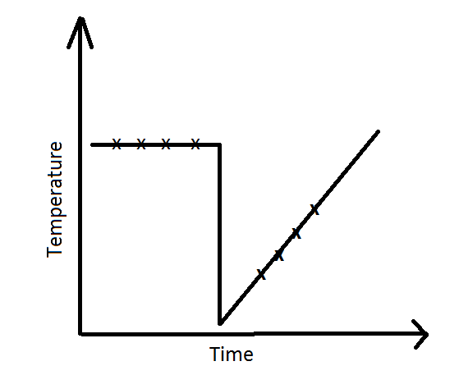✓1mk

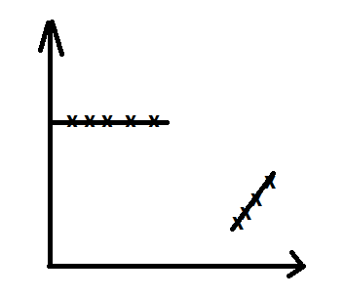✓½mk

b) Correct ∆ T read from a correctly drawn graph. (1mk)

c) ∆ H = mc∆T

✓½

= CORRECT ANSWER ✓½

d) ✓½

✓½

= CORRECT ANSWER ✓½ ∆H = + ve

(Penalise ½mk if units or sign are missing)

**PROCEDURE II**

Table II

- Complete table (1mk)

- Decimal place (1mk)

- Accuracy (1mk)

e) – Principles of averaging (1mk)

- Final accuracy (1mk)

5mks

f) ✓½

✓½

(Penalise ½mk for wrong formula)

g) i) ✓½ = 0.015✓½

ii) Mole ratio 1:1

✓½

ANSWER ✓½

iii) Moles of HCl that reacted with R = 0.0179

Moles that were 100cm³ of R = answer g(ii)

Moles of HCl in 50cm³ of P = 0.0179 + answer g(ii)✓1

= answer ✓½

iv) ✓½ = answer ✓½

**QUESTION 2**

a) i)

|  |  |
| --- | --- |
| Observations | Inferences |
| White ppt✓½  Soluble in excess✓½ | Pb2+, Zn2+ , Al3+  3✓1mk  2✓½mk  1- 0mk |

ii)

|  |  |
| --- | --- |
| Observations | Inferences |
| White ppt✓½  Insoluble in excess✓½ | Pb2+✓½, Al3+✓½ |

iii)

|  |  |
| --- | --- |
| Observations | Inferences |
| No white ppt✓1 | Each ion ½mk to maximum of 2mks  Penalise ½mk for each contradicting ion up to a maximum of 2mks |

iv)

|  |  |
| --- | --- |
| Observations | Inferences |
| Yellow ppt✓1 | Pb2+ ✓1mk  Penalise fully for any contradicting ion |

v)

|  |  |
| --- | --- |
| Observations | Inferences |
| - Effervescence✓½  - Colourless gas with pungent smell✓½  - Red litmus changes to blue✓½  - Blue litmus remains blue ✓½ | ✓1  Penalise fully for any contradictory ion |

**Question 3**

a)

|  |  |
| --- | --- |
| Observations | Inferences |
| - Melts✓½  - Burns with a yellow sooty flame✓½ | ✓1  Or long chain organic substance or high ratio of C:H |

b)i)

|  |  |
| --- | --- |
| Observations | Inferences |
| - purple colour acidified potassium manganate (vii) persists ✓1 | ✓½  And R-OH Absent✓½ |

ii)

|  |  |
| --- | --- |
| Observations | Inferences |
| - Orange colour of acidified potassium dichromate (vi) persists✓1 | R-OH absent✓1 |

iii)

|  |  |
| --- | --- |
| Observations | Inferences |
| - PH = 4/5 ✓1 | Weakly acidic✓1 |