NAME…………………………………………………………………….ADM NO…………......…
SCHOOL……………………………………………………CANDIDATES SIGN ….......…………
DATE……………………… CLASS..................................................................
233/2
CHEMISTRY PAPER 2
JUNE-2022
TIME: 2 HOURS
CEKENAS END OF TERM ONE EXAM-2022
FORM FOUR EXAM
Kenya Certificate of Secondary Education.(K.C.S.E)
CHEMISTRY PAPER 2
INSTRUCTIONS TO CANDIDATES
- Write your name, admission number in the space provided.
- Answer all the questions in the spaces provided.
- Mathematical tables and scientific calculators may be used.
- All working must be clearly shown where necessary.
- Candidates should check the question paper to ascertain that all pages are printed as indicated and that no questions are missing.
FOR EXAMINERS USE ONLY
QUESTION | MARKS | CANDIDATES SCORE
1 | 13
2 | 11
3 | 12
4 | 10
5 | 11
6 | 12
7 | 11
TOTAL | 80 MARKS
1. The table below shows some elements in the periodic table. Use it to answer the questions that follow. The letters are not the actual symbols of the elements.
 |  |  |  |  |  |  |  |  | F
A | G |  | E |  | B |  | D
C
a) i) Show the electron arrangement of ions of elements:
A (½mk)
.......................................................................................................................................................................................
B (½mk)
.......................................................................................................................................................................................
ii) Using dots (.) and crosses (x) to represent electrons draw a diagram to show how elements C and oxygen combine to form a compound. (O = 8) (1mk)

b) Show on the grid above an element Y whose ion Y²⁻ has an electron configuration of 2.8.8. (1mk)
c) Compare the following with explanation.
i) The reactivity of A and C. (2mks)
.......................................................................................................................................................................................
.......................................................................................................................................................................................
.......................................................................................................................................................................................
.......................................................................................................................................................................................
ii) Atomic radii of elements A and B. (2mks)
.......................................................................................................................................................................................
.......................................................................................................................................................................................
.......................................................................................................................................................................................
.......................................................................................................................................................................................
iii) The melting point of the oxide of element G and the oxide of D. (2mks)
.......................................................................................................................................................................................
.......................................................................................................................................................................................
.......................................................................................................................................................................................
.......................................................................................................................................................................................
d) Name the type of bond formed when E and D react. Explain your answer. (2mks)
.......................................................................................................................................................................................
.......................................................................................................................................................................................
.......................................................................................................................................................................................
.......................................................................................................................................................................................
e) The ionic radius of element E is bigger than its atomic radius. Explain. (2mks)
.......................................................................................................................................................................................
.......................................................................................................................................................................................
.......................................................................................................................................................................................
2. The following diagram below shows a series of steps followed in the manufacture of sodium carbonate.
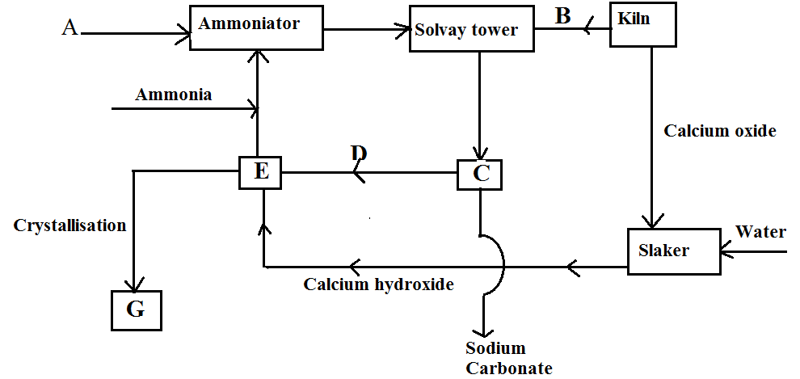
a) Name substances A and B (2mks)
A....................................................................................................................................................................................
B....................................................................................................................................................................................
b) Write equations for the reactions taking place in:
i) The solvay tower. (2mks)
.......................................................................................................................................................................................
.......................................................................................................................................................................................
ii) Chamber E. (1mk)
.......................................................................................................................................................................................
.......................................................................................................................................................................................
c) i) Identify substance G. (1mk)
.......................................................................................................................................................................................
.......................................................................................................................................................................................
ii) State one laboratory use and one industrial use of substance G.
I. Laboratory use (1mk)
.......................................................................................................................................................................................
.......................................................................................................................................................................................
II. Industrial use (1mk)
.......................................................................................................................................................................................
.......................................................................................................................................................................................
d) Name one most important industry where sodium carbonate is used as a raw material. (1mk)
.......................................................................................................................................................................................
.......................................................................................................................................................................................
e) The reaction equation below represents a chemical change that occurs when hydrated sodium carbonate is exposed to the air for 24 hrs.
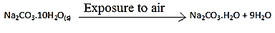
i) Give the name of the chemical change represented by the above equation. (1mk)
.......................................................................................................................................................................................
ii) What observable change is accompanied by the above reaction? (1mk)
.......................................................................................................................................................................................
.......................................................................................................................................................................................

3. a) Draw the structures of the following compounds. (2mks)
i) 2 – methylbut-2-ene

ii) heptanoic acid

b) Describe a physical test that can be used to distinguish between methanol and hexanol. (2mks)
.......................................................................................................................................................................................
.......................................................................................................................................................................................
.......................................................................................................................................................................................
c) Use the flow chart below to answer the questions that follow.
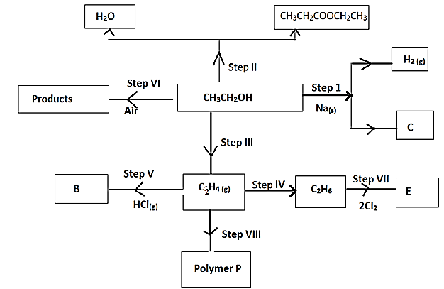
i) Name:
I. The type of reaction that occurs in step VII. (1mk)
.......................................................................................................................................................................................
II. Substance B
.......................................................................................................................................................................................
ii) What conditions and reagents are necessary to convert CH₃CH₂OH to CH₃CH₂COOCH₂CH₃ in step II
Conditions (1mk)
.......................................................................................................................................................................................
.......................................................................................................................................................................................
.......................................................................................................................................................................................
Reagent (1mk)
.......................................................................................................................................................................................
.......................................................................................................................................................................................
iii) Give the formula and name of substance C. (1mk)
.......................................................................................................................................................................................
iv) Give the reagent and conditions necessary for the reaction in step IV. (2mks)
.......................................................................................................................................................................................
.......................................................................................................................................................................................
.......................................................................................................................................................................................
.......................................................................................................................................................................................
v) i)Draw and name the structure of polymer P. (1mk)

ii) Name one use of the polymer P. (1mk)
.......................................................................................................................................................................................
4. a) Two reagents that can be used to prepare chlorine gas are manganese (IV)oxide and concentrated hydrochloric acid.
i) Write an equation for the reaction. (1mk)
.......................................................................................................................................................................................
.......................................................................................................................................................................................
ii) Give the formula of another reagent that can be reacted with concentrated hydrochloric acid to produce chlorine gas. (1mk)
.......................................................................................................................................................................................
.......................................................................................................................................................................................
iii) Describe how the chlorine gas could gas could be dried in the laboratory. (1mk)
.......................................................................................................................................................................................
.......................................................................................................................................................................................
.......................................................................................................................................................................................
b) In an experiment dry chlorine gas was reacted with aluminum as shown in the diagram below.
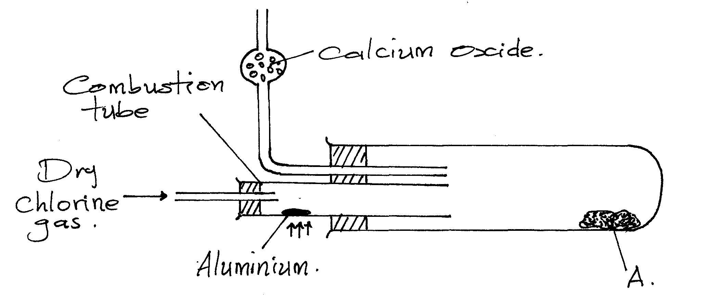
i) Name substance A. (1mk)
.......................................................................................................................................................................................
ii) Write an equation for the reaction that took place in the combustion tube. (1mk)
.......................................................................................................................................................................................
.......................................................................................................................................................................................
iii) 0.84g of aluminium reacted completely with chlorine gas. Calculate the volume of chlorine gas used. (Molar gas volume is 24dm³ Al = 27). (3mks)
.......................................................................................................................................................................................
.......................................................................................................................................................................................
.......................................................................................................................................................................................
.......................................................................................................................................................................................
.......................................................................................................................................................................................
.......................................................................................................................................................................................

iv) Give two reasons why calcium oxide is used in the set-up. (2mks)
.......................................................................................................................................................................................
.......................................................................................................................................................................................
.......................................................................................................................................................................................
5. The combustion of propane can be represented by the following equation:
C₃H_{8 (g)} + 5O_{2 (g)} 3CO_{2 (g)} + 4H₂O _{(l)}
a) i) Define the term ‘molar enthalpy of combustion’ of a compound. (1mk)
.......................................................................................................................................................................................
.......................................................................................................................................................................................
ii) Use the thermo chemical equations below to answer the questions that follow.
1. C_{(graphite)(s)} + O_{2 (g)} CO_{2 (g)} ∆H₁ = - 393.5kJ/mole
2. H_{2 (g)} + ½O_{2 (g)} H₂O _{(l)} ∆H₂ = -285.8kJ/mole
3. 3C_{(graphite)(s)} + 4H_{2 (g)} C₃H_{8 (g)} ∆H₃ = - 103.7kJ/mole
I. Name the type of enthalpy change represented by ∆H₃. (1mk)
.......................................................................................................................................................................................
.......................................................................................................................................................................................
II. Draw an energy level diagram for the reaction represented by equation 1. (3mks)

iii) Using energy cycle diagram, calculate the molar enthalpy of combustion of propane. (3mks)
.......................................................................................................................................................................................
.......................................................................................................................................................................................
.......................................................................................................................................................................................
.......................................................................................................................................................................................

b) The enthalpy of formation of ethanol (CH₃CH₂OH) is -3239Kj/mole. Use the bond energies given below to calculate the bond energy of formation of O-H. (3mks)
C-C = -346kJ/mole
C-H = -414kJ/mole
C-O = -360kJ/mole
.......................................................................................................................................................................................
.......................................................................................................................................................................................
.......................................................................................................................................................................................
.......................................................................................................................................................................................
.......................................................................................................................................................................................
6. Equal volumes of dilute sulphuric (vi) acid of various concentrations were placed in five test tubes. 0.26g of zinc granules was used in each experiment and time taken for each experiment to be completed noted. The table below shows the results obtained.

Acid concentration | 0.25M | 1.5M | 1.6M | 2.6M | 3.5M
Time in sec | 500 | 250 | 67.5 | 40 | 30
a) i) Complete the table above by calculating $\frac{1}{time}$ (2mks)

ii) Using the grid provided plot a graph of against concentration of the acid. (3mks)
iii) Using the graph determine the rate of reaction when the concentration is 1.5M. (1mk)
iv) Briefly explain the relationship between the rate of reaction and concentration. (2mks)
.......................................................................................................................................................................................
.......................................................................................................................................................................................
.......................................................................................................................................................................................
.......................................................................................................................................................................................
v) Identify any other condition if carried would increase the rate of reaction between Zinc and Dilute suplhuric (vi) acid. (1mk)
.......................................................................................................................................................................................
.......................................................................................................................................................................................
.......................................................................................................................................................................................

b) What volume of hydrogen gas is evolved when all the zinc is reacted with excess dilute sulphuric (vi) acid. (Zn = 65.4, molar gas volume = 22.4 litres) (3mks)
.......................................................................................................................................................................................
.......................................................................................................................................................................................
.......................................................................................................................................................................................
.......................................................................................................................................................................................
.......................................................................................................................................................................................
.......................................................................................................................................................................................
7. Study the scheme below and answer the questions that follow.
p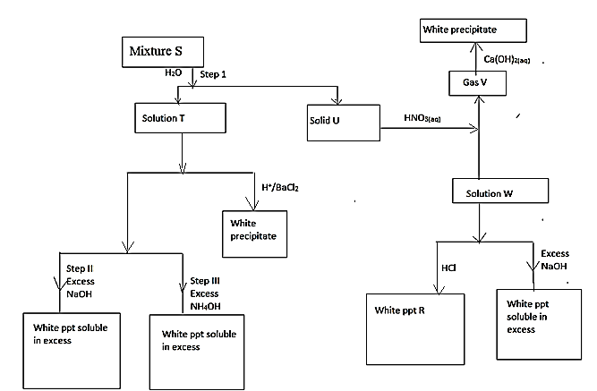
a) What property of mixture S is shown in step 1. (1mk)
.......................................................................................................................................................................................
.......................................................................................................................................................................................
b) Name the following. (1mk)
i) Solid U
.......................................................................................................................................................................................
ii) Solid V
.......................................................................................................................................................................................
c) Write the formula of precipitate R. (1mk)
.......................................................................................................................................................................................
.......................................................................................................................................................................................
d) Identify the ions present in solution T. (1mk)
.......................................................................................................................................................................................
.......................................................................................................................................................................................
e) Write an ionic equation for the reaction between solution T and Barium chloride solution. (1mk)
.......................................................................................................................................................................................
.......................................................................................................................................................................................
.......................................................................................................................................................................................
f) Identify mixture S. (1mk)
.......................................................................................................................................................................................
g) i) Write a chemical equation for the reaction in which the white precipitate dissolves in excess reagent in Step II. (1mk)
.......................................................................................................................................................................................
.......................................................................................................................................................................................
iii) Name the complex ion formed in Step III. (1mk)
.......................................................................................................................................................................................
.......................................................................................................................................................................................
h) Starting with lead (II) oxide, describe how a pure sample of lead (II) sulphate can be prepared in the laboratory. (3mks)
.......................................................................................................................................................................................
.......................................................................................................................................................................................
.......................................................................................................................................................................................
.......................................................................................................................................................................................
.......................................................................................................................................................................................
.......................................................................................................................................................................................

THIS IS THE LAST PRINTED PAGE!

