

**CEKENAS END OF TERM I EXAM-2022**

**FORM FOUR EXAM**

*Kenya Certificate of Secondary Education (K.C.S.E)*

**MARKING SCHEME**

**CHEMISTRY 233/2**

**PAPER 2**

1. a) i) A- 2.8

B – 2.8.8

ii)

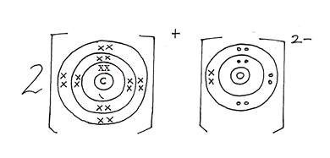

b) Shown on the grid between (B and D)

c) i) A is less reactive✓1 than C, C has a larger atomic radius✓1  hence loses its outermost electrons more easily.

ii) B has a smaller✓1 atomic radius than A since B has stronger nucleus✓1 charge.

ii) Oxide of G has a higher melting point than oxide of D ✓1 since G oxide is ionic and has strong ionic bonds✓½ whereas oxide of D has a molecular structure with weak vanderwaal forces✓½ between molecules.

d) Covalent bond✓1

E and D share valence electrons✓1 to form covalent bond.

e) E forms ion by gaining electrons ✓1. There exist repulsive forces ✓1 between the incoming electron and the existing electrons in E making the outer energy level bulge outward.

2. a) A – Brine/ concentrated sodium chloride. Reject sodium chloride

B – Carbon (iv) oxide

b) i) NH3(g) + H2O(l) + CO2(g) NH4HCO3(aq) ✓1

NH4HCO3(aq) + NaCl(aq) NH4Cl(aq) + NaHCO3(s) ✓1

iii) Ca(OH)2(s) + 2NH4Cl(aq) CaCl2(aq) + 2H2O(l) + 2NH3(aq) ✓1

(award ½mk for correct equation without symbols)

c) i) Calcium chloride✓1

ii) I- Drying agent for gases/ as a drying agent✓1  in the desiccators

II – In extraction of sodium from molten sodium chloride✓½. It lowers the melting point✓½ of NaCl from 8010c to above 6000c

d) i) Glass manufacturing industry

ii) Paper industry

e) i) Efflorescence✓1

ii) –Decrease in mass✓½

- Loss of crystalline nature✓½

3a)

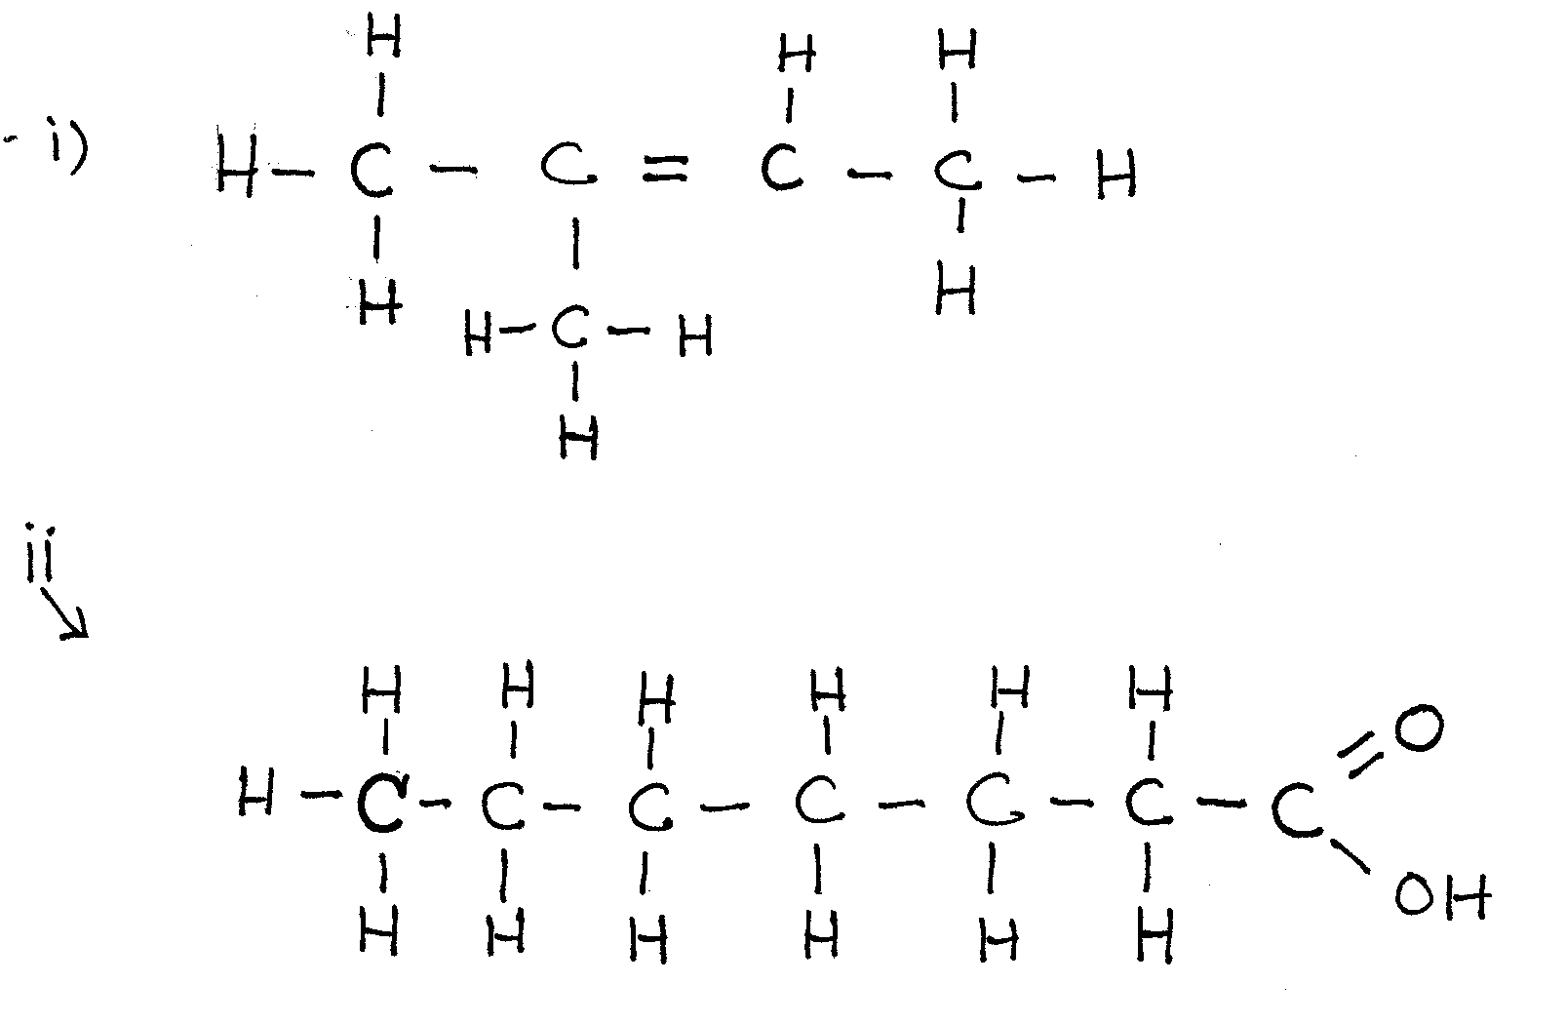

b) Heat the two substances separate and determine their boiling point✓1. Hexanol has a higher boiling point than methanol. ✓1

c) i) I – Substitution

II – Chloroethane

ii) Condition

Warming✓½

Concentrated sulphuric (vi) acid✓

Reagent

Propanoic acid ✓1

iii) CH3CH2ONa✓½ – Sodium Ethoxide✓½

iv) Hydrogen ✓1

Nickel catalyst✓½

Temperature 1500c – 2500c✓½

v) I

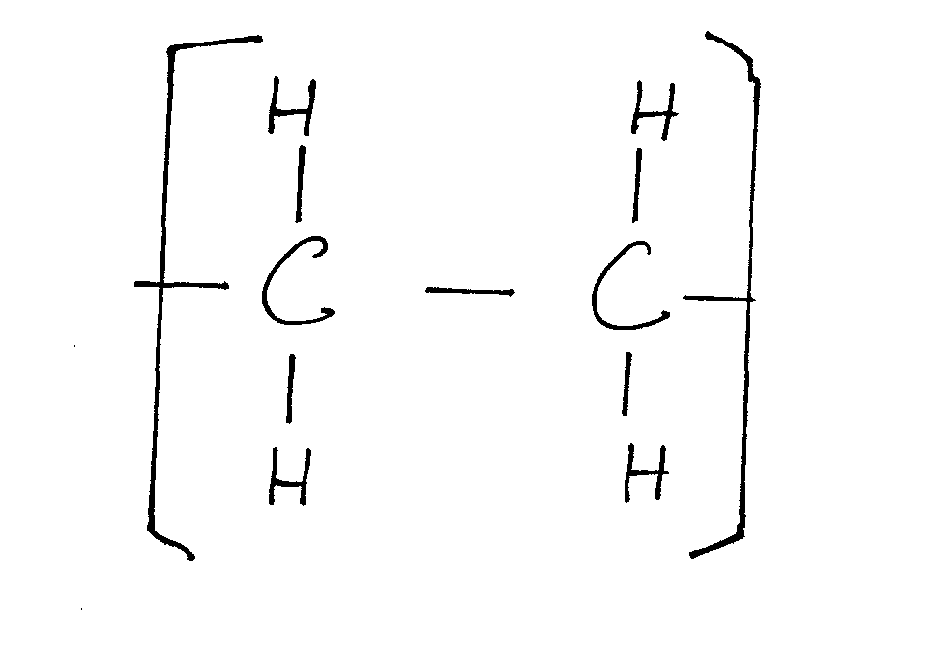✓½

Polyethene✓½

II – Polythene bags✓1

✓1

✓1

iii) By passing it through concentrated sulphuric (vi) acid. ✓1

b) i) Aluminium chloride ✓1

✓1

✓1

✓½

✓½

Volume of chlorine = 0.09333 x 24000✓1

= 2240cm³

iv) – Calcium oxide prevents any moisture from outside since the AlCl3 is deliquescent hence keeps combustion tube dry. ✓1

- Calcium oxide reacts with moisture forms calcium hydroxide that prevents chlorine from escaping to the atmosphere. ✓1

5.a) i) Energy or enthalpy change that occurs when a compound reacts completely with oxygen at standard conditions. ✓1

ii) I - Molar enthalpy of formation of propane. ✓1

II –

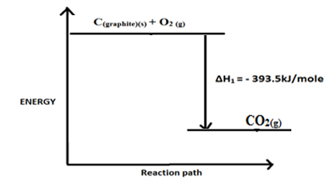

iii)

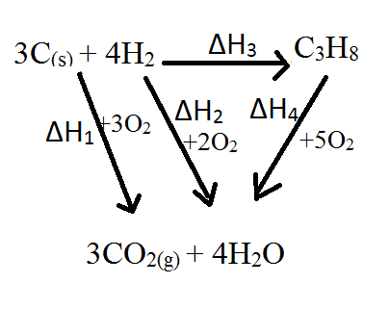

✓½

✓½

✓½

✓½

b)

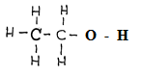

 ✓1

1 x -346kJ

5x -414 = - 2070kJ

1 x -360 = - 360Kj

**-** 2776kJ + (O – H) = -3239 ✓1

O – H = -463kJ ✓1

6. a) i)

|  |  |  |  |  |  |
| --- | --- | --- | --- | --- | --- |
| Acid concentration | 0.25M | 1.5M | 1.6M | 2.6M | 3.5M |
| Time in sec | 500 | 250 | 67.5 | 40 | 30 |
|  | 0.002 | 0.004 | 0.015 | 0.025 | 0.033 |

**ii)**

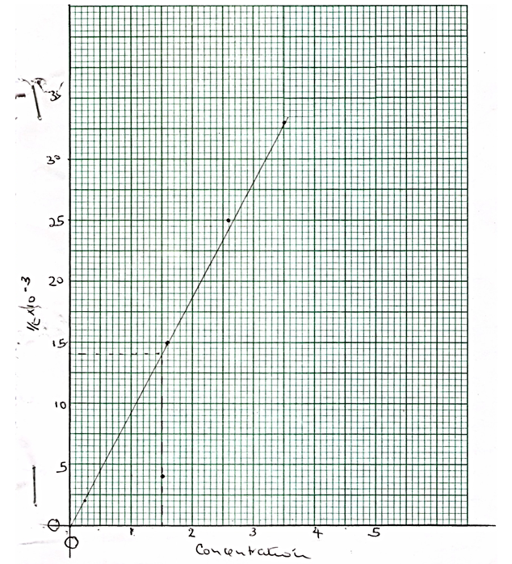

- Labelling – ✓½

- Scale – ✓½

- Plots – ✓1

- Line -✓1

NB: Straight line passing through the origin.

ii) 0.014✓ correct showing ✓½

Correct reading ✓½

iv) The rate of reaction increases with increase in concentration ✓1/ increased concentration increases the number of reacting particles and number of effective collisions✓1.

v) – Increased temperature (warm the mixture) ✓1

- Presence of a catalyst/ add crystals of CuSO4

✓½

1: 1 1: 1✓½

65.4g of Zinc produce 22400cm³ of H2 at STP✓½

0.26G of Zinc produces cm³ of H2 at STP

✓1

= 89.05cm3✓½

7. a) Mixture of soluble and insoluble salt

b) i) Lead carbonate (Reject formula)

ii) Carbon (iv) oxide (Reject formula)

c) PbCl2

d) Zn2+, SO2-4  (Reject names)

e) (Penalise ½for wrong state symbol)

f) PbCO3 and ZnSO4 (accept names tied to the two for 1mk)

g) i) 

(Reject fully if not balanced, penalise ½mk for wrong state symbols)

ii) Tetramine Zinc (ii) ions

h) Add excess lead (ii) oxide to dilute nitric (v) acid✓½.

Filter✓½ the unreacted lead (ii) oxide;

Add sodium sulphate✓½/ K2SO4/ H2SO4 to the filtrate

Filter✓½ to obtain lead (ii) sulphate as the residue

Wash the residue✓½ with distilled water

Dry the residue between filter paper✓½