CEKENAS END OF TERM I EXAM-2022
FORM FOUR EXAM
Kenya Certificate of Secondary Education.(K.C.S.E)
MARKING SCHEME
CHEMISTRY 233/1
PAPER 1
1. a) Under constant temperature and pressure, the rate of diffusion of a gas is inversely proportional to the square root of its density.
b) ^{1/2}
2. – A place where experiment producing poisonous gases are carried out. 1
- Storage of substances that produce foul or poisonous fumes.1
3. i) Hydrogen bond 1mk
ii) Covalent bond 1mk
4. i) a) Ca(HCO₃)₂, Mg(HCO₃)₂
b) CaSO₄, MgSO₄ any present 1mk
ii) – Ion exchange
- Addition of sodium carbonate any present 1mk
- Distillation
5. – Add excess Lead metal to a certain volume of nitric(v) acid. ^{1/2}
- Filter to obtain excess lead metal as a residue and lead (ii) nitrate as a filtrate. ^{1/2}
- Add distilled water to sodium sulphate to form sodium sulphate solution. ^{1/2}
- Add lead (ii) nitrate solution to sodium sulphate solution to precipitate lead (ii) sulphate and form sodium nitrate solution. ^{1/2}
-Filter to obtain lead (ii) sulphate as a residue and sodium nitrate as a filtrate. ^{1/2}
- Wash the residue and dry it between the filter paper. ^{1/2}
6. a) Yield of sulphur(vi) oxide decreases. Increase in temperature favours backward reaction which is endothermic. 1
b) No effect on the yield.1 Absence of a catalyst makes the equilibrium not to be achieved faster. 1
7. a)
Element | Fe | O
Mass | 3.36 | 1.281
Molar mass | 56 | 16
Mole | 0.06 | 0.081
Mole ratio | 1x3 | 1.333x3
 | 3 | 4
Empirical formula = Fe₃O₄1
b) Reducing property1
8. a) Isotopes
b)
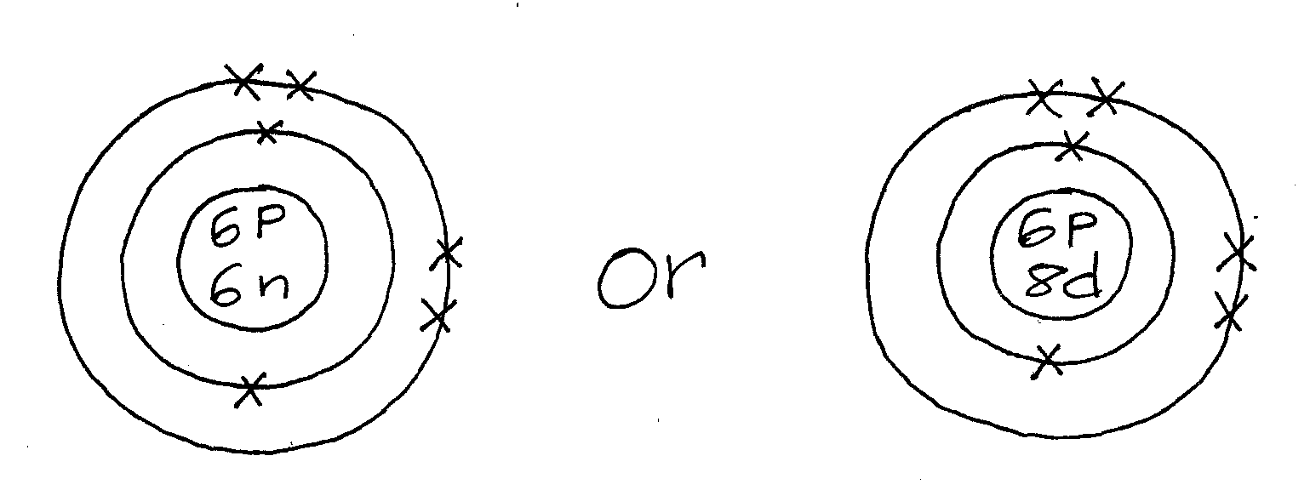
9. a) i) –Yellow solution changes to pale green solution.1
- Yellow deposit.1
ii) 2FeCl_{3(s)}+ H₂S_{(g)} 2FeCl_{2(aq)}+ S_{(s)}+ 2HCl_{(g)}
10. – A brown coating/ rust is observed on nail y. ^{1/2}Rust occurs on Y because silver is less reactive than iron^{1/2}
- No brown coating/ no rust on nail X. ^{1/2}This is because magnesium is more reactive than iron^{1/2}
11. a) Sodium sulphite/ NaSO₃1
b)
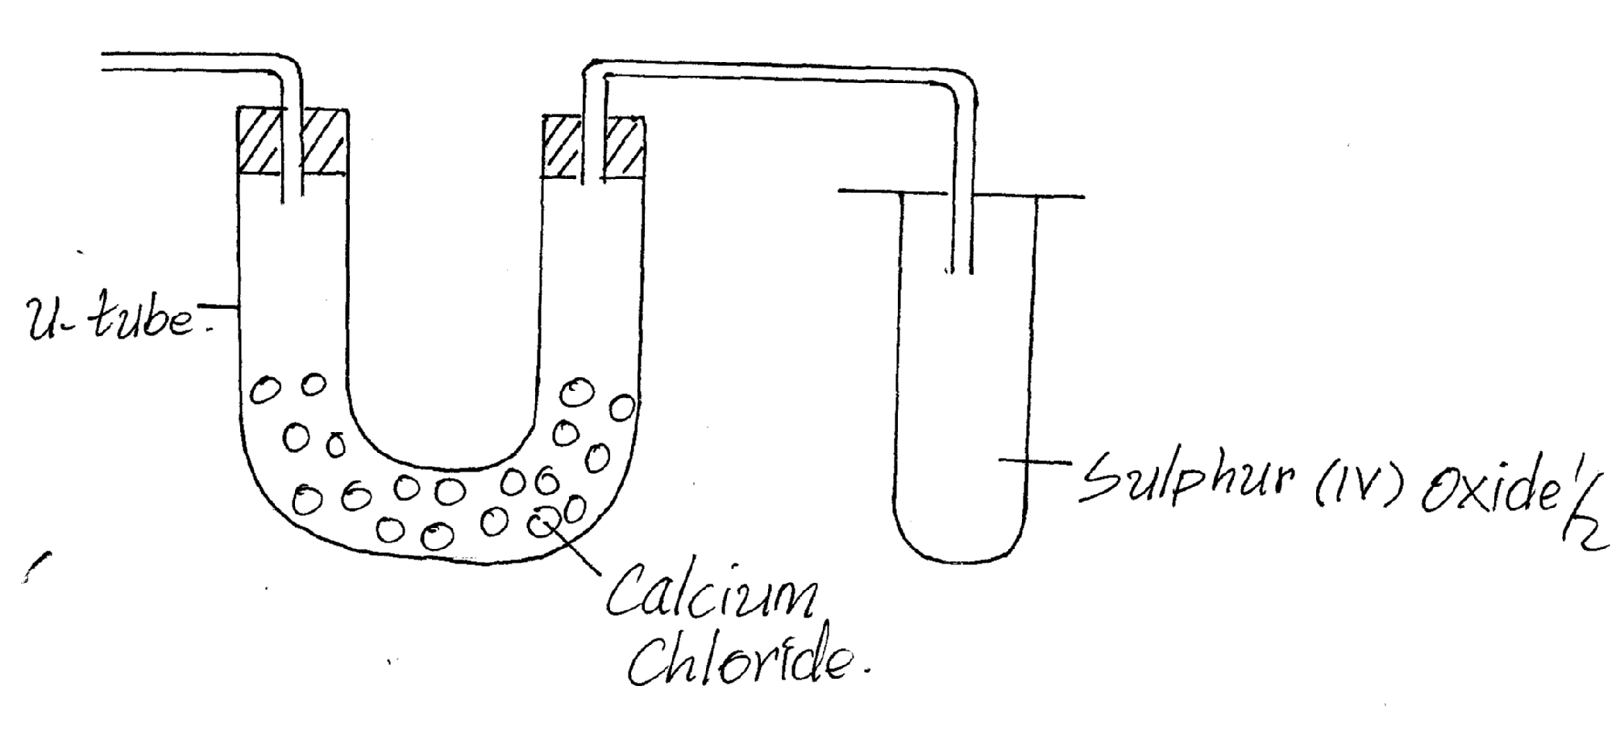
12. Reactants Products
C-C = 348x1=348 C-C = 348x1=348
C-H = 6x414= 2484 C-H = 5x414= 2070
Cl-Cl = 243x1=243 C-Cl = 432x1=432
+ 3075KJ/mol1 H- Cl = 340x1= 340
-3190KJ/mol1
∆H = 3075-3190^{1/2}
= - 115kJ/mol^{1/2}
13. a) Hydrogen chloride gas 1
b) Polymerisation 1
c) Polyvinylchloride1
14. a)

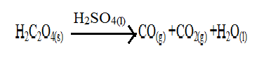
b) Bubble/ pass the mixture of two gases through sodium hydroxide solution.1
- Carbon (iv) oxide is absorbed leaving carbon (ii) oxide.1
15. a) Grey solids are deposited Pb²⁺ ions migrate to the cathode and gain electrons to form lead metal.1
b) Electroplating
- Purification of water any one correct 1
16. a) Solubility1
b) When tap is opened and closed a small drop of water dissolves a large volume ^{1/2} of ammonia gas creating a partial vacuum^{1/2} decreasing pressure inside the flask. When the tap is opened for the second time, water gets in forming a fountain.1
c) HCl gas / NO₂ gas
17.
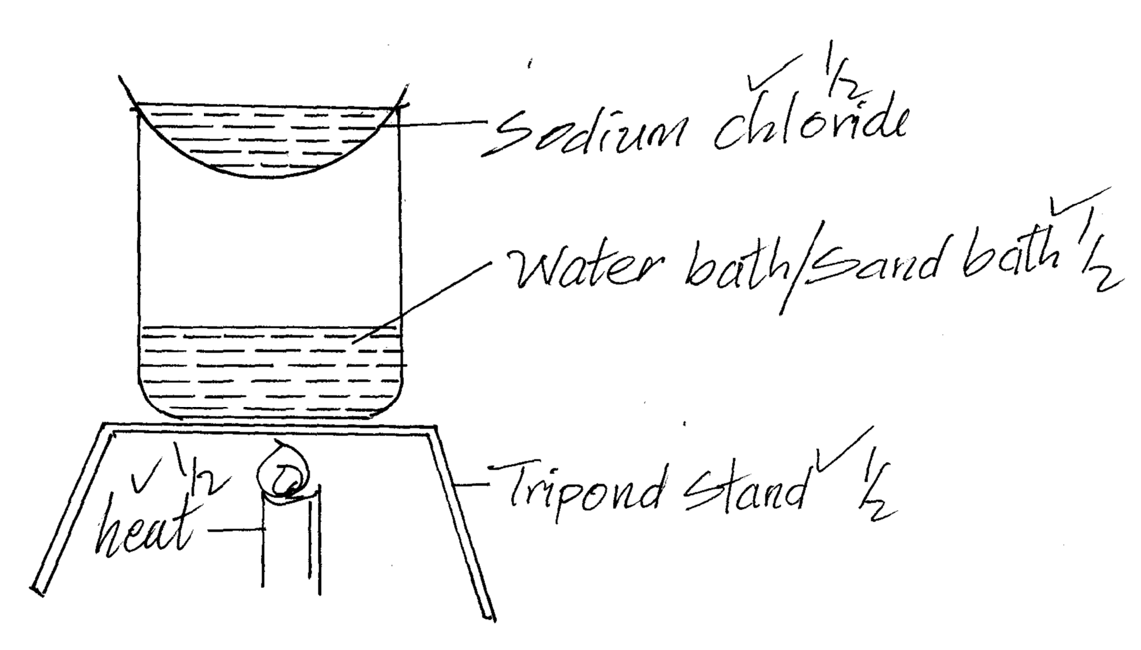
18.a) The maximum mass in grams of a solute that saturates 100g of water at a specific temperature.
b) Mass of water = 40 – 15 ^{1/2}
= 25g of H₂O^{1/2}
15g of salt = 25g of H₂O
? = 100g of H₂O
^{1/2 =} 60g/100g of H₂O^{1/2}
19.- Deforestation
- More cars
- More industries
- Sea unable to absorb extra CO₂ produces. Any two 2mks
20. Blue litmus paper remains blue;¹HCl gas dissolves in methylbenzene but does not dissociate to produce H⁺ ions. 1
21- - The activation energy should be from the reactants to the peak.1
-The product should be below the reactants/ products should have less energy than reactants.1
22. Water has hydrogen bond^{1/2} as intermolecular forces of attraction while H₂S gas has weaker vanderwaal forces^{1/2} of attraction between its molecules. Hydrogen bonds are stronger than weak vanderwaal forces.1
23. a) Atomic radius of R is bigger than that of G.1
b) Oxide of A is acidic while oxide of E I basic.1
c) Indicated in the periodic table before letter C.1
24. a) Curve II
b)
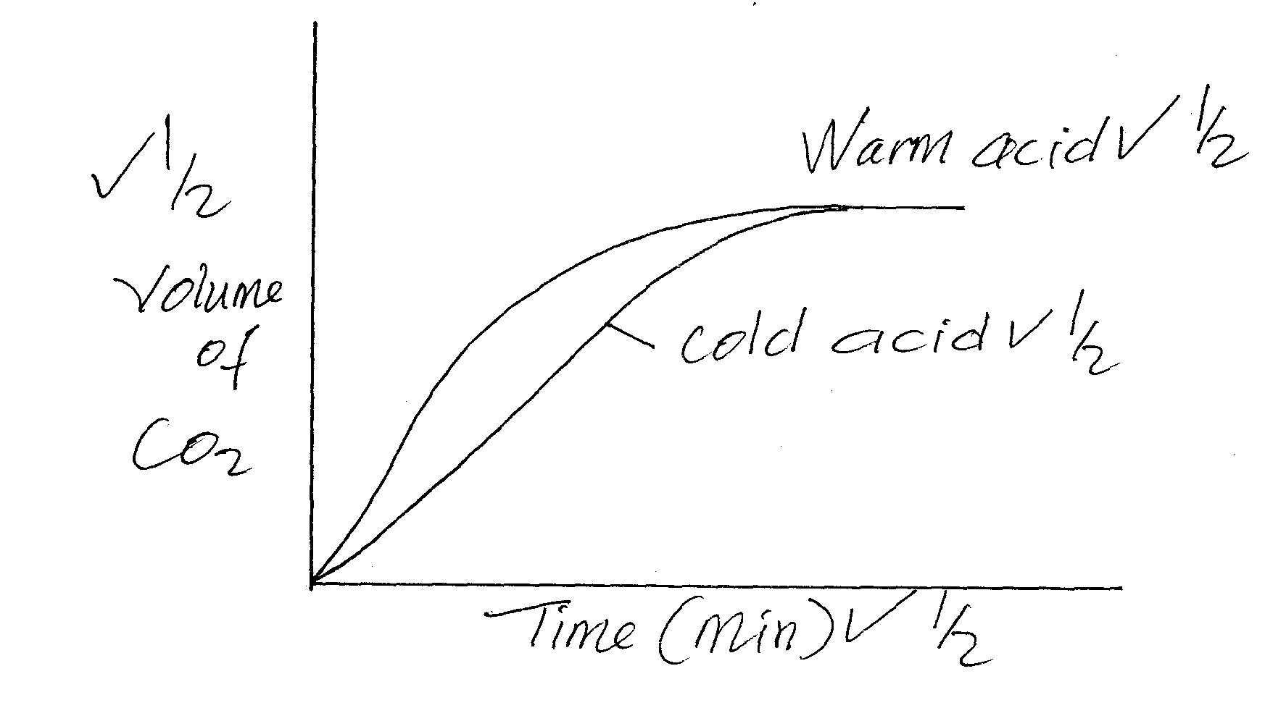
25. i) – Melts into a silvery ball1
- Darts on the surface of water.1
- Ignites spontaneously to produce a lilac flame1 Any two
ii) Alkali metal
26. a) Alkynes
b) C_{x}H_{y(g)} + Cl_{2(g)} C_{(s)} +HCl_{(g)}
27. i) Hydrogen gas
ii) To increase surface area for absorption.
iii) – Pricking of metal.
- Treatment of sewerage
- Standardizing of pH in beers and wine. Any one 1mk
28. a) ∆H = 50gx4.2Jg⁻¹k⁻¹ x 3K
= 630J
b) Moles of NaOH = ^{½} = 0.0125 moles^{½}
^{½} = -50400J^{½}
^{OR}
Moles = -50.4kJ/mol

