NAME:……………………………………. SCHOOL………………………………………

ADM NO: ……………………DATE:…………………………..SIGNATURE……..……..

233/2
CHEMISTRY
PAPER 2
FORM FOUR
2 Hours

CATHOLIC DIOCESE OF KAKAMEGA EVALUATION TEST.
AUG/SEPT EXAM 2022

INSTRUCTION TO CANDIDATES

- Write your name and index number in the spaces provided above.
- Sign and write the date of examination in the spaces provided above.
- Answer ALL the questions in the spaces provided in the question paper.
- KNEC Mathematical tables and silent non-programmable electronic calculators may be used.
- All working MUST be clearly shown where necessary
- This paper consists of 10 printed pages.
- Candidates should check the question paper to ensure that all pages are printed as indicated and no questions are missing.
- Candidates should answer all the questions in English.

For Examiner’s Use Only

Question | Maximum Score | Candidate’s Score
1 | 14
2 | 12
3 | 13
4 | 9
5 | 10
6 | 10
7 | 12
TOTAL SCORE | 80

- The grid below shows a section of the periodic table. The letters do not represent the actual symbols of the elements.

K | L |  |  |  |  |  |  | M |  |  |  | N | P
 | Q |  |  | R |  | S |  |  |  | T |  | V
W

- Name the family to which element P belongs. ( 1mk)

- Which two elements will form carbonates that do not decompose on heating ( 2mks)

- With a reason, identify an element in period 3 with the largest atomic radius ( 2mks)

- Write the formula of the compound formed between L and M ( 1mk)

- State two uses of element R and for each use , state property of element R that makes it possible for the use
- Use ( 1mk)

Property (1 mk)

- Use ( 1mk)

Property (1mk)

- Using dots (.) and cross (x), show bonding in the compound formed between R and oxygen ( 2 mks)

- In terms of structure and bonding explain why the oxide of element V has relatively low boiling points ( 2mks)

- a. Name the following compounds ( 3mks)
- CH₃CH₂CH₂COOH

- H₂C Br– CH(CH₃) – CH₂ – CBr = CH – CH₃

- CH₃CH₂COOCH₂CH₃

b. Two types of detergents P and Q can be represented as

P; OSO₃⁻Na⁺

Q; COONa⁺

- Identify each type of the detergent ( 2mks)

P

Q

ii) Which of the two detergents is the best to use with hard water? Give reason. ( 2mks)

iii). State one disadvantage of detergent P ( 1mk)

iv). State advantage of detergent Q ( 1mk)

c. A compound is represented as shown below

CH₃CH₂CH₂COOC₂H₅

- Name the compound. ( 1mk)

- Name two reagents that can be used to generate the compound( 2mks)

- (a) Define the term electrolysis ( 1mk)

(b) State two function of the salt bridge during electrolysis (2mks)

(c) During the electrolysis of a molten chloride of metal Q, a current of 0.25A was passed through the molten chloride for 2 hours and 10 minutes .Given that 0.9 g of metal Q were deposited at the cathode.
(i) Calculate the quantity of electricity passed (1mk)

(ii) Charge carried by the ions of metal Q given that R.A.M of metal Q is 84 (3 mks)

(d)Electric current was passed through a concentrated solution of copper (II) chloride as shown in the diagram below.
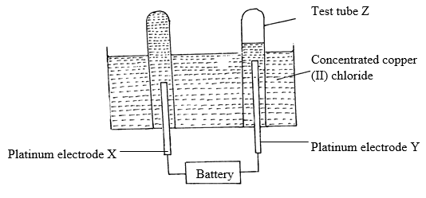
(i) Write the chemical equation for the reaction at the cathode? (1 mark)

(ii) After sometime test-tube Z was found to contain a mixture of two gases. Explain this observation. (2 marks)

(iii) State the observations that would be made at the anode if the platinum electrodes are
replaced with copper electrodes. (2 marks)

- State one application of electrolysis in iron industry (1mk)

- a) Define the term saturated solution. (1mk)

b) Solubility of salt X and Y were determined at different temperatures as shown in the following data.
Temperature (ºC) |  | 0 | 20 | 40 | 60 | 80 | 100
Solubility of 100g of water | X | 12 | 30 | 75 | 125 | 185 | 250
 | Y | 15 | 20 | 35 | 45 | 65 | 80

- On the grid provided, plot a graph of solubility (vertical axis) against temperature. (4mks)
ii. From the graph determine the solubility of each at 50ºC.
X (1mk)

Y (1mk)

iii. At what temperature was the solubility of both salts equal? (1mk)

c) What is permanent hardness of water? (1mk)

- The diagram below shows an experiment incorrectly set-up to investigate a property of carbon (ii) oxide. Study it and answer the questions that follow.
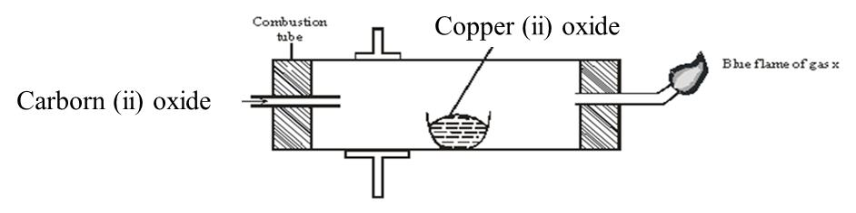

- Name one condition that is missing in the set up that must be present if the experiment to proceed. (1mk)

- If the experiment was carried out properly, what observation would be made in the combustion tube? (1mk)

- Give a name for the type of reaction that occurs in the combustion tube. (1 mk)

d) Write an equation for the reaction that takes place as gas x burns. (1 mk)

- Why is it necessary to burn gas x? (1mk)

- Name the reducing and oxidizing agent. (2mks)
- Reducing agent

- Oxidising agent

- Identify any other substance that would have the same effect on copper (II) oxide as carbon (II) oxide. (1mk)

- What would happen if copper (II) oxide was replaced with sodium oxide? Explain.
(2mks)

- Dry chlorine was collected using the set up below.
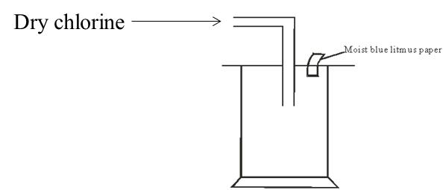

- Name a suitable drying agent for chlorine gas? (1mk)

- State one property of chlorine gas which facilitates this method of collection. (1mk)

- State the observations made on the moist blue litmus paper. Explain. (2mks)

- Chlorine gas was bubbled through distilled water. With aid of an equation show the formation of chlorine water. (1mk)

- Write the formula of the compounds formed when chlorine gas reacts with warm dry phosphorous. (2mks)

- Chlorine gas is mixed with moist hydrogen sulphide gas. State and explain the observations.
(2mks)

- Give one use of chlorine gas. (1mrk)

- A metal F is very reactive and therefore it is extracted by electrolysis of its fused chloride. The electrolytic cell used in its extraction is made of anode surrounded by a ring shaped iron cathode enclosed in a wire gauze shell that acts as a partition separating the two electrodes.When exposed to air it loses its lustre.At 620°C, it reacts with liquid ammonia liberating hydrogen gas.It is used as a deoxidizing agent in the preparation of light alloys and some rare earth metals from their oxides.
- Name the process by which metal F is extracted. (1mk)

- What is the identity of metal F. (1mk)

- State the name of the ore from which metal F is extracted. (1mk)

- Explain why the metal loses its lustre when exposed to air. (1mk)

- What is the function of wire gauze shell that separates the anode from the cathode?
(1mk)

- Write a chemical equation for the reaction between metal F and ammonia(1mk)

- Apart from being a deoxidizing agent, state two other uses of metal F. (2mks)

- During extraction of aluminium by electrolysis, molten cryolite is used instead of water and the anode must be replaced from time to time.
- State the main ore from which aluminium is extracted (1mk)

- Explain why cryolite is preferred over water (1mk)

- Give a reason why the anode is replaced from time to time. (1mk)

- Extraction of aluminium is very expensive compared to other metals like Iron, explain (1mk)

