CATHOLIC DIOCESE OF KAKAMEGA EVALUATION TEST.
CHEMISTRY PAPER 2
MARKING SCHEME

a) Noble gases reject rare/inert gases
b) K and W accept Lithium and Potassium
c) Q, hs the fewest number of protons hence experiences weaker nuclear force of attraction.
d) L₃M₂
e) i) Making electric cables: it is a good conductor of electricity, it is ductile.
ii) Making cooking pans: It is malleable good conductor of heat.
f) R₂O₃
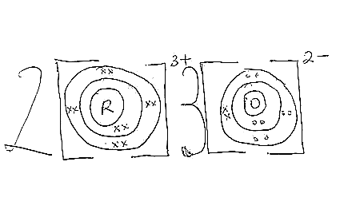

g) Hassimple molecular structure with weak van der waals forces holding the molecules together.
2.
a) i) Butanoic acid
ii) 3,6-dibromo-5-methylhex-2-ene
iii) ethylpropanoate
b) i) P - Soapless detergent
Q- Soapy detergent.
ii) P, does not form scum/ lathers easily with hard water.
iii) Non- biodegradeable hence pollutes the environment// exppensive
iv) Biodegradeable hence does not pollute the environment// cheap
c) i) ethylbutanoate
ii)butanoic acid& ethanol
3.
a) Decomposition of an electrolyte by passing an electric current through it.
b) -completing the circuit
- maintain electrical neutrality within internal circuit.

c) i) Q=it
= 0.25x7210
=1802.5

ii) 0.9→1802.5
84→?
$$\frac{48x1802.5}{0.9}$$

= 168,233.3333

1 charge→96500 C
? →168,233.333

$\frac{168,233.333}{96,500}$

=1.7434
=+2

d) i) Cu²⁺_{(aq)} + 2e → Cu_{(s)}
ii) At the beginning, OH⁻ion are preferentially discharged at the anode where they lose electrons producing O₂ gas. After sometime the concentration of OH⁻ decreases and Cl⁻ are preferential discharged due to their higher concentration, they lose electron producing Cl₂ gas.
iii) Anode dissolves in the solution, copper anode is an active electrode.
iv) Electroplating to prevent rusting and improve its appearance
4.
a) A solution in which no more solute can dissolve at a particular temperature.
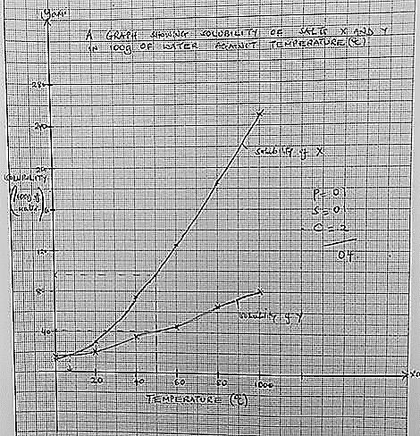
b) i)

ii). X = 96g/100g of water $±2g$
Y = 41g /100g of water $±2g$
iii). 7˚C $±1°$C
c) Hardness that cannot be removed by boiling/ hardness caused by dissolved Mg²⁺ or Ca²⁺ ions carnonates.

5.
a) Heat/heating Cuo.
b) Black Cuo turns /changes to reb-brown copper metal.
c) Redox
d) 2CO_{(g)} + O_{2 (g)}→ 2CO_{2 (g)}
e) It is poisonous.
f) i) carbon (II) oxide ii) Copper (II) oxide
g) Ammonia gas // Hydrogen gas (any one)
h) White ash of Na₂O remains white// no change ; Na is above C in the reactivity series hence CO cannot reduce Na₂O.

6.
a) Concentrated Sulphuric (VI) acid.
b) Denser than air.
c) turns red then eventually bleached to white. Turns red because solution is acidic, turns white because it is bleached
by HOCI
d) Cl_{2(g)} + H₂0_{(I)}→HOCl_{(aq)} + HCl_{(aq)}
e) PCl₅
PCl₃
f) Yellow deposits of sulphur; chlorine oxidizes to H₂S to S and itself is reduced to hydrogen chloride’
g) Treatment of water (accept any other)

7.a)
i). Downs process
ii) Sodium
iii). Rock salt
iv) Reacts with oxygen , nitrogen and hydrogen carbonates in air forming a coat on the surface.
v) Prevents Cl_{2(g)} from combining with Na_{(l)}
vi) 2Na_{(s)} + 2NH_{3 (L) 620}°_{C} 2NaNH_{2(L)} + H_{2 (g)}
vii) Combined with cyanide used in extraction of gold. etc

b)
i)Bauxite
ii) Bauxite is insoluble in water but soluble in cryolite
iii) O₂ produced reacts with carbon anode.
iv) A lot of electricity is used in its extraction.

