NAME:……………………………………. SCHOOL………………………………………

ADM NO: ……………………DATE:…………………………..SIGNATURE……..……..

233/1
CHEMISTRY
PAPER 1
FORM FOUR
2 Hours

CATHOLIC DIOCESE OF KAKAMEGA EVALUATION TEST.
AUG/SEPT EXAM 2022

INSTRUCTIONS TO CANDIDATES
- Write your name, admission number, date and school in the spaces provided.
- Answer all the questions in the spaces provided.
- All working must be clearly shown where necessary.
- Scientific calculators may be used.
- Answer all questions in English

FOR EXAMINERS’ USE ONLY

Questions | Maximum Score | Candidate’s Score
1 – 27 | 80

This paper consists of 12 printed pages. Candidates are advised to check and to make sure all pages are as indicated and no question is missing.

- Ammonia burns in air in the presence of a catalyst according to the equation below :
4NH₃(g)+5O₂(g) 4NO(g) +6H₂O(g)
- Given that increase in temperature raises the amount of ammonia .State whether the left-right reaction is exothermic or endothermic .Give a reason. (2mks)

- How will increase in pressure affect the yield of nitrogen (II) oxide? (1mk)

- 0.98g of zinc and 100cm³ of 0.2M hydrochloric acid were reacted .
- Show that zinc metal was in excess. (2mks)

- Calculate the volume of hydrogen that was liberated at s.t.p (Zn =65.4,MGV=22400cm³)
(1mk)

- The general formula for a homologous series of organic compound is C_{n}H_{2n+1}OH ,name and draw the structural formula of the third member of this series
- Name (1mk)

- Structural formula (1mk)

- Write an equation for the complete combustion of third member of the series (1mk)

- The following are electrode potential of two half cells.(the letters do not represent actual symbols of the elements)
Half cell E^{θ}(V)
M²⁺/M(s) -0.76
C²⁺/C (s) +0.34
- Calculate the potential difference of the following cell:
M(s)/M²⁺(aq)//C²⁺(aq)/C(s) (1mk)

- Draw a cell diagram for the cell in (a) above (3mks)

- 50g of crystals of salt W were added to 80cm³ of water at 25ºC. after stirring 10g of the crystals of salt W were filtered out. Determine the solubility of salt W at 25ºC (density of water =1g/cm³) (3mks)

- Elements F and G react forming a compound H. The compound has the following properties :
    - It does not conduct electricity in solid state.
    - It has low melting and boiling points.
- State weather the elements are metals or non-metals (1mk)

- What type of structure does compound H have ? (1mk)

- Name the bond formed between F and G. (1mk)

- a) Distinguish between nuclear fission and nuclear fusion (1mk)

b) The half life of ²³⁵₉₂U is 4500 years.
- The isotope decays by alpha emissions, Write a nuclear equation for its decay for thorium (Th). (1mk)

- Work out the fraction of radioactive material that would be remaining after 18000 years (3mks)

- The diagram below represents a set-up that was used to react iron with steam. Study it and answer the equations that follow.

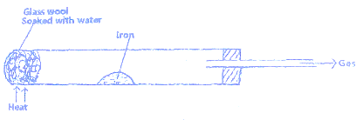

- Write an equation for the reaction that takes place. (1mk)

- Why would it not be advisable to use potassium in place of iron in the above set –up?
(1mk)

- The glass wool is heated prior to heating of iron. Explain. (1mk)

- In an experiment , sulphur (IV) oxide was bubbled into water followed by chlorine gas. The resulting solution gave a white precipitate when mixed with acidified barium chloride solution .
- Explain this observation . (2mks)

- Write an ionic equation for the formation of the white precipitate . (1mk)

- Elements X³⁺ and Y⁻ have atomic numbers 13 and 8 respectively :
- Write down the electron arrangement of elements X and Y. (1mks)

- Write the formula of the compound formed between element X and Y (1mk)

- Corn oil can be converted into solid fat as shown by the equation below.

Corn oil reagent Y solid fat

- Name the process shown above by the equation. (1mk)

- What is the importance of this process (1mk)

- Name reagent Y (1mk)

- The set up below was used to investigate electrical conductivity of lead (II) iodide .study it and answer the questions that follow.
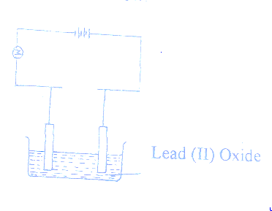

    - Label the anode (1mk)
    - State one omission on the set up above (1mk)

    - If the omission is corrected, Write an equation at the cathode. (1mk)

- A student was provided with copper turnings and concentrated sulphuric (VI) acid. Draw a set- up that the student would use to prepare and collect a dry sample of sulphur (IV) oxide gas. (3mks)

- Copper is extracted from its ores by a process of froth floatation and then roasted in air to produce copper (I) oxide.
  - What is froth floatation (1mk)

  - Write an equation for roasting of the ore in air (1mk)

  - Name one impurity in the ore and how it is removed. (1mk)

- Dry ammonia gas was passed over hot copper (II) oxide as shown below.

Copper

NH₃(g) Hot CuO Nitrogen gas

Water

    - State the property of ammonia being investigated above . ( ½ mk)

    - Write an equation for the reaction that took place (1mk)

    - Name one other gas that would be used in place of ammonia gas. (1mk)

- Hydrogen peroxide decomposes according to the equation given below.
H₂O_{2(l)} H₂O_{(l)}+$\frac{1}{2}$O_{2(g)}; ΔH =-98KJ/mol
If 6.8 g of hydrogen peroxide contained in 75cm³ of solution with water were completely decomposed, determine the rise in temperature due to the reaction. (3mks)
(specific heat capacity of water =4.2Jg⁻¹K⁻¹,density =1g/cm³,O=16.0, H=1.0)

- The figure below shows a Bunsen burner flame.
- Describe how this type of flame is produced. (1mk)

- Which part on the diagram is the hottest part of the flame. ( ½ mk)

- Name the gas produced by a burning candle that is non-pollutant. (1mk)

- A mixture of 5.0 g of sodium carbonate and sodium hydrogen carbonate was heated until there was no further change in mass .the loss in mass was 0.31 g. calculate the percentage by mass of sodium hydrogen carbonate in the mixture. (3mks)
(Na=23.0, H=1.0, C=12.0, O=16.0). (Assume loss in mass is due to loss of carbon (IV) oxide)

- In the manufacture of sodium carbonate by Solvay process, ammonical brine trickles down the carbonator while carbon (IV) oxide rises up the same tower.
  - What is ammonical brine. (1mk)

  - Write two equations taking place in the carbonator. (2mks)

- An atom of an element W has atomic radius of 0.099 nm and ionic radius of 0.181 nm.
  - State whether W is a metal or a non- metal. (1mk)

  - Explain the difference in atomic and ionic radius. (2mks)

- The figure below shows a set up used by form 3 students to compare the rates of diffusion of ammonia and hydrogen chloride gas.
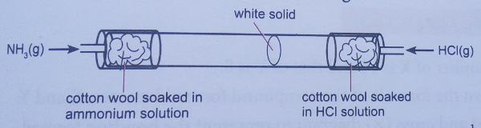

Given that ammonia travels through a distance of 30cm in 1 ½minutes.

- Calculate the distance through which hydrogen chloride travels within same time.(3mks)

- Write an equation to show how the white solid is formed. (1mk)

- Given that 3.52 g of carbon (IV) oxide and 1.40 g of water are produced when a mass of a hydrocarbon is completely burnt in oxygen , determine the formula of the hydrocarbon.
(H=1, C=12, O=16) (3mks)

- 10cm³ of a gaseous hydrocarbon were mixed with 30cm³ of oxygen gas and the mixture exploded . After the mixture had cooled to room temperature, 20cm³ of gas remained. After shaking this gas with sodium hydroxide solution its volume was reduced to 10cm³.The remaining gas rekindled a glowing splint.
Determine the formula of the hydrocarbon. (3mks)

- The diagram below shows a method used by a student to determine the boiling point of ethanol. After setting the apparatus as shown below he inserted a thermometer into the ethanol.
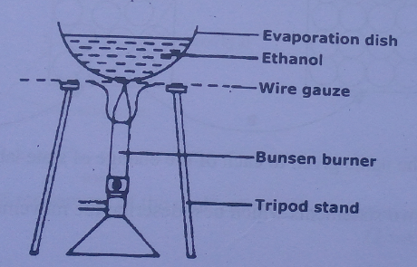

    - Give a reason why it is not a safe method. (1mk)

    - Suggest a better method. (1mk)

    - What will happen to the boiling point of ethanol if crystals of benzoic acid were first dissolved in it? (1mk)

- A form two student in an attempt to stop rusting she put copper and magnesium in contact as shown.
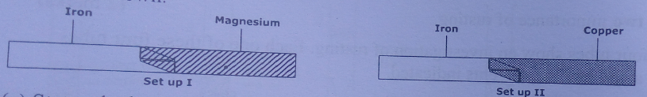

- State whether rusting occurred in each set-up after one week if the set-ups were left outside. (1mk)

- Explain your answer in (a) above. (2mks)

- The table below describes the properties of an acid,alkali and a salt solution.
- Complete the table. (2 ½ mk)
solution | Colour with universal indicator solution | Approximate pH | Ions present
Sodium hydroxide | blue |  | Na⁺ , OH⁻
Hydrochloric acid | red
Sodium sulphate |  | 7
- Name two solutions which when mixed together form a solution of sodium sulphate.
(1mk)

- Complete the following equation.
H H
C==C + [O] cold dilute
H H H⁺/KMnO₄

Name the reaction above. ( ½ mk)

