CATHOLIC DIOCESE OF KAKAMEGA EVALUATION TEST
CHEMISTRY PAPER 1
MARKING SCHEME
- Ammonia burns in air in the presence of a catalyst according to the equation below :
4NH₃(g) + 5O₂(g) 4NO(g) +6H₂O(g)
- Given that increase in temperature raises the amount of ammonia. state whether the left-right reaction is exothermic or endothermic .Give a reason. (2mks)
Exothermic ;since increase in temperature favours the right-left/backward reaction ,then decrease in temperature favours the left-right equation meaning it is exothermic
- How will increase in pressure affect the yield of nitrogen (II) oxide?(1mk)
The yield would be lower
- 0.98g of zinc and 100cm³ of 0.2M hydrochloric acid were reacted .
- Show that zinc metal was in excess.
Moles of zinc reacted = $\frac{0.98}{65.4}$ = 0.015
Moles of zinc needed =$\frac{1}{2}$ moles of acid
=$\frac{1}{2}$ x $\frac{100}{1000}$ x 0.2 = 0.0100moles ;zinc was in excess
- Calculate the volume of hydrogen that was liberated at s.t.p (Zn =65.4,MGV=22400cm³)
Moles of H₂(g) liberated = $\frac{1}{2}$ moles of acid =0.01
1 mole of H₂(g) occupies 22.4ltr
Therefore, 0.01 moles would occupy;

0.01 x 22400cm³ = 224cm³
- The general formula for a homologous series of organic compounds is C_{n}H_{2n+1}OH ,name structural formula of the third member of this series
- Name (1mk)
Propanol reject the formular
- Structural formula (1mk)
H H H
H - C - C - C - OH
H H H
- Write an equation for the complete combustion of third member of the series (1mk)

2C₃H₈O(l) + 9O₂(g) 6CO₂(g) + 8H₂O(l) award zero if not balanced.
- The following are electrode potential of two half cells.(the letters do not represent actual symbols of the elements)
Half cell E^{θ}(V)
M²⁺/M(s) -0.76
C²⁺/C (s) +0.34
- Calculate the potential difference of the following cell:
M(s)/M²⁺(aq)//C²⁺(aq)/C(s) (1mk)
Emf = E^{θ} reduced – E^{θ} oxidised
=+0.34-(-0.76V)
=+1.10V
- Draw a cell diagram for the cell in (a) above (2mks)
- 50g of crystals of salt W were added to 80cm³ of water at 25ºC. after stirring 10g of the crystals of salt W were filtered out. Determine the solubility of salt W at 25ºC (density of water =1g/cm³) (3mks)
Mass dissolved =(50-10)=40g
Mass of water (density x volume)= 80cm³ x 1g/cm³ =80g
80g of water dissolves in 40grams ;100g of water will dissolve?
$\frac{100}{80}$ x 40 =50g/100g of water
- Elements F and G react forming a compound H. The compound has the following properties :
    - It does not conduct electricity in solid state.
    - It has low melting and boiling points.
- What type of elements are F and G ? (1mk)
They are non metal/ non-metalic
- What type of structure does compound H have ? (1mk)
Simple molecular
- Name the bond formed between F and G.
Covalent bond
- a)Distinguish between nuclear fission and nuclear fusion (1mk)
Nuclear fission involves splitting of heavy nuclide when hit by fast moving neutrons to release energy and radiations.
Nuclear fusion involves combining of light nuclides with release of energy and radiations.
- Award separately
b) The half life of ²³⁵₉₂U is 4500 years.
- The isotope decays by alpha emissions,write a nuclear equation for its decay to thorium (Th). (1mk)

²³⁵₉₂U ²³¹₉₀Th + ⁴₂He
- Work out the fraction of radioactive material that would be remaining after 18000 years

1 4500 $\frac{1}{2}$ 9000 $\frac{1}{4}$ 13500 $\frac{1}{8}$ 18000 $\frac{1}{16}$

- The diagram below represents a set-up that was used to react iron with steam . study it and answer the equations that follow.

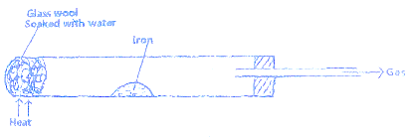

- Write an equation for the reaction that takes place
3 Fe(s) + 4H₂0 (g) Fe₃0₄(s) + 4H₂(g) award zero if not balanced
- Why would it not be advisable to use potassium in place of iron in the above set –up? (1mk)
Potassium would react with steam explosively .
- The glass wool is heated prior to heating of iron. Explain. (1mk)
To expel all the air so that the iron only reacts with steam when heated.
- In an experiment , sulphur (IV) oxide was bubbled into water followed by chlorine gas. The resulting solution gave a white precipitate when mixed with acidified barium chloride solution .
- Explain this observation . (2mks)
SO₂ dissolves in water to form SO₃²⁻ Which is oxidized to SO₄²⁻ by chlorine which then reacts with barium chloride to form white insoluble barium sulphate.

- Write an ionic equation for the formation of the white precipitate . (1mk)

Ba²⁺(aq) + SO₄²⁻(aq) BaSO₄(s)

- Elements X³⁺ and Y⁻ have atomic numbers 13 and 8 respectively :
- Write down the electron arrangement of the ions. (2mks)
X- 2.8.2
Y- 2.7
- Write the formula of the compound formed between element X and Y (1mk)
X₂Y₃
- Corn oil can be converted into solid fat as shown by the equation below.
Corn oil reagent Y solid fat
- Name the process shown above by the equation. (1mk)
Hydrogenation
- What is the importance of this process (1mk)
Manufacture of margarine
- Name reagent Y (1mk)
Hydrogen
- The set up below was used to investigate electrical conductivity of lead (II) iodide .study it and answer the questions that follow.

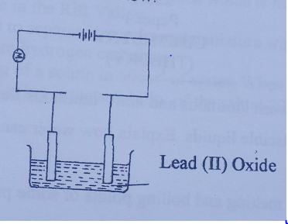
Anode

    - Label the anode (1mk)
    - State one omission on the set up above (1mk)
Heat
    - If the omission is corrected ,write an equation at the cathode. (1mk)
Pb²⁺(l) + 2e Pb(s)

- A student was provided with copper turnings ,concentrated sulphuric (VI) acid. Draw a set- up that the student would set up to prepare and collect a dry sample of sulphur (IV) oxide gas. (3mks)
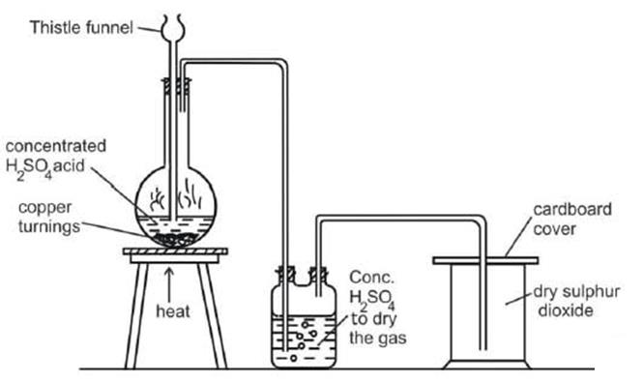
Appropriate apparatus 1mk
Drying agent 1mk
Collection method 1/2mk
Labeling 1/2mk

- Copper is extracted from its ores by a process of froth floatation and then roasted in air to produce copper (I) oxide.
  - What is froth floatation (1mk)
Concentration of an ore
  - Write an equation for roasting of the ore in air (1mk)
2CuFeS₂(s) + 4O₂(g) Cu₂S (s) + 2FeO(s) + 3SO₂(g)
  - Name one impurity in the ore and how it is removed. (1mk)
Iron (II) oxide; ore is heated together with silica to remove iron oxide as slag (iron (II) silicate)

- Dry ammonia gas was passed over hot copper (II) oxide as shown below.

Cu

NH₃(g) Hot CuO N₂

H₂O

    - State the property of ammonia being investigated above . (1mk)
Reducing
    - Write an equation for the reaction that took place (1mk)

3CuO(s) + 2NH3(g) 3Cu(s) + N2(g) + 3H2O(l)
  - Penalize fully for wrong/no balance
    - Name one other gas that would be used in place of ammonia gas. (1mk)
Hydrogen /carbon (II) oxide ;reject formula

- Hydrogen peroxide decomposes according to the equation given below.
H₂O₂(l) H₂O(l) + $\frac{1}{2}$O₂(g); ΔH = -98KJ/mol
If 6.8 g of hydrogen peroxide contained in 75cm³ of solution with water were completely decomposed ,determine the rise in temperature due to the reaction. (3mks)
(specific heat capacity of water =4.2Jg⁻¹K⁻¹,density =1g/cm³,O=16.0, H=1.0)
Moles of H2O2 = $\frac{6.8}{34}$ = 0.2 mole
1 mole produce 98kJ
0.2 mole will produce = 98 x 0.2 = 19.6KJ/19600 J
Heat change =mcΔT
19600 J= 75 X 4.2 X ΔT
$\frac{19600}{75 X 4.2}$ = 62.2 k
- The figure below shows a Bunsen burner flame .
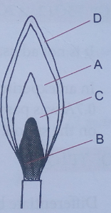
- Describe how this type of flame is produced. (1mk)
By closing the air hole completely.
- Which part on the diagram is the hottest part of the flame. (1mk)
D
- Name the gas produced by a burning candle that is non-pollutant. (1mk)
Water vapour (steam)
- A mixture of 5.0 g of sodium carbonate and sodium hydrogen carbonate was heated until there was no further change in mass .the loss in mass was 0.31 g. calculate the percentage by mass of sodium hydrogen carbonate in the mixture. (3mks)
(Na=23.0, H=1.0, C=12.0, O=16.0). (Assume loss in mass is due to loss of carbon (IV) oxide)
2NaHCO₃(s) Na₂CO₃(s) + CO₂(g) + H₂O(l) ;mole ratio:2 : 1
Moles of CO₂ produced =$\frac{0.31}{44}$ = 7.04 x 10⁻³
Moles of NaHCO₃ from the mole ratio = 0.00704 x 2 = 0.01408
Mass of NaHCO3 =0.01408 X 84 =1.18272 g
% by mass = $\frac{1.18272}{5}$ x 100
= 23.6544%
- In the manufacture of sodium carbonate by solvay process ,ammonical brine trickles down the carbonator while carbon (IV) oxide rises up the same tower.
  - What is ammonical brine. (1mk)
Concentrated Sodium chloride saturated/mixed with ammonia.
  - Write two equations taking place in the carbonator. (2mks)
- NH₃(g) + NaCl(aq) + CO₂(g) + H₂0(l) NH₄Cl(aq) NaHCO₃(s)

- NH₄HCO₃(aq) + NaCl(aq) NH₄Cl(aq) + NaHCO₃(s)
- An atom of an element W has atomic radius of 0.099 nm and ionic radius of 0.181 nm.
  - State whether W is a metal or a non- metal. (1mk)
Non-metal ;the ionic radius is larger than the atomic radius.
  - Explain why ionic radius is bigger than atomic radius. (2mks)
Gains an electron to be stable (1) hence repulsion between existing and incoming electrons
- The figure below shows a set up used by form 3 students to compare the rates of diffusion of ammonia and hydrogen chloride gas.
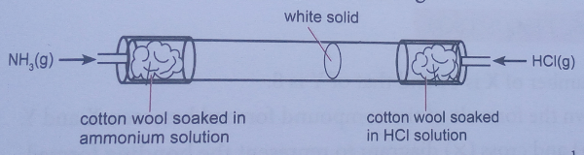
Given that ammonia travels through a distance of 30cm in 1$\frac{1}{2}$minute ,
- calculate the distance through which hydrogen chloride travels within same time. (2mks)
$\frac{Rate of HCl}{Rate of NH3}$ = $\frac{\sqrt{molecular mass of NH3}}{\sqrt{molecular mass of HCl}}$
Let rate of ammonia be a
NH₃ = 14+3 = 17
HCl = 35.5 +1 = 36.5
Rate of NH₃ = $\frac{30}{1.5}$= 20cm/min
a² = $\frac{17 x (20)2}{36.5}$ = 186.32
a = 13.65cm
rate of HCl = $\frac{distance }{time}$
13.5 = $\frac{D}{1.5}$ ; distance = 13.65 x 1.5 = 20.48cm

- Write an equation to show how the white solid is formed. (1mk)
NH₃(g) + HCl (g) NH₄Cl(s)

- Given that 3.52 g of carbon (IV) oxide and 1.40 g of water are produced when a mass of a hydrocarbon is completely burnt in oxygen , determine the formula of the hydrocarbon.
(H=1, C=12, O=16) (3mks)
CO₂ = 12 + 16 + 16 = 44
Mass of carbon in CO₂ = $\frac{12}{44} x$3.52 = 0.96g
Moles of carbon = $\frac{0.96}{12}$ = 0.08 mole
Mass of hydrogen in water = $\frac{2}{18}$ x 1.40
$\frac{0.156}{1}$ = 0.156 mole
Mole ratio
C : H
0.08 : 0.156
M.R – 1 : 1.95
1 : 2
Hence E.F = CH₂
- 10cm³ of a gaseous hydrocarbon were mixed with 30cm³ of oxygen gas and the mixture exploded . after the mixture had cooled to room temperature ,20cm³ of gas remained. After shaking this gas with sodium hydroxide solution ,its volume was reduced to 10cm³.the remaining gas rekindled a glowing splint.
Determine the formula of the hydrocarbon. (3mks)
Explosion equation C_{x}H_{y} + ( x +$\frac{y}{4}$) O₂ XCO₂ = $\frac{Y}{2}$H₂O
Volume of O2 produced = x x volume of hydrocarbon bond
10 = x x 10
X = 1
Volume of O2 used = ( x + $\frac{y}{4}$) volume of hydrogen bond
20 = ( x + $\frac{y}{4}$) = 10
Y = 4
M.F = CH₄
_{Alternatively}
C_{X}H_{Y} + O₂ CO₂ + H₂O
10cm³ 20cm³ (30-10) 10cm³
C_{X}H_{Y} + 20₂ CO₂ +2H₂O
C_{X} = C₁
X = 1
H_{Y} = H₄
Y = 4
M.F CH₄
- The diagram below shows a method used by a student to determine the boiling point of ethanol. After setting the apparatus as shown below he inserted athermometer into the ethanol.
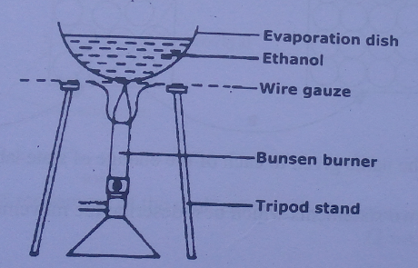

    - Give a reason why it is not a safe method. (1mk)
Ethanol is flammable and should not be heated directly / on a naked flame.

    - Suggest a better method. (1mk)
It should be heated in a water bath; in an air tight boiling tube having a safety outlet tube;

    - What will happen to the boiling point of ethanol if crystals of benzoic acid were first dissolved in it? (1mk)
Boiling point would be higher because benzoic acid acts as an impurity and impurities raise boiling points substances.

- A form two student in an attempt to stop rusting she put copper and magnesium in contact as shown.
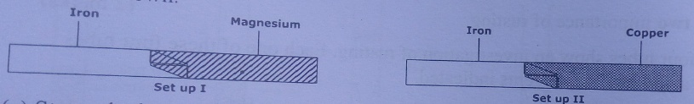

- State whether rusting occurred after one week if the set-ups were left outside. (1mk)
No rusting occurred in set up I while rusting occurred in set up II
- Explain your answer in (a) above. (2mks)
In set up I magnesium has a higher affinity for combined oxygen than iron and thus reacted with oxygen at the expense of iron to form magnesium oxide.
In set up II iron has a higher affinity for combined oxygen than copper and thus reacted with oxygen and water to form hydrated iron (III) oxide (rust).

- The table below describes the properties of an acid,alkali and a salt solution.
Complete the table. (1mk)
solution | Colour with universal indicator solution | Approximate pH | Ions present
Sodium hydroxide | blue | 12-14 | Na+ , OH-
Hydrochloric acid | red | 1-2 | H⁺ ,Cl⁻
Sodium sulphate | Green | 7 | Na⁺, SO₄²⁻

Name two solutions which when mixed together ,form a solution of sodium sulphate. (2mks)
Sodium chloride and sulphuric (VI) acid
Accept any two correct substances;
- Complete the following equation. (1mk)
H H
C==C + [O] cold dilute
H H H⁺/KMnO₄

Name the reaction above. (1mk)
Oxidation

