CREATIVE ARTS AND SOCIAL STUDIES - GRADE 6 EXAMS TERM 1 2023
CREATIVE ARTS ACTIVITIES
- Which one is NOT used in making a wax crayon?
  - paint
  - Bel wax
  - paraffin wax
  - colour pigment
- Which factor is NOT considered when drawing two overlapping cylindrical forms?
  - Proportion of forms
  - Balance of forms
  - Variation of lines
  - Inadequate space
- The following are conventional mounting materials except:-
  - Banana fibres
  - Manilla paper
  - Mounting board
  - Catridge paper
- Which one is NOT a 3-D artwork?
  - sculpture
  - pottery
  - drawing
  - marionette
- The following are techniques used to decorate a modelled clay pot. Which one is NOT?
  - Incising
  - Embedding
  - Tie and dye
  - Stamping
- Which one is NOT a primary colour?
  - Green
  - Blue
  - Yellow
  - Red
- Grade six learners were told by their Art and Craft teacher to make a collage. Which of the materials is NOT needed?
  - water
  - sand
  - glue
  - picture from a newspaper
- Mama Joyce makes pots for sale. Which one of the following materials she does not use?
  - water
  - clay soil
  - sharp objects
  - metal strips
- Primary colours when mixed with secondary colours in equal amounts will produce ___________________________ colours.
  - Black
  - Rainbow
  - Tertiary
  - Secondary
- Which shading technique is used in the cup below?
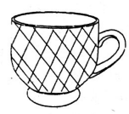
  - coiling
  - stripling
  - cross hatching
  - Tonal variation
MUSIC ACTIVITIES
- Which Musical instrument is drawn below?
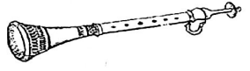
  - Nzumari
  - Bung'o
  - Chivoti
  - Biringi
- Which sound is represented by the hand sign below?
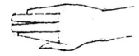
  - d
  - m
  - f
  - r
- A flute is played by:-
  - bowing
  - shaking
  - blowing
  - hitting
- Which one is NOT a part of a quaver
  - head
  - tail
  - stem
  - abdomen
- Which one of the following is a way appreciating rhythms? By
  - Crying
  - Wailing
  - Walking
  - Clapping
- The arrangement of notes of different pitches and directions sung is called:-
  - Rhythm
  - Tempo
  - Melody
  - mood
- Dancers decorate their bodies using paints to make patterns. This is called:-
  - Body ornaments
  - Body costumes
  - Body colouring
  - Body adornment
- Songs sung to soothe babies is classified as:-
  - Sacred songs
  - Lullaby songs
  - Folk songs
  - Action songs
- What is the name given to the part marked Q in the musical instrument below?
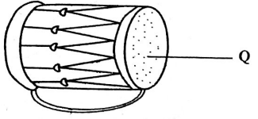
  - Membrane
  - Sound box
  - Sling
  - Resonator
- Which one of the following countries does NOT sing the East African Anthem?
  - Uganda
  - Ethiopia
  - Rwanda
  - Democratic Republic of Congo

SOCIAL STUDIES ACTIVITIES
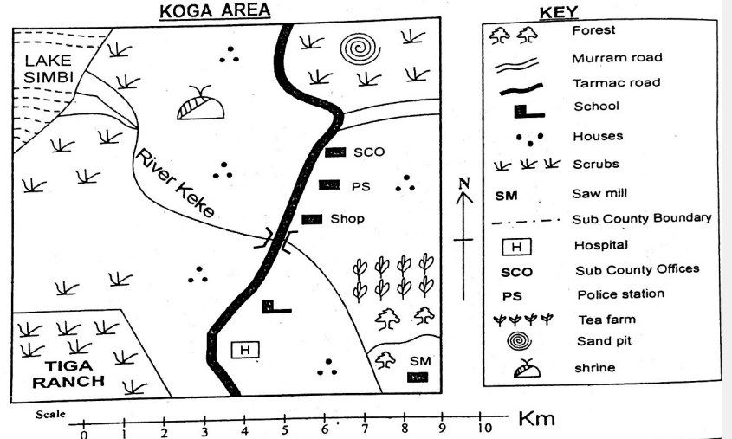
- What is the direction of the sand pit from Tiga Ranch?
  - South West
  - North East
  - South East
  - North West
- Most people in Koga area are mainly:-
  - Traditionalists
  - Muslims
  - Pagans
  - Christians
- Which economic activity is NOT likely to be carried out in Koga Area?
  - Mining
  - Lumbering
  - Cattle keeping
  - Fishing
- Which feature is NOT found along River Keke?
  - Estuary
  - Delta
  - Confluence
  - Tributaries
- What is the climate of South East part of Kega Area?
  - Hot and dry
  - Hot and Wet
  - Cool and Wet
  - Cool and warm
- Study the poster below.
TAXES GRANTS
LOANS COUNTERFINES
- From the above posters, the message communicated is
  - types of expenditure
  - sources of foreign exchange
  - sources of revenue
  - types of taxes.
- Which country borders Kenya to the North West?
  - Ethiopia
  - Uganda
  - South Sudan
  - Tanzania
- Which one of the following is NOT an element of weather?
  - Temperature
  - Wind
  - Raingauge
  - Sunshine
- The following are characteristics of a certain climatic region in Kenya.
  - Has low temperatures
  - It is cool and wet
  - It receives rainfall of between 1200mm-2000mm anually.
  - It covers parts of Rift valley.
The above climate is likely to be:-
    - Desert climate
    - Equitorial climate
    - Tropical climate
    - Mountain climate.
- Which one is NOT a historic built environment in Kenya?
  - Museums
  - Cultural centres
  - Tall buildings
  - Monuments
- The largest Lake in Kenya is:-
  - Lake Turkana
  - Lake Victoria
  - Lake Elementaita
  - Lake Naivasha
- A family is a group of people related by the following except:-
  - Fore father
  - Blood
  - Adoption
  - Marriage
Use the map of Kenya to answer questions 36-39.
- Which one of the following minerals is correctly matched with the method of mining?
  - Gold - Dredging.
  - Copper - Deep shaft.
  - Limestone - Open cast.
  - Soda ash - Drilling. 30.
- Grade 4 learners were asked by their socia! studies teacher to give the main reason why they started an entrepreneurship project in their school, who among them gave the correct answer?
  - Amina- To make use of locally available resources.
  - Peter - To help the school in buying land.
  - Margaret - To help themn raise income.
  - William - To help them create employment in school
- The headteacher of Kabarak Primary Schoool sabarak Primary School invited Mr. Kigen one of the officers from East African Community to talk about challenges facing the organization. Which one of the following was not mentioned as a challenge?
  - Poor roads.
  - Mistrust among members.
  - Use of a common currency.
  - Natural calamities.
- Below are examples of rights and freedoms of Kenya citizens.
  - Freedom of Movement.
  - Right to health care.
  - Right to fair pay.
  - Righi to privacy
  - freedom of speech.
The Which one of these rights and freedoms are grouped as social?
    - (ii) and (iv)
    - (i) and (v)
    - (iii) and (iv)
    - (i) and (ii)

- Which means of transport is suitable for transporting horticultural crops to European market?
  - Pipeline
  - Water
  - Road
  - Air
- Which one was the title of the Maasai leader?
  - Nabongo
  - Kivoi
  - Oloibon
  - Moran
- Three of the following communities belong to the Western Bantus except:-
  - Abaluyia
  - Abakuria
  - Abagusii
  - Abasuba
- The mangrove vegetation in Kenya is found:-
  - in the highlands
  - along the coastal regions
  - in swampy areas
  - along the rivers

CHRISTIAN RELIGIOUS ACTIVITIES
- John the Baptist's preaching was about:-
  - The day of passover
  - Repentance and forgiveness
  - Revenge bad for worse
  - Going to the wilderness
- Which book of the Bible tells christians that God has good plans for their future?
  - Jeremiah
  - Genesis
  - Luke
  - Mathew
- King Solomon used ____________________________ to solve difficult cases.
  - talents
  - abilities
  - knowledge
  - wisdom
- How did Adam and Eve disobey God? By:-
  - Selling the fruit of knowledge.
  - Cultivating the land.
  - Eating the fruit in the middle tree,
  - Running away form the garden of Eden.
- Human beings are different from the rest of God's creation because they:-
  - Walk like God
  - Pray to God
  - Talk like God
  - Were created in God's image.
- The book of Exodus was written by:-
  - David
  - Moses
  - Paul
  - Solomon
- Who among the following visited Jesus at night?
  - Lazarus
  - Thomas
  - Justus
  - Nicodemus
- Which one is NOT a fruit of the Holy spirit?
  - Kindness
  - Self control
  - Faith
  - Gentleness
- Why is it important to show respect to the elderly?
  - grow in adulthood
  - get money
  - be cursed
  - be rewarded by God.
- All our prayers are answered by __________________________________
  - Our teachers
  - Our parents
  - Our elders
  - God

MARKING SCHEME
CRTART
- C
- D
- D
- B
- C
- A
- A
- D
- C
- C
MUSIC
- A
- D
- C
- D
- D
- C
- D
- B
- A
- B

SOCIAL STUDIES
- B
- A
- D
- A
- C
- C
- C
- C
- D
- C
- A
- A
- A
- C
- B
- A
- C
- A
- D
- B

C.R.E
- B
- A
- D
- C
- D
- B
- D
- C
- D
- D

