Name…………………………………………… Adm. No…………… Class……………….

School:………………………………………… Index:…………………………..

313/1
CHRISTIAN RELIGIOUS EDUCATION
Paper 1

2:30 hrs.

MUMIAS A.C.K DIOCESE MOCK SEPTEMBER 2022
Kenya Certificate of Secondary Education
CHRISTIAN RELIGIOUS EDUCATION
Paper 1
Instructions to candidates
- Write your name, admission number and class in the spaces provided above.
- This paper consists of six questions.
- Answer any five questions in the answer booklet provided.
- Each question carries 20 marks.
- Candidates should answer questions in English

For Examiner’s Use Only
Question | 1 | 2 | 3 | 4 | 5 | 6 | Candidate’s  Total Score
Candidate’s
score

1a) Apocrypha Books
- Tobit
- Judith
- Maccabees 1
- Maccabees 11
- Book of wisdom
- Baruch
- Ecclesiasticus
(6x1 =6mks)
b) Identify teaching from Genesis creation stories which support equality between man and woman
- Both depend on God for their survival.
- Both share equal dignity and personality /both are superior to the rest of creation.
- Both are made in the image of God /likeness of God.
- Both have ability to have spiritual understanding.
- Both were given a divine command /by being co-creators with God /procreation
- Both were responsible over the rest of the creation
- Both have a common origin
- Both have flesh and blood
- Both are made for companion (7x1 =7mks)
c) Ways through which the church is spreading the word of God in Kenya
- By use of electronic media
- By providing Bibles
- Through publishing /printing Christian literature/magazines/print media
- By carrying outreach campaigns/door witness
- Organizing youth camps/seminars/retreats/study /conferences
- Helping the needy/ building homes for the aged
- Supporting the teaching of Christian Religious education/carrying our
- By preaching the word/holding crusades
- By sending out missionaries/financing them
- By organizing choirs/singing groups/drama. (7x1 =7mks)

2a) How God prepared the Israelites for the making of the covenant at Mt. Sinai
- God told Moses that He wanted to make a special relationship with Israel/ make
- them a kingdom of priests
- Moses called all the elders/ people and told them what God had said. God told Moses that he wanted the Israelites to obey him.
- The Israelites promised to do all that the Lord had said.
- God promised to come down and meet with the people on the third day. The people were instructed to consecrated themselves/wash their garments
- The people were to abstain from sexual relationships
- On the third day, there was a thick cloud upon the mountain / loud trumpet blast /earthquake.
- Moses brought the people out of the camp to meet God /they took their stand at the foot of the mountain
- The Lord came down to the top of the mountain / called Moses to go up to him (7x1=7mks)
b) Reasons why the Israelites broke the covenant while at mount .Sinai
- Moses their leader delayed to come down from the mountain.
- Aaron who had been left in charge of the people was a weak leader
- The people demanded for a god / gods they could see/ feel
- The people were still influenced by the Egyptian way of worship /idolatry
- Moses teaching / influence had faded / vanished from people’s minds
- The people had lost faith in their invisible God (4x2=8mks)

c) Lessons learned by Christians about the nature of God from the Exodus
- God is caring
- He communicates
- He provides He is powerful He guides
- He protects
- He commands
- He is to be obeyed
- He punishes those who disobey
- He is holy
- He is faithful
- He is merciful
- He is jealous (5x1=5mks)

3a
Outline factors which led to the wide spread of idolatry in Israel during the time of Prophet Elijah
- The foreign princesses married to Israelite kings brought with them idol/false prophets were brought to Israel
- Israelites changed their lifestyle from pastoralism to agriculture when they settled in Canaan and this forced them to worship the god of fertility
- Israelites worshipped God/Yahweh and Baal gods on different occasions/syncretism
- The king built temples for Baal worshiping in the northern kingdom of Israel
- Israelites broke the covenant through intermarriages with foreigners thus adopted Canaanite way of life/temple prostitution
- The true prophets of Yahweh who were in Israel were being persecuted
- Israelites felt that Yahweh had forsaken them after they were defeated in wars by neighboring nations/turned to other gods
- The kings made festivals for the Canaanite gods to be on the same dates as those of the Jewish calendar hence Israelites were influenced to worship idols
- King Ahab made Baalism the official state religion
- The rampant presence of visible idols compared to unseen God/Yahweh (6x1=6 mks)

b) Describe the incident in which prophet Elijah challenged the prophets of Baal at Mount Carmel
- Prophet Elijah requested King Ahab to send the prophets of Baal/all the Israelites to Mount Carmel
- Elijah asked the people for how long would they limp on two different opinions/told the people to choose the lord God or Baal
- Prophet Elijah asked for the two bull’s one for those who worship Baal and the other for him
- Each group was to offer a sacrifice to their god/the God that would send fire into consume the sacrifice is the true God
- Elijah gave the prophets of Baal the first chance to prepare their sacrifice
- The prophets of Baal called on their god to send fire but there was no response
- Elijah mocked them to shout louder for their god to answer
- Elijah prepared the altar with twelve stones /made a trench around it
- He prepared the sacrifice/asked for water to be poured on it
- Elijah prayed to God of Abraham, Isaac and Israel to reveal himself
- Fire fell from heaven and burned up the sacrifice
- The people acknowledged the God of Elijah as the true God
- Elijah commanded the people to seize/kill the prophets of Baal
- Elijah told Ahab to go and eat/prophesied the coming rain (8x1=8 mks)

C )Outline reasons that may influence some Christians to turn away from God today
- Influence from non-believers/ridicule/discouragement
- Peer pressure/critic influence/fear of other people
- Lack of faith/trust in God
- Quest for better economic power/pride/education/greed/materialism
- Lack of role models in the society
- Unemployment/poverty
- Negative influence from the mass media
- Emergence of different beliefs/cults/religious pluralism
- Lack of time/family responsibilities/work pressure
- Unanswered prayers/frustrations of life
- permissiveness in the society/moral decay
(6x1=6 mks)

4(a) State the differences between prophets in the Old Testament and traditional African communities
- The Old Testament prophets stressed the worship of one God/Monotheism while in some traditional African communities, prophets recognized many gods/goddesses.
- The Old Testament prophets received their call from God while the traditional African prophets inherited their work from their ancestors.
- The Old Testament received their power, guidance directly from God while the African traditional prophets got their power from God through the living dead/spirits.
- The Old Testament prophets spoke to the nations God sent them to, while the traditional African prophets were confined to their ethnic communities.
- The Old Testament prophets faced opposition from their people while the traditional African prophets were respected leaders in their communities
- The work of the Old Testament prophets was recorded and presented while in the African Traditional prophets it was passed on through oral traditions. (4x2=8mks)

(b) The call of Amos to become a prophet in Israel
(i) Amos was a farmer fending sycamore trees / shepherd
(ii) He came from a village called Tekoa in Judah
(iii) He became a prophet during the reign of king Uzziah and Jeroboam 11
(iv) God called him through a vision
(v) He felt a strong compulsion to prophesy
(vi) He responded to God’s call in faith / obedience (7x1=7mks)

c) Challenges which Church leaders in Kenya face in their work
- Church leaders are rejected/persecuted
- They have rivalry among themselves/inferiority/superiority complex
- They experience discrimination based on nepotism/tribalism/gender/status
- There is hypocrisy among Church members/religious syncretism
- Inadequate finances/materials for their work
- They encounter language barrier while spreading the word of God
- They encounter interpretation of the Bible/denomination differences
- There is political interference in their work/sex
- Poor infrastructure makes it difficult for them to access some areas
- Insecurity/hostility/terrorism /non-believers
- Family commitment /work /over depended
- Negative influence of science and technology/mass media (5x1=5mks)

5a) Describe the fall of Jerusalem and the exile of the people of Judah. Jeremiah 39
- Babylonian soldiers took 30 months before they finally conquered Jerusalem and the nation of Judah
- The fall of Jerusalem happened during the reign of King Zedekiah
- The soldiers of Judah were defeated because they failed to get assistance from Egypt
- The Babylonian soldiers stopped food supply into the city of Jerusalem and people died of starvation
- Babylonians killed many people including the sons of Zedekiah and the Government officials
- King Zedekiah was arrested , blinded and taken to exile in Babylon
- The Temple, Kings Palace and other buildings in Jerusalem were looted and completely destroyed.
- Babylon set up an administrative headquarters at Mizpah from where they governed Judah.
- The upper class residents of Judah which were taken to Babylon as captives included the priests , court officials and craftsmen
- The poor and the aged were left in Judah. They were given land and vineyards to farm (8x1=8mks)

(b) Reason why Nehemiah carried out religious reforms in Judah
- To preserve the identity of the Jews as people of God
- To separate the Jews from foreign influence.
- To purify the temple which had been defiled by keeping a foreigner.
- To reinstate the services of the Levites as priests of the temple
- To restore the tithing system that had been forgotten for the up keep of the temple.
- To ensure that the Sabbath day was free from business activities.
- In order to cleanse the Jews who had intermarried with foreigners / exposed to idolatry 6x1=6mks)

(c) Lessons from the renewal of the covenant by Nehemiah
- Christian should ask for their sins to be forgiven.
- They should lead righteous lives.
- Christian should always pray to God
- Christian should demonstrate humility
- They should avoid groups that can negatively influence their faith in God
- They should teach others the word of god
- They should set aside a day for worship
- They should respect the church as a place for prayer (6x1=6mks)

6. (a) Causes of death in traditional African communities.
  - Witchcraft/bad omen.
  - Curses
  - Sorcery/magic
  - Breaking of taboos
  - Evil spirits.
  - Breaking of an oath (social secrecy)
  - Wars and raids.
  - Offending the ancestors/spirits/God
  - Natural calamity/disease .
  - Old age/God's will (5x1=5 mks)

(b) Significance of ritual performed after the death of a person in traditional African Communities.
- Wailing/crying is a sign of sorrow/announcing death.
- Making sacrifices to appease the ancestors/deceased/spirits.
- Prayers are made to ask the ancestors to accept the dead in the world of spirits.
- Shaving the members of the bereaved family signify new life in the community.
- Singing and dancing depict anger towards death/in praise of the dead.
- Washing / oiling of the body before burial shows respected the departed.
- Burying of the dead in the ancestral land shows that one is still a member of the community.
- Burying the dead with personal belongings symbolizes life after death.
- Driving of cattle/livestock shows chasing away of evil spirits which caused death.
- Fasting/drinking is meant to bid farewell to the dead.
- Breaking of pots/destruction of property symbolizes the disorder brought by death.
- Sharing of deceased's property among relatives as a sign of solidarity.
- Lighting of fire chasing away evil spirits/warning spirits of the deceased.
- Pouring of libation shows continuity of life.
- Burying the dead in a particular position signifies protection/responsibility. 8x1=8 mks)

(c) Moral values promoted during funeral ceremonies in traditional African communities.
- Cooperation/unity
- Responsibility
- Respect :
- Obedience
- Loyalty
- honesty
- Courage
- Love
- Faith/trust
- Hope
- Thankfulness
- Self-control
- Generosity
(7x1=7 mks)

Name…………………………………………… Adm. No…………… Class……………….

School:………………………………………… Index:…………………………..

313/2
CHRISTIAN RELIGIOUS EDUCATION
Paper 2

2:30 hrs

MUMIAS A.C.K DIOCESE MOCK SEPTEMBER 2022
Kenya Certificate of Secondary Education
CHRISTIAN RELIGIOUS EDUCATION
Paper 2
Instructions to candidates
- Write your name, admission number and class in the spaces provided above.
- This paper consists of six questions.
- Answer any five questions in the answer booklet provided.
- Each question carries 20 marks.
- Candidates should answer questions in English

For Examiner’s Use Only
Question | 1 | 2 | 3 | 4 | 5 | 6 | Candidate’s  Total Score
Candidate’s
score

1. (a)
- She was highly favoured among women.
- She will bring forth a son/will be named Jesus.
- He will be called the son of the most highest/son of God/will be great.
- He will be given the throne of his father David.
- He will reign over the house of Jacob forever.
- The kingdom will be everlasting.
- The Holy Spirit would come upon her.
- The child to be born would be holy.
- That Elizabeth her cousin had also conceived in her old age.
- With God, nothing will be impossible. (8x1=8 mks)

- He told the people to repent and be baptized for forgiveness of their sins/he asked People to prepare the way for the Lord.
- He told them to be faithful/obedient to God and not to pride in Abraham as their ancestor.
- He warned them of God’s punishment on sin.
- He encouraged the rich to share with the needy.
- He told the tax collectors not to steal/be honest.
- He told the soldiers to be contented with their wages/stop greed.
- He told the soldiers to stop robbing/accusing people falsely/should be truthful.
- He told them that the messiah who was to come after him was mightier/He was unworthy to untie his sandals.
- The Messiah would baptize the people with fire and the Holy Spirit.
- The Messiah would separate the good from the evil/the evil would be punished.
- He condemned Herod for his adulterous life/marrying his brother’s wife 7x1=7 mks)

- They lack faith in God’s word.
- Divisions along tribal/racial/denominational lines affect unity among Christians.
- Clinging to the past/inability to abandon the old/previous life style.
- Negative attitude by the rich towards the needy/poor.
- The influence of the mass media/moral decadency in society.
- Some Christians lack what to share with others/poverty.
- There is rampant corruption in the society.
- The emergence of cult leaders/false prophets in the society/lack of role models.
- Some Christians lead hypocritical life.
- Peer pressure. (5x1=5 mks)

2.a)With reference to the sermon on the plain, state five teachings of Jesus on how human beings should relate to one another (. Lk 6:17-49) 5marks
- Human beings should love one another/ their enemies.
- They should practice sharing/help others/ be generous.
- They should be merciful to each other/ kind/ compassionate.
- They should not judge/ condemn others.
- They should forgive one another/ not revenge.
- Pray for those who wrong them.
- They should not discriminate against each other.
- They should be good to those who hate them.
5x1=5 mks

- Describe the incident when Jesus calmed the storm (lk 8:22-25 )
- Jesus got into a boat with his disciples.
- He told them that they should go to the other side of the lake and so they set out.
- As they sailed, Jesus fell asleep.
- A storm of wind came down on the lake.
- The boat was filled with water/ they were in danger.
- The disciples went and woke Jesus saying, “Master, master we are perishing.”
- Jesus got up, rebuked the wind and the raging waters/ waves.
- The storm subsided/ ceased/ there was calm.
- Jesus asked the disciples where their faith was.
- The disciples were afraid/ they marveled.
- The disciples wondered who Jesus was that even the wind and water could obey Him.
10 marks
- Identify virtues that Christians learn from the miracle of the feeding of the 5000
      - Service
      - Obedience
      - Faith/trust
      - Humility
      - Cooperation
      - Thankfulness
      - Carefulness
      - Responsibility
      - Kindness/generosity/sharing
      - Concern/compassion/mercy
      - SSSRespect .5marks
3. a) Outline events that took place between the death and burial of Jesus. Luke 23:44-56 .7marks

- The sun stopped shining/there was darkness over the land
- The curtain of the temple was torn into two
- Jesus committed his spirit into his father’s hand. Breathed his last breath
- The centurion who witnessed the death of Jesus praised God/confessed that Jesus was an innocent man
- The multitude who witnessed the death beat their breasts as they went away
- The women from Galilee stood at a distance/watched in silence
- Joseph of Arimathea went to Pilate to ask for the body of Jesus
- He took down the body from the cross/wrapped it in linen clot and laid it in a tomb
- The women from Galilee followed Joseph/saw the tomb/how the body was laid.
7marks

(b)
- Peter was afraid of being arrested/killed
- He was overcome by the devil/Satan
- The denial had been predicted by Jesus
- Peter was confused by the turn of events
- He was disappointed by the fact that Jesus did not fight back
- He lacked faith in Jesus
- He had not support /solidarity with other disciples (3 x 2 =6mks)
(c)
- Through the death of Jesus Christians are forgiven their sins
- Christians are not supposed to make animal sacrifices to God
- It demonstrates God’s love for human beings
- Christians have a personal relationship with God
- Christians are able to commit themselves to the will of God.
- It enables Christians to face death with courage
- Through his death, salvation/eternal life is availed to all people
- He has become their everlasting high priest by offering his own body
(7 x 1 =7mks)

4. (a)Reasons why Jesus sent the Holy spirit to the disciples after his ascension
- The Holy Spirit would comfort the disciples
- He was to council the disciples
- He would guide the disciples on what is right/god’s righteousness
- He was to convict people of their sins
- He to the disciples on what is right/God’s righteousness
- He was to convict people of their sins
- He was to reveal the future/enable the disciples to prophets/God’s will
- He would glorify Jesus through the work of the disciples
- He would enable the disciples to witness Christ throughout the world.
- He would replace the physical presence of Jesus/stay with the disciple forever
- He would empower the disciples to be able to speak with courage/confidence/authority.
(7x1=7 mks)
(b)Describe how the unity of believers is expressed in the body of Christ. (8 marks)
- St. Paul describes the believers as the body of Christ
- Christ is the head of the church
- The believers form parts of the body.
- The body has different organs. In the same way the Church has different members
- They all need to work together for the well-being of the church.
- Every part of the body is needed to make it whole /all parts are interdependent/ one part cannot be without the other.
- The different church members are given different spiritual gifts by the Holy Spirit to carry out God’s work.
- Believers are united through baptism in the Holy Spirit.
(c) State ways in which Christians in Kenya demonstrate the New Testament teaching on unity. (5 marks)
- Christians meet for prayers/fellowship together.
- They observe a day of worship to honor God.
- They share the Holy communion/meals.
- They help those who are poor/needy
- They solve problems affecting the Church members
- They hold joint crusades/rallies
- They also cooperate by providing Christian programs in the mass media/ resource materials.
- They speak in one voice to condemn evil in society

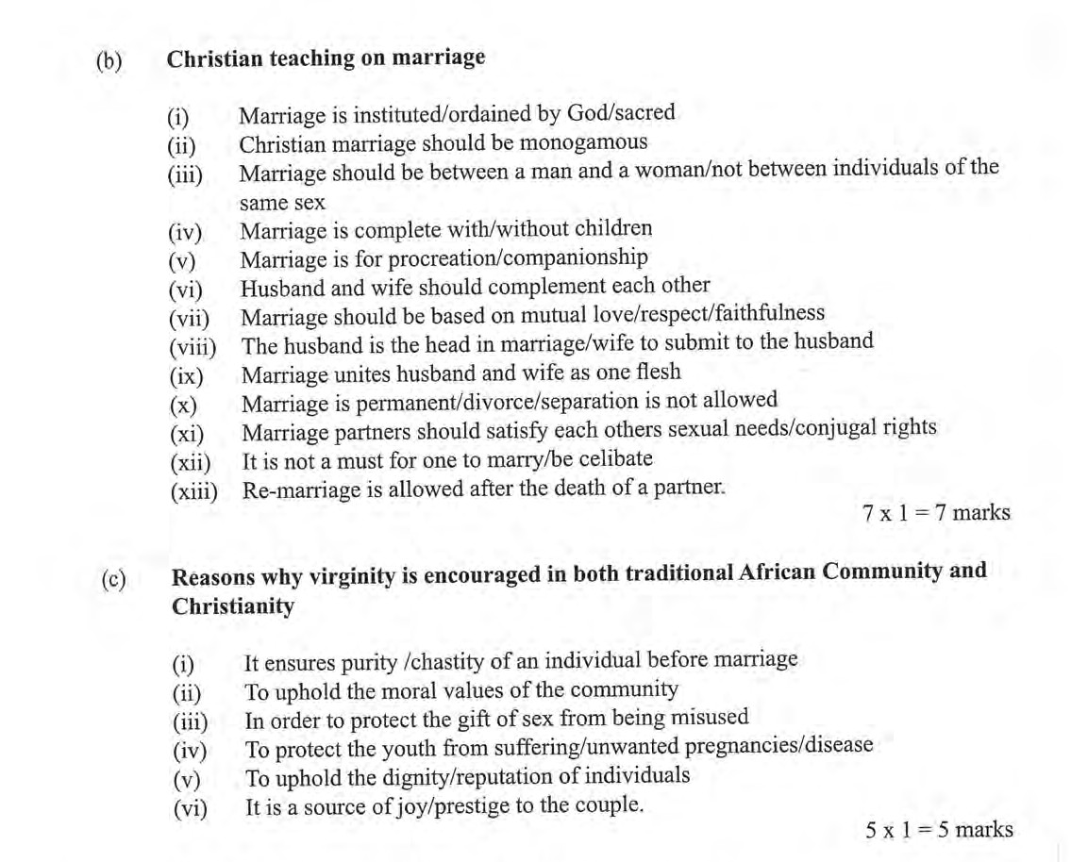

6 (a) The negative effects of the introduction of money economy on traditional African communities.
- It has led to introduction of wage labour instead of communal working that existed
- It led to migration to town as people search for better paying jobs, destroying the closely knit traditional way of life.
- It has led to the formation of Socio-Economic classes among the people/rich versus poor thus creating suspicion/insecurity.
- It has created individualism which has destroyed the communal way of living /extended family relationship.
- It has led to vices like bribery/corruption/exploitation which have replaced honesty/fairness in traditional African setting.
- The dependency on no money has led to social evils like prostitution, immorality which has destroyed the traditional concept of marriage /value of sex.
- It has led to private ownership of land /land can be bought by those with money one hence destroying the traditional land ownership.
- Dowry has been commercialized thus destroying the traditional African meaning of showing appreciation of the family of the bride /girl
- The type of education one receives is now determined by the amount of money one has unlike in the traditional set up where the elders passed on education to all without being paid.
- Due to the introduction of money economy modern means of transport have been acquired which has led to accidents/pollution of the environment.
- Age is no longer a determinant of social status /a rich young man maybe respected by an elder who is not economically stable.
4x2=8 mks)
(b) Methods of disciplinary errant members in traditional African communities.
- Paying fines
- Denying children food for some time.
- Reprimanding wrong doers.
- Giving unpleasant names to reflect the wrong that the person has done
- Denying culprits access to social occasions / being detained / isolation
- Summoning an indiscipline member before the council of elders.
- Excommunicating wrong doers from the community.
- 'Through caning and beating.
- Disowning by parents / relative / friends.
- Being cursed by elders,
- Refusing to name children after them. (6x1=6 mks)
(c) Obstacles to effective maintenance of law and order in Kenya today.
    - There is an increase in the rate of crime / the law enforcement officers can
    - Not cope with the work load.
    - Due to unequal distribution of resources,
    - Permissiveness in the society.
    - Due to political instability / incitement by politicians,
    - Extreme poverty.
    - Social discrimination.
    - Some cultural beliefs / practices hinder effective maintenance of law/
    - High rate of unemployment.
    - Bribery / corruption.
    - Greed for material wealth
    - Inadequate modern equipment to combat crime,
    - Delay in the delivery of justice to the offended.
    - The citizens lack knowledge on the procedures for the effective maintenance of law and order.

(6x1=6 mks)

