MARKING SCHEME

COMPUTER STUDIES PAPER 451/1

ARISE AND SHINE TRIAL 1 EXAM-AUGUST/SEPTEMBER -2022

SECTION A [40 MARKS]
Answer ALL questions in this section in the spaces provided
- State three features of fifth generation computers. . [3 marks]
- Have very high processing power
- Support complex programs
- Have increasingly become small
- Connectivity to internet
- Superior hardware.
- Using relevant examples distinguish between a formula and function. [3 marks]
- Formula is a mathematical expression that creates a relationship between cells to return a new value like
= A2 + A3 + A4
- Functions are inbuilt formula that the used can quickly use instead of having to create a new each time a calculation has o be carried out like = sum (A2:A4)
(Correct difference @ 2 marks
(Examples @ ½ mark)
3. A publisher intends to use a desktop publishing programme to create a publication which is to have many graphics. State three ways in which the graphics may be acquired for this purpose. [3mark]
- Using digital camera
- Scanning the graphics from other sources
- Downloading from the internet
- Drawing from scratch/Drawing tools
- Clip art
4. The management of an organisation intends to purchase a printer. State three factors that they should consider during the purchase. [3 marks]
- Volume of work to be printed.
- Maintenance cost below e.g. consumables like toners should be affordable.
- Speed of printing.
- Type of work to be printed; type of paper, paper size, use needs/range of capability.
- Type of printout whether color us required or not.
- Compatibility with the existing hardware
- Initial cost
- Availability of in the market
5. State three reasons why it is important to define data types of fields in a database correctly. (3 marks)
- Memory use optimization when the program is loaded;
- Assist in trapping errors during data input;
- So that appropriate computation can be performed
- Increase speed of processing. (correc @ 3 marks)

6. An engineering company requires a computer system to design roads and bridges. (2 marks)
Explain one suitable choice for:
(i). Output device: A plotter because it prints large size drawings to high precision.
(ii). Software: A CAD software because it facilitates in the design of engineering drawings.
7. State three circumstance under which the use of wireless communication would be preferred in data communication. [3 marks]
- When the targeted recipients are many and diverse e.g. different platforms, devices, geographical locations.
- When the sender or receiver is mobile and it in practical to use wired media.
- When there is no space or it is inconvenient to lay cables e.g. in a congested town.
- When the distance of travel is very big e.g. extraterrestrial communication.
(Correct @ 1 mark each)
8. Headache, back and neck pain may result from the use of computers. State how each of them can be minimized. [2 marks]
(a). Headache
- Use of filters/antiglare
- Proper lighting
- Regular break
(b). Back and Neck Pain
- Proper/correct furniture for the computer
- Correct position of the screen
- Correct sitting posture
- Taking a break
(Correct @ 2 marks)
9. Explain the importance of each of the following in word processing:
(i). tab stops; (2 marks)
- When tab stops are set, they allow aligning of the text into columns
(ii). Section breaks. (2 marks)
- Section breaks allow splitting of a document into different sections so that different formatting styles can be applied on different sections.
(Correct @ 2 marks)
10. State three problems associated with using e-mail technology for communication. (3 marks)
- Threats to privacy
- Organization: system admn” can snoop into peoples’ mails
- Email can be unsolicited/spam mail
- Messages can be sent to masses of people without their consent
- Vulnerability to machine failure
- Email can be overwhelming when many messages are received leading to email overload and going through each of them can be taxing
- Email can be faked
- Email attached can be a source of viruses
- Email technology not available to all/Technology illiteracy
- Encourage illicit communication such as immoral behavior
(Correct @ 3mrks)

11. State two ways in which each of the following can be prevented
(a). Software errors (1 mark)
- Use of anti-virus software
- Update system frequently
- Purchase software from authentic sources
- Test the software from authentic sources
- Test syntax/logic
- Proper training
- Proper enactment of laws
(Correct @ 1 mark)
(b). Computer fraud (1 mark)
- Data encryption
- Password protection
- Audit trail
- Surveillance system
(Correct @ 1 mark)
12. Differentiate between analogue data and digital data as used in computers. (2 marks)
- Analogue data uses values that changes continuously between instances while digital data are values that change from one value to the next in step by step sequence
(Correct @ 2 marks)
13. State four properties that an operating system displays about file. (2 marks)
- File size
- Date modifies
- File type
- File name
- Author
- Date created
- Time created
- Hidden
- Archived
(Correct @ 2marks)
14. State the functions of each of the following keys on the computer keyboard. [2 marks]
(a). backspace;
- Move the display cursor one position backwards, deletes the character at the position and shifts back the text after that position by one position
(Correct @ 1 mark)
(b). insert (ins)
- When insert is selected, keys add characters to the screen at the cursor (insertion point) without deleting those already there
(Correct @ 1 mark)

15. Give three file organization methods in a computer. (3 marks)
- Serial (heap)
- Sequential
- Random
- Indexed sequential
(Correct @ 3 marks)

SECTION B [60 MARKS
Answer question 16 and any other three questions from this section in the spaces provided.

16.[a]. State three ways in which a programmer can make program code easy to follow. (3 marks)
- Using modules or short blocks of program/functions/procedures; making internal documentation/comments;
- Using meaningful variable names and user word in the program;
- Using indent to represent nested statement:
- Using blank liens o separate blocks of code stamen;
- Test formatting of reserved words e.g. bolding (Correct @ 3marks)
(b). Outline two disadvantages of low level programing languages. (2 marks)
- Difficult and cumbersome to use and learn
- They require highly trained experts to develop and maintain programs
- Removing errors (debugging is difficult
- Are machine dependent i.e. are now transferrable from one hardware of software platform to another.
(c).Differentiate between compilers and interpreters as used in programming. (2 marks)
- An interpreter translates the source program one statement at a time while a compiler translates the entire source code at one before execution
- Interpreted programs are slower than compiled program
- Interpreted programs takes less memory compared to compiled program. (Correct @ 2 marks)
[d). A trader bough a car from a manufacturer and later sold it to another person. Write a pseudocode for a program that will accept the buying price and the selling price of the car, determine whether the trader made a profit/or loss, calculate the profit/loss and display it. [4 marks]
START
ENTERR “Buying Price) (Bp), Selling price (Sp)”
IF “Bp, Sp THEN
Profit = Sp-Bp
PRINT Profit
Else
Loss=Bp-Sp
PRINT Loss
Endif
STOP
(e).Draw a flowchart for the above pseudocode. (4 marks)

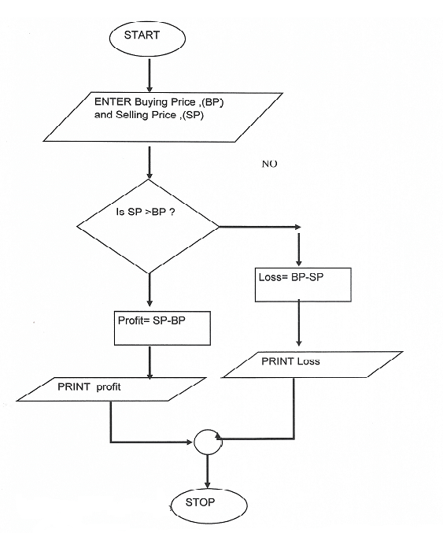
17. (a). Subtract 0111₂ from 1001₂ (2 marks)
0010₂
(b). Using two’s compliment, subtract 7 from 4 and give the answer in binary notation. (4 marks)
7 = 111₂
4 = 100₂
-4 in two’s compliment is 100
-$∴$ 111
100
+1011
The resulting answer is 011 since the overflow is ignored in decimal notation that is 3₁₀

(c). Convert
(i). 91C₁₆ to octal (3 marks)
9 | 1 | C
1001 | 0001 | 1100

100 | 100 | 011 | 4
4 | 4 | 3
91C₁₆ =4434₈

(ii). 377₈ to hexadecimal (3 marks)

3 | 7 | 7
011 | 111 | 111

0000 | 1111 | 1111
0 | F | F
$∴$377₈ = FF₁₆

(iii). 9.625₁₀ to binary (3 marks)
9 = 1001
0625 x 2 = 1.25 WRITE 1
0.25 x 2 = 0.5 WRITE 0
0.5 x 2 = 1.0 WRITE 1
18. [a].Explain three circumstances under which observation method may be preferred during data collection.
(6 marks)
- When the subjects that are being observed need not be made aware of the fact
- When there is need to collect data without interfering with the working of the subjects
- When there is need to directly see what subjects do rather than rely on what they tell you
- When nature of data can only be collected via observation e.g. traffic flow
- When collecting data in situation that subjects may be unwilling to give information

(b). State three activities that may be carried out when during system implementation. [3 marks]
- File conversation
- Staff training
- Change over strategies
Type of maintenance that is done to make the system to adapt the hanging technology e.g. changing the system because of new operating system

(c). Explain three approaches that may be used to replace an old system with a new computerized system (3 marks)
- Direct approach
- Parallel approach
- Phased approach
- Pilot approach
- (with correct explanation)

19. (a). What is meant by each of the following terms as used in data security and controls? [2 marks]
(i). Confidentiality
- Sensitive data that belongs to an organization or government should not be accessed or disclosed to unauthorized persons.
(ii). Industrial espionage
- Spying on your competitor to get information that you can use to counter of finish the competitor
(b). Jane a form four student was advised to partition a hard disk for her computer. Explain two reason that may have necessitated this. (4 marks)
- Install two operating systems
- Use one portion for backup
(c). If one table in a database contains the field: EMPLOYEE - ID, LAST – NAME, FIRST – NAME and
HIRE – DATE and another contains the fields DEPARTMENT, EMPLOYEE – ID and SALARY, it
is possible to establish a relationship between the two tables. (6 marks)

(i). Name the type of such a database
- Relational database
(ii). What type of relationship can be established between the tables? (1 mark)
- One to one
(iii). provided the most appropriate data types for each of the fields. (3 marks)
EMPLOYEE – ID TEXT
LAST – NAME – TEXT
FIRST – NAME – TEXT
HIRE – DATE – DATE/TIME
DEPARTMENT – TEXT
SALARY – CURRENCY/NUMBER
(d). A publishing firm designed the following publication using a DTP software,

(i). Give two reasons why the firm prefer using DTP instead of Word Processors. (2 marks)
- DTP has wide range of templates
- Master pages can be used to set up a common layout
- Every item is contained in a frame and can be formatted independently
(ii). Identify four formatting features used in the designing the publication. (2 marks)
- Bolding
- Underlining
- Drop cap
- Bullets
- Font (style, size and type)

20. (a) State the function of each of the following
(a). Network Interface Card (1mark)
- A device that creates a physical link to the computer and the transmission media
(b). Modem (1mark).
- Modem converts a signal from digital to analogue from for the purpose of transmission over the transmission media

(c). Repeater (1mark)
- Receive signal from one section of a network, clean it to remove any distortion, boosts/amplifies it and sends it to another section
(d). Crimping tool
- Used terminate a cables/used to attach RJ 45 to cable
(b). State any three reason why the fibre optic cable is preferred for data transmission over the other cables. (2 marks)
- Fiber optic transmission is faster
- Fibre optic transmission can cover greater distances
- Fiber optic cables are impervious to electromagnetic interference (EMI)
- Save space and enhance cable management
- Fiber optics are future-proof
- Extremely High Bandwidth
- Low Security Risk
- Light Weight
(c). State two functions of networking operating systems other than providing network security. (2 marks)
- Provide access to network resources;
- Supporting network services like protocols;
- Support communication;
- Respond to requests from applications;
(d). Explain four advantages of networking. (4 marks)
- Improves reliability e.g. in case one computer breaks down, users can still access data and information from other computer on network
- Resources sharing i.e. data/information, files, printers, modems, programs etc. can be attached to the network for access by all users
- Distributed processing facilities
- Remote communication i.e. transfer of data signals between two communication devices located differently
- Cost effectiveness. Although initial cost of laying down the network components may be expensive the savings experienced and the value added to service delivery make them cost effective
(e). The figure below shows a network topology. Use it to answer the questions that follows:

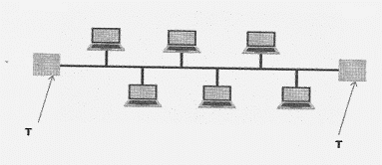

(i). What is the name of the topology? (1mark)
- Bus topology
(ii). What is the work of the part labelled T. (1 mark)
- Terminator in a backbone is used to prevent data signal from bouncing back/absorb signals.
(iii). Highlight one disadvantage of the above topology identified in 20(e). (1 mark)
- Cable break of backbones cable brings down the whole network
- Limits the number of computers that can be connected

