COMPUTER SCIENCE - GRADE 7 TERM 1 EXAMS 2023

COMPUTER.
- Timothy and Caroline were discussing the difference between data and information. Give the definition of data and information to show their differences. (2mks)
- Grade 7 learners were asked to name characteristics of computers. List 6 characteristics of computers they were likely to give. (6mks)
- We can use computers to perform different activities in our daily life. State three uses of the computers. (3mks)
- There are advantages and disadvantages of using computers in data processing. Outline four disadvantages of using computers. (4mks)
- State four stages involved in data processing cycle in a computer. (4mks)
- Patel was asked by his father to give the meaning of the term 'computer'. What meaning was he likely to give? (1mk)
- Identify five places where computers are used. (5mks)
- The diagrams below show different examples of computers. Name them. (8mks)
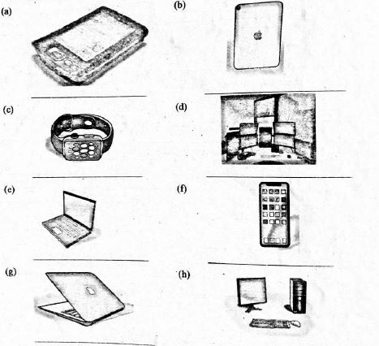
- At home we can use computers for different purposes. Write five purposes of computers at home. (5mks)
- Grade 7 learners visited a computer resource person to learn about evolution of computers. They were taught about evolution stages of computers. Name 4 devices at different evolution stages of computers. (4mks)
- Grade 6 learners visited a computer laboratory. The computer technician asked the learners to mention safety precautions they should observe when using computers. State three precautions. (3 mks)
- Grade 6 learners created an excel spreadsheet document. Which button would they use to insert, delete or format sheets, columns and rows? (1 mk)
- Identify the button marked X on the computer monitor below.
- What is the function of the desktop icons when creating a word document in a computer? (1mk)
- The diagram below shows a keyboard. Name the key marked X and state its use. (2mks)
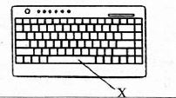
Name
Use

MARKING SCHEME
  - They are raw facts, symbols or numbers that not yet processed.
  - Processed data,

  - Speed
  - Automation
  - Versatility
  - Storage
  - Diligence
  - Garbage in garbage out

  - Performing arithmetic operations
  - To listen to music
  - To draw designs

  - They are expensive to buy
  - They depend on human beings hence not accurate on their own.
  - They can lead to health problems e.g backache, eye strain.
  - Can lead to loss of jobs to the computer illiterate.

  - Data input
  - Data processing
  - Data output
  - Data storage

- An electronic device that processes raw data into information

  - In schools
  - In hospitals
  - In factories
  - In offices
  - In banks

  - personal digital assistant
  - ipad
  - smart watch (d) work station
  - Laptop
  - smart phone
  - Mac Book
  - desktop

  - Online shopping
  - For socialising
  - For attending virtual meetings
  - Preparing home budgets
  - For entertainment.

  - Abacus
  - Mechanical devices
  - Electromechanical devices
  - Modern digital computers.

  - The devices should be stored in safe lockable cabinets.
  - We should avoid crinks and food when operating the computers.
  - We should not bang on the screen.
- Cells
- Start button
- Indicate shortcuts to get to other programs in the computer

  - Name - space bar
  - Use creates space between (w) words.

