NAME: …………………………………………………………………………….
ADMNO:…………………………. CLASS……………….
DATE …………… SIGN……………

MOKASA II JOINT EXAM
451/2
COMPUTER STUDIES
Paper 2
451/2
SEPT, 2022
PRACTICAL
21/2 Hours

INSTRUCTIONS TO CANDIDATES
- Type your name and Adm No. at the top right hand corner of each printout.
- Passwords should NOT be used while saving in the CD.
- Answer all questions
- All questions carry equal marks

FOR OFFICIAL USE

QUESTION | MARK AWARDED
1
2
TOTAL

- The table below shows records of booking schedule kept by Milele Resort on participants expected to attend a CBC workshop in the month of June 2022.
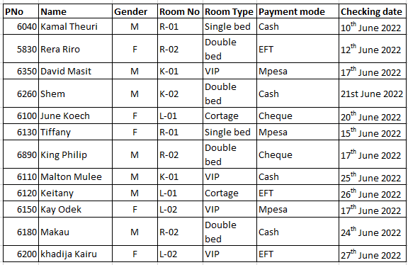

- Open a database program and create a database named Milele Rooms. (1 mark)
- From Table 1 above create two tables, one for participants’ details and another for room details using appropriate data types. Name the tables “Participants table and rooms table respectively. (2 marks)
- Enter the data from table 1 in the respective table above. (13 marks)
- Create a relationship between the two tables. (2 marks)
- Enforce referential integrity. (1 mark)
- Modify the rooms table so as to capture the booking fee as shown below.(2 marks)

Room type | Booking fee per room
Single bed | 7,000
Double bed | 12,000
Cortage | 15,000
- Create a query that would display the following fields:
- PNo, name, gender, room No, and those who booked room for the meeting on 17th June 2022. Save the query as Ckd_Query. (4 marks)
- PNo, name, room No, room type , booking fee and payment mode.
- Compute total amount of money collected.
- Save the query as Amt_Query. (4 marks)
- PNo, name, gender room type, booking fee, payment mode and check in date.
- Show the number of participants who occupied VIP rooms.
- Save the query as CR_Query. (3 marks)
(g)(i)Create a report to display PNo, name room No, room type, payment mode, booking fee and check in date. Compute (4 marks)
- Total revenue collected.
- Group records per room type.
(ii) Modify the report to appear as follows:
- To have a report title “MILELE RESORT MAY MONTHLY REPORT 2022”
- Underline the report title.
- save the report as “MR__Report” (3 marks)
- Create a form using the format in figure 1. Save the form as MR_ Entry Form.
(4 marks)
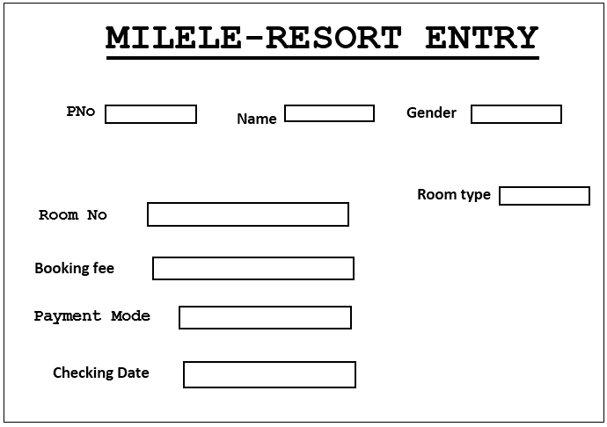

Figure 1
(i)Create a bar graph to display Names and booking fee per participant (2mks)
(j)Print out later each of the following: (5 marks)
- Tables(rooms table)
- Queries(CR query)
- Report
- Form
- chart

2. Plantesha Hotel Intend to use a Desktop publishing program to design a plan for a section of the hotel. Assume you have been given the task.

(a) (i) Open a desktop publishing program and set the page layout orientation to portrait and paper size to A4. (2Marks)
(ii) Save the publication as Hotel . ( 2 Marks)
(b) Create the Hotel plan as it appears in Figure 1 ensure that the design covers the entire printable area of the page (35Marks)
(i) Apply appropriate pattern, gradient to Pantesha Hotel and shade blue color (3 Marks)
(ii) Shade the river with sky blue color ( 2 Marks).
(c) Type your name and index number as the header ( 2 Marks)
(d) Type the name of your school as a footer ( 2 Marks)
(e) Save the changes and print the publication later (2 Marks)

Plantesha Hotel

Limpopo Streat

Conference Room

Offers 80⁰% of most of flexible,
modern and comfortable
meeting rooms and boardrooms
Swimming pool

Bamboo street

Department in Plantesha hotel
Food &Beverage
Front office Hotel
House keeping
Reservation
Human Resource
Plantesha Hotel provides travelers with shelter, food, refreshment and similar services and goods offering on commercial basis things that are customarily furnished within household but unavailable to people on a journey away from home
Figure 1

