MUMIAS WEST JOINT EXAMINATION
COMPUTER MARKING SCHEME
451/PP2 2022

QUESTION ONE

    - Typing 12 mks
    - Underlining headings 2mks
    - Drop cap 2 mks
    - Column 2 mks
line 1 mk
    - Diagram 2 mks
    - Square wrapping 2 mks
    - Table
- Text direction 1 mk
- Correct shading 2 mks
- All text at the right position 3 mks
    - Correct saving 1 mk

- Format the headings, bold, font type Times New Roman, size 14, double underline and Centre alignment (4mks)
- The footer “News letter you can rely on” header “:Vision update” (2mks)
- Insert page numbers N of M on the footer at the right bottom of the document. (2mks)
- Search Article and replace with “PC” (2mks)
- Spell check the document (1 mk)
- Change the first paragraph to double line spacing (2mks)
- Apply a character space expanded, 30 points to the headline computer. (2mks)
- Insert a caption for the graphic in the article and name it computer. Place the caption below the graphic (2mks)
- Save the entire document as Article 1 (1 mk)
- Print the document Article 1 and Article (2mks)

Question two
The following data was extracted from the IEBC registration book. Use it to answer the questions given.
- Enter the data shown below in a spreadsheet and save it as Election 2022 (10 mks)

- Rename Registration (1 mk)
- Copy and rename it as Registration1 (1 mk)
- Sort in ascending order of their county (1 mk)
- total number of voters for each county (3 mks)
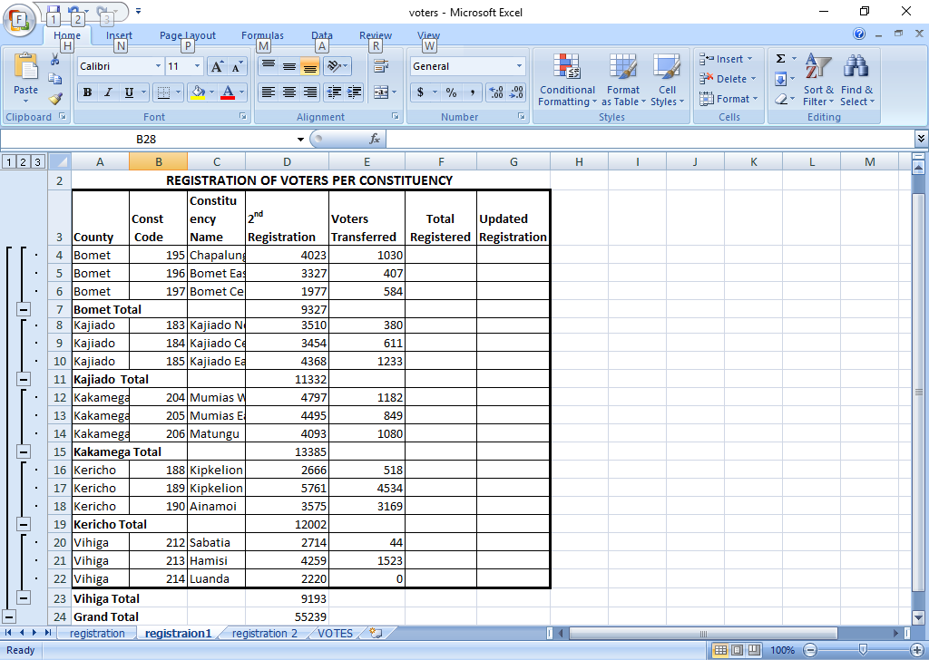

- Copy &Renaming registration2 (1 mk)
- Given that the 1ST Registration was above the 2nd Registration in all constituency:
    - Enter the label % increment in cell A20 and the value 12 in B20. (1 mk)
    - Insert a column
    - absolute cell =(E4-($B$20*E4/100)) (4 mks)
    - =SUM(D4:E4) (2 mks)
    - =G4-F4 (3 mks)
- Using the total registered column, determine
    - =MIN(G4:G18) (2 mks)
    - The average =AVERAGE(H4:H18) (2 mks)

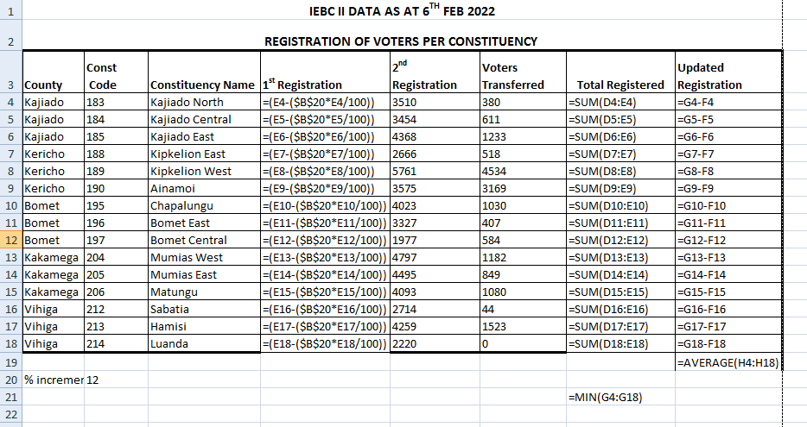

- Create a column graph on a new sheet. Name it votes. That compares the constituency name against 1st Registration and 2Nd Registration. Label the following (7 mks)
- Chart title VOTER REGISTRATION 2022
- Y – Axis constituency name
- X – Axis Registered voters
- Legend Right

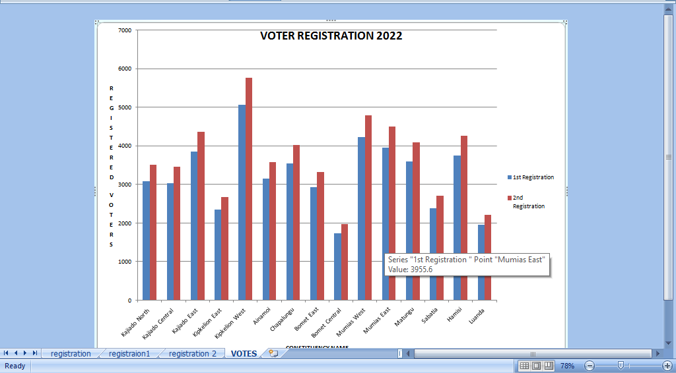

- Print registration and votes (graphs) sheets (2 mks)

