Name: ………………………………………………………. Index No: …………………………

School: ………………………………………………………. Candidate’s Signature ……………

Date …………………………..

**MUMIAS WEST JOINT EXAMINATION**

MAY/JUNE EXAMS

KENYA CERTIFICATE OF SECONDARY EDUCATION

COMPUTER STUDIES

451/2

PAPER 2

(PRACTICAL)

TIME: 2 ½ HRS

2022

**INSTRUCTIONS TO CANDIDATES**

1. Indicate your name and index number at the top right corner of each printout.
2. Write your name and index number on the CD / Removable storage medium provided
3. Write the name and version of software used for each question attempted in the answer sheet provided.
4. Answer all the questions
5. All questions carry equal marks
6. Passwords should not be used while saving in the CD/Removable storage medium.
7. All answers must be saved in your CD/Removable storage medium used.
8. Make a printout of the answers on the answer sheet.
9. Arrange your printouts and tie / staple them together.
10. Hand in all the printouts and the CD/Removable storage medium used
11. **This paper consist of 4 printed pages**
12. **Candidates should check the question paper to ascertain that all the pages are printed as indicated and that no questions are missing.**
13. **Candidates should answer the questions in English**

**QUESTION ONE**

1. Type the document below as it appears using a word processing package and save it as Article (30 mks)

INTRODUCTION TO COMPUTING

What makes human being different from animals is the ability to invent tools. Tools assisted man in building shelters, making clothes and hunting food.

Machines were then invented to help the thinking skills of man. It started with adding machines, computers then came calculators. Now computers help the thinking skills of a man.

Computers have undoubtedly come to stay. They are part of our day to day lives.

Infact, it is not possible to escape contact with computers. We use the term “computer” quite easily let us see what the definition of the term “Computer” is.

A COMPUTER

A

 computer is a high-speed electronic device capable performing arithmetic and logical operations and of sorting and executing a set of instructions which will enable it to perform a series of such operations without manual interventions. Thirty years ago computers

Were huge machines, they were very costly, only companies and Government Organizations could afford the luxury of using computers. In the last ten years the microprocessor revolution changed the entire world of computers. Computers of any capacities are available now.

From super computers to micro computers there is a wide variety of computers available today. Now personal computers are available at affordable prices.

|  |  |  |
| --- | --- | --- |
| **CLASSIFICATION OF COMPUTERS** | | |
| **Computer** | Physical size | Super computers |
| Mainframe computers |
| Mini computers |
| Micro computers |
| Purpose | Special purpose |
| General purpose |
| Function | Analog computers |
| Digital computers |
| Hybrid computers |

1. Format the headings, bold, font type Times New Roman, size 14, double underline and Centre alignment (4mks)
2. Put a **header** and footer**.** The footer should read “News letter you can rely on” while header should read “:Vision update” (2mks)
3. Insert page numbers N of M on the footer and should be at the right bottom of the document. (2mks)
4. Search for the word computer throughout the Article and replace with “PC” (2mks)
5. Spell check the document (1 mk)
6. Change the first paragraph to double line spacing (2mks)
7. Apply a character space expanded, 30 points to the headline computer. (2mks)
8. Insert a caption for the graphic in the article and name it computer. Place the caption below the graphic (2mks)
9. Save the entire document as Article 1 (1 mk)
10. Print the document Article 1 and Article (2mks)

**Question two**

The following data was extracted from the IEBC registration book. Use it to answer the questions given.

1. Enter the data shown below in a spreadsheet and save it as Election 2022 (10 mks)

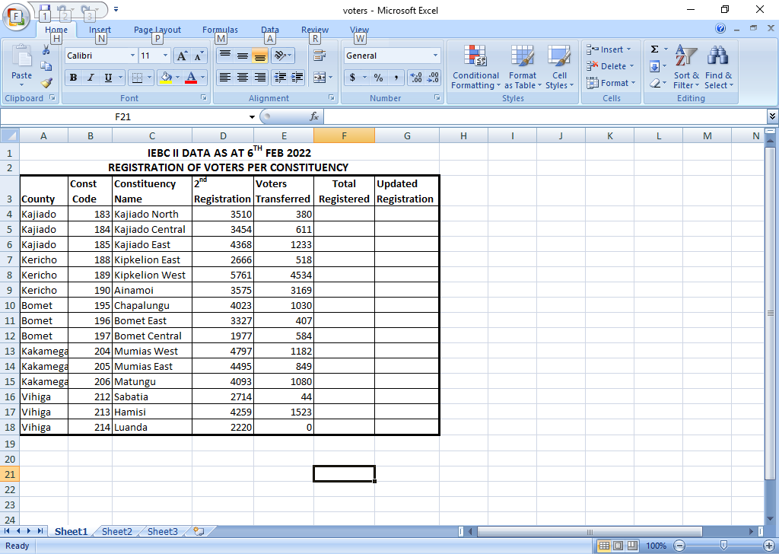

1. Rename the sheet as Registration (1 mk)
2. Copy the work into sheet 2 and rename it as Registration1 (1 mk)
3. Sort the worksheet in ascending order of their county (1 mk)
4. Get the totals of voters 2nd registration for each county (3 mks)
5. Copy details on registration sheet and paste it in sheet three. Rename it as registration2 (1 mk)
6. Given that the 1ST Registration was less than the 2nd Registration in all constituency by 12%:
   * 1. Enter the label % increment in cell A20 and the value 12 in B20. (1 mk)
     2. Insert a column between constituency name and 2nd registration and label it first registration. Use absolute cell reference to calculate the 1st Registration. (4 mks)
     3. Get the totals for the 1st Registration and the 2nd Registration in cell F4. Copy the formula to the rest of the cells. (2 mks)
     4. Some voters transferred from their stations to new stations. Using the total registered column and the voters transferred column. Calculate the new values in cell G4. Copy the formula down to other cells. (3 mks)
7. Using the total registered column, determine
   * 1. The lowest registered voters in cell G21 (2 mks)
     2. The average number for all registered voters in all constituencies in cell H19 (Use updated registration column) (2 mks)
8. Create a column graph on a new sheet. Name it votes. That compares the constituency name against 1st Registration and 2Nd Registration. Label the following (7 mks)

* Chart title VOTER REGISTRATION 2022
* X – Axis: constituency name
* Y – Axis: Registered voters
* Legend Right

1. Print registration and votes (graphs) sheets (2 mks)