451/2
COMPUTER STUDIES
PAPER 2
PRACTICAL
AUGUST-2022
TIME 2 ½ HOURS.

CEKENAS END OF TERM TWO EXAM-2022
FORM FOUR EXAM
Kenya Certificate of Secondary Education. (K.C.S.E)
COMPUTER STUDIES
PAPER 2
PRACTICAL
INSTRUCTIONS TO CANDIDATES
- Type your name and index number at the top hand corner of each printout.
- Write your name and Adm no. number of the CD-RW
- Write the name and version of the software used for each question attempted in the answer sheet
- Passwords should not be used while saving the CDs
- Answer all questions
- All questions carry equal marks
- All answers must be saved in your CD
- Make printouts of the answers on the answer sheets provided
- Hand in all the printouts and the CDs
- Arrange your printouts and staple them together
FOR EXAMINERS USE ONLY
QUESTION | MAX. MARKS | CANDIDATE’ S SCORE
1 | 50
2 | 50
TOTAL SCORE

1.a)The following table was extracted from a form four class. Create a workbook named performance .Enter it as it is and save it as grades. Use it to answer the questions that follow. (12mks)
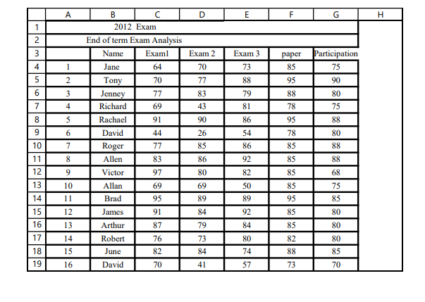
(b) Add the following two students before victor and enter the following information: (3mks)
Name: Thomas, Washington.
Exam 1: 82 65
Exam 2: 75 79
Exam 3: 81 84
Paper: 87 92
Participation: 94 65

(c) Copy the data in the worksheet grade and paste it in worksheet 2 and save as Rank. (2mks)
(d) Calculate the final average for each student. The three exams should each count 25% of the final average, the paper should count for 15%, and participation should count for the remaining 10%. Using Absolute cell referencing. (5mks)
(e). Calculate the class average for each exam. (3mks)
(f) Apply one decimal point to the average point (2mks)
(g) Rank the students based on average points (3mks)
(h) Sort the students based on rank after average in ascending order (2mks)
(i) Create a column after rank and name it Grade. Using IF function, grade the students based on the following criteria. (A=90-100; B=80-89; C=70-79; D=60-69; F=below 60) (6mks)
(j) Below the average for each exam get the highest score and lowest score for exam1, exam2, and exam3 (4mks)
(k)Create a chart that shows the grade distribution for the final average and insert in a new worksheet. (5mks)
(l)Print the following GRADE, RANK and CHART (3mks)

Question 2
The following tables were extracted from king secondary school.

STUDENTS TABLE

AdmNo | StudentName | Class | Male | DOB
1021 | AMOS WOKO | 4E | Y | 10/08/2005
1023 | JUNE KENDI | 4N | N | 23/01/2002
1025 | WINNIE OMOKE | 4N | N | 02/07/2003
1027 | CHARLES OPIYO | 4E | Y | 10/04/2001

EXAMS

Term | AdmNo | Opener | MidTerm | EndTerm
T1/2021 | 1021 | 56 | 65 | 45
T2/2021 | 1021 | 78 | 76 | 67
T1/2021 | 1023 | 77 | 78 | 78
T2/2021 | 1023 | 45 | 67 | 70
T1/2021 | 1025 | 87 | 56 | 85
T2/2021 | 1025 | 67 | 74 | 69
T1/2021 | 1027 | 68 | 69 | 58
T2/2021 | 1027 | 83 | 89 | 56

LIBRARY TABLE
AdmNo | BookNo | BookTitle | DateIssued
1021 | COMP 2/002 | LOG ON COMPUTER BOOK 2 | 10/2/2020
1023 | COMP 2/004 | LOG ON COMPUTER BOOK 2 | 10/2/2020
1025 | COMP 2/201 | LOG ON COMPUTER BOOK 2 | 20/2/2020
1027 | COMP 3/007 | LOG ON COMPUTER BOOK 3 | 11/2/2020
1027 | COMP 4/004 | LOG ON COMPUTER BOOK 4 | 10/2/2020
1023 | COMP 4/006 | LOG ON COMPUTER BOOK 4 | 11/2/2020
1025 | COMP 3/002 | LOG ON COMPUTER BOOK 3 | 6/2/2020
1023 | COMP 1/004 | LOG ON COMPUTER BOOK 1 | 6/2/2022

- Create a database file and name it as KingsSchool (2 mks)
- Design the tables listed above and set the most appropriate primary key and data types. (9mks)
- Create appropriate relationships among the table and enforce referential integrity (3mks)
- Create appropriate form to enter the records above. (9mks)
- Design the query that shows list of students who have borrowed books in the Library. Save the query as borrowed books (3mks)
- Using a query, Calculate the total scores for each student. Save the query as totals.(4mks)
- Create a query called Age to display Adm No, Book No, Student name, D.O.B and Age of the student by the year 2021. (5mks)
- Design a query to extract the list of students whose name has letter A. Save the query as THE A (4 mks)
- Create a report to display student name, subject score, total scores per subject and the average score per subject grouped by classes’ performance. Save the report as performance. (6 mks)
- Create a report of all students and save it as students. (2 mks)
- Print the following; (3 mks)
- Library table
- Totals query
- Performance report.

