COMPETENCY BASED CURRICULUM GRADE 2 -EXAM 2023 – RELIGIOUS ACTIVITIES
- I was created in the of God

(face ,image)

- God knows me by my _ (face, name)
- Who is the father of Jesus?(Ishmael, joseph)

- Draw a picture of the bible (3mks)

- The Bible is divided into (3,4,2)

- Jesus was born in ( Kenya, Bethlehem)
- Who killed Goliath ? (Jacob, David)

- Draw and color your church in the box bellow (4mks)

- Jesus was baptized in

river ?(Jordan,kuja)

- God created human being, male and female and put them in the garden called ( Eden, Canaan )
- Father, mother, uncle, Mary, son, sister, joseph, aunt.

Male | Female
1.
2.
3.
4.

- What are the uses of the body parts bellow?

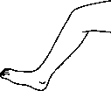 _

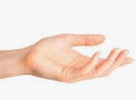
20. Jesus was baptized by

13.

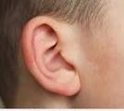
14.

  - Who created human beings

_(God, Satan)

  - Write a short prayer before going to sleep.(4mks)
………………………………………………

………………………………………………

………………………………………………

………………………………………………

(Jacob, john)

- God created and Eve?(Adam, Human being )
- God rest on day after creation(7,6)

- was created by God ( doors, animals

)

- Name two domestic animals created by God

- What is the person doing (praying, laughing)
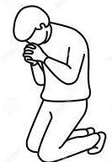

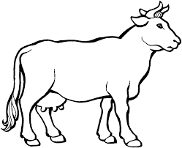
- Color the animal below?

- We should not

- Abraham was the father of
( fight, forgive)

(Isaac, Moses)

- New testament has

books(27,39)

