COMPETENCY BASED CURRICULUM

GRADE 2 - TERM 1 2023 –
MATHEMATICS ACTIVITIES

1. + =

2. + =
6. 8

7. 10

Write the next number 8. 1,2,3,4, , ,

9. 10,20, , ,
10. 11,12,13,14 , , ,

3. =
+

Draw enough balls

4. 3

5. 5
11. Select the bigger number 20 or 30
12. 13 or 31

Write numbers from 1-10

13. , , , ,

14. , , , ,

Write the numbers

- Forty

- Twenty

- Ninety

- Eighty

- Nineteen

Put together the following

20. 10- = 0

21. 6 + = 13
How many are they

22.

  - Otieno has two banana, Sheila has three, how much total do they have
  - What is the shape of egg
  - which one is tall
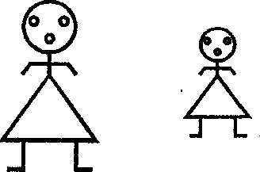

A B

