COMPETENCY BASED CURRICULUM

GRADE 2 - TERM 1 EXAM 2023– KISWAHILI ACTIVITIES

IMLA

1.

2.
Chora picha hizi

- Kikombe

3.

4.

5.

- Msichana

Jibu maswali yafuatayo

- Watu walifika ( wengi, tatu )

- Mwalimu alikufa (yetu, wetu )

- Sisi tunaenda jumapili ( kanisa, jela

)

- Mama ugali (anapika, anakanyaga )

- Dactari amenidunga ( chuma, shindano)
Maliza sentensi ukitumia hawa,huyu,

- Kijana anakula ndizi(hawa,huyu)

- Watoto ni wachoyo(huyu,wale)

- Mama anafua nguo(sisi. Yake)

- Baba ni mkulima(sisi, yangu)

- Wasichana walichapwa (wale,huyu)
  - Mvulana

  - Runinga

  - Kiti

Andika majina ya wanyama hawa

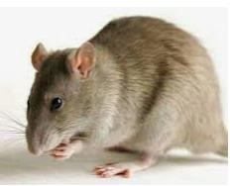
.
21.

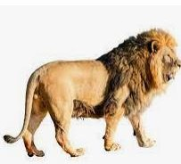
22.
.

23.
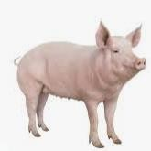
24.
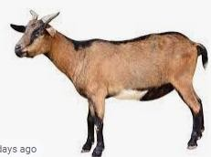

25.
