COMPETENCY BASED CURRICULUM GRADE 2 - TERM 1 EXAM– HYGIENE AND NUTRITION ACTIVITIES
  - We use to cook tea (milk, maize)
  - Cows gives us ( milk, millet )

  - We always brush our teeth

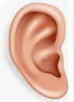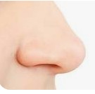Name pictures below 10.

meals (Before, After )

  - We buy meat from (market, burchery )
  - We should not play with

11.

(knives, toys )

  - 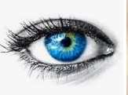Sick people go to ( hospitals, market )

  - We take to feel better when sick ( alcohol, medicine )
  - Teeth that are removed are called ( milk teeth, permanent teeth )
  - is used to clean our nose

(handkerchief, tissue )

12.

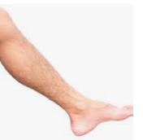
13.

Draw the following fruits

    - Mango

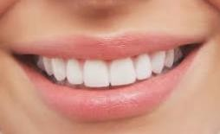
14.

    - Orange

Name the fruits in your locality

15.

16.
    - We should always keep medicines in the ( store, curd board)
    - We should not take drugs (expired, prescribed drugs )
    - Too much sugar is to our health ( good, bad )

17.

18.

- Dirty fruits make us ( healthy, sick)
- We should not eat

bananas (rotten, clean )

