COMPETENCY BASED CURRICULUM GRADE 2 - TERM 1 EXAM– ENVIRONMENTAL ACTIVITIES
Use the weather chart to answer the questions
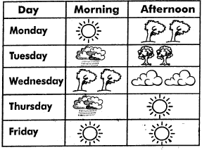
- The weather on Monday morning was?
- Which day was the weather sunny throughout the day ?
- Name the days of the week which the weather was sunny
- On Tuesday afternoon the weather was
- Draw the sources of light
  - bulb
  - sun
  - candle
- Name parts of a plant(stem, fruit, flower, leaf, roots)
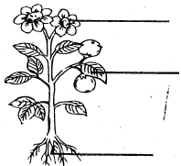
- We go to______ learn (hospital, school)
- Name three domestic animals (lion, zebra, donkey,monkey,sheep,cow)
- ______teaches pupils at school. (doctor, teacher)
- Name the things used to store water (pipe, bucket, pot, jerry can, cup)
