COMPETENCY BASED CURRICULUM GRADE 2 - TERM 1 EXAM 2023 – ENGLISH ACTIVITIES

Dictation

1.

2.

3.

4.

5.

Complete the sentence below

  - She bought ball (an, a )

  - She not tall ( not, is)

  - Otieno sick (was, not )

  - She brought glass of water (the, a )

  - I not going to school (am, I Name the pictures below
11. .
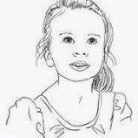
12. .

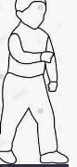

13.
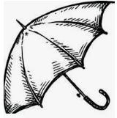
14.
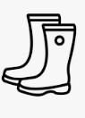

15.

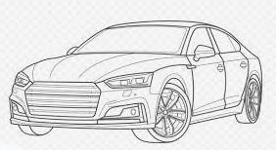

Write in capital letters.

16.ten_ 17.chair_ 18.house - 19.cup 20.television
Write words that begins with these sounds
- h_ 22.ch_ 23.th_ 24.b_ 25.cl_

