COMPETENCY BASED CURRICULUM GRADE 2 - TERM 1 EXAM ART AND CRAFT, MOVEMENT ACTIVITIES 2023

Make number patterns. 4MKS

5. Wavy line

Color the picture below (6MK)

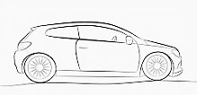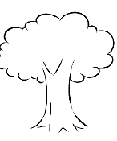Draw the following line: (8MKS)
6.
- Straight line

- Curved line

- Zigzag line

7.

- What is the color of healthy vegetable? (2mks)
- We use fire to food( slaughter, cook)(2mks)
- We use our hands to ( food(eat, rot)

