COMPETENCY BASED CURICULUM MATHEMATICS ACTIVITIES - GRADE 2 TERM 1 EXAMS 2023

QUESTIONS
- Count and write____________________________________
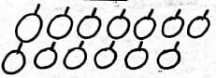
- Fill in the missing numbers
5, 6, ___, 8, 9
- 11,10,9, ___, 7
- Write in words
7 ________________________________
- 6 tens and 4 ones = ______________________________
- 83 = _____tens and _____ones.
- 5 + 3 = ________________________
- 42 + 5 = ___________________________
- 40 + 20 =____________________________
- 8 + 9 = _________________________________
- 8 - 6 = ___________________________________
- 13 take away 4 is __________________________________
- 19 take away 6 is _____________________________________
- Which one is the longest
- Which one is heavier?
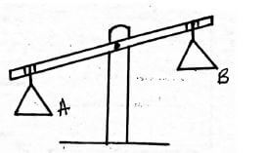
- This is ______________________shillings coin.
- Which day is missing?
Tuesday,_________________, Thursday
- How much is a ball?_________________________________
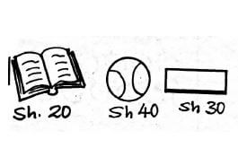
- Draw a rectangle

- Complete the pattern
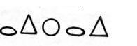

Marking Scheme
- 13 / thirteen
- 7
- 8
- seven
- 64
- 8 tens and 3 ones
- 8
- 47
- 60
- 17
- 2
- 9
- 13
- B
- A
- 5
- Wednesday
- sh. 40

