COMPETENCY BASED CURICULUM MATHEMATICS ACTIVITIES - GRADE 2 TERM 1 EXAMS 2023

QUESTIONS
READ CAREFULLY AND ANSWER ALL THE QUESTIONS (30 MARKS)
- A shopkeeper has 8 baskets each with 10 oranges. How many oranges are there altogether?____________________________________________________________________________________________
- Grade 2 has 45 pupils. 15 of the pupils are girls, while the rest are boys. How many boys are there?____________________________________________
- A pupil was asked by the teacher to count numbers in three's forward from number 25. He counted 25, 28__________________________________Which number was he supposed to count next?
- Otieno took 2 days to finish his homework. Onyango took 5 days to finish the same amount of work. Who among the two took a longer period of time to finish their work?__________________________________________________
- A farmer planted 67 tomato seedlings and 13 cabbage seedlings. How many plants were planted in the farmer's farm in total?_____________________________________________________________
- A farmer bought 56 kilograms of hay in a day.
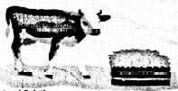
His cow ate 12 kilograms of hay that day, how many kilograms of hay was left?_______________________________________
- There are 33 learners in grade 2 class. On Monday 12 learners were absent. How many learners were present that day?______________________________________
- A farmer has twenty-five goats and fifteen cows. How many animals does he have altogether?._____________________________________________
- Mr Kamau bought a 50 litres water tank. His friend Otieno decided to buy a 70 litres water tank.
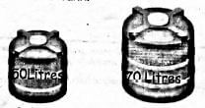
Which of the tanks holds less water?
- Mary has 12 toys which she arranges all of them neatly on her bed. One day she realized that only 6 toys were in her bedroom. She remembered that she gave some of her toys to her baby sister. How many toys had she given her sister?
- Asha has 5 pencils, Katanu has 5 pencils and Otata has 6pencils. How many pencils do they have altogether?
- In a place value tin, there are two counters in the ones place value and 6 counters in the tens place value.
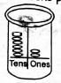
Which number is represented in the tin?
- There are 20 desks in grade 2 class. The teacher asked learners to arrange the desks in groups of 5. How many groups were created?
- In a class there are 20 boys and 10 girls. How many pupils are in the class altogether?
- Mary had 10 sweets. She gave 10 sweets to Jane. How many sweets did she remain with?
- Kamau bought a weighing machine to measure weight of his products. In one day, he measured 15 kilograms of sugar and used it to measure 15 kilograms of rice.
What was the weight of rice measured by Kamau?.
- Paul was given sh 90 by his father. His uncle gave him sh. 50. He used sh 30 to buy a book. How much money was he left with?
- Grade 2 has 30 learners. The teacher grouped them in 6 groups. How many learners were in each group?
- Grade 2 learners decided to contribute some money to buy books. Each pupil contributed sh 20. How much amount was contributed in total?
- Four learners bought sixteen apples. They shared the apples equally among themselves. How many apples did each learner get?
- Jane had 40 eggs. Ten of them broke. How many good eggs remained?
- A goat weighs 20 kilograms, a cat weighs 2 kilograms.
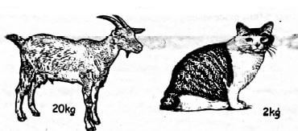
Which is heavier between the two?
- Tumaini school opened on Tuesday. Mary went to school the following day. On which day did mary go to school?
- Juma had sh. 50 note. Draw the note on the space below.
- A pole is 15m tall. Another pole is 12m tall.
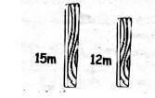
What is the difference between the lengths of the two poles?

Marking Scheme
- 80
- 30
- 31
- Onyango
- 80
- 44
- 21
- 40
- 50 litres / Mr.Kamau's tank
- 6 toys
- 16 pencils
- 62
- 4
- 30 pupils
- 0 / none
- 15 kg
- 110
- 5
- number of grade 2 students multiplied by sh.20
- 4
- 30
- the goat
- Wednesday

- 3 m

