COMPETENCY BASED CURICULUM INTEGRATED LEARNING ACTIVITIES - GRADE 1 EXAMS TERM 1 2023

QUESTIONS
ENVIRONMENTAL ACTIVITIES (15mks)
- Draw what we see during the day in the sky
sun | clouds
- Match the weather conditions
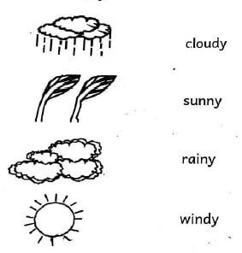
- We get water from...............................
(house, river)
- Tick the plant that is not eaten
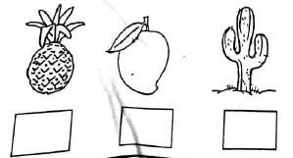
- Write the uses of water at home and in school
  - c__ __king
  - dr__nking
  - w__shing
- Jane was walking around home compound at night. She looks up the sky and saw the stars and moon. Draw;
stars | moon
HYGIENE AND NUTRITION ACTIVITIES (10mks)
- We wash our ____________after visiting the toilet.
(legs, hands)
- ____________is a place where we pass waste at home and also in school.
(Toilet, Forest)
- We wash our hands with soap and____________
(water, soil).
- Drinking clean____________water make us healthy.
(safe, dirty)
- When we are sick we take____________
(medicine, sweet)
- The first set of teeth are called____________
(milk teeth, permanent teeth)
- Draw foods that make our bodies healthy
orange | fish
sukumawiki | carrots
- ____________is not healthy food.
(Soda, Apple)
CHRISTIAN RELIGIOUS ACTIVITIES (10mks)
- ____________created me and you.
(God, Satan)
- We all have____________
(money, names)
- I am____________
(bad, special)
- God knows me by my ____________
(name, face)
- God has writen my name on hi____________
(palm, leg)
- How can I take care of myself
  - I eat good____________
(food, leaves)
  - I____________my hands.
(brush, wash)
  - I____________my teeth two times a day.
(beat, brush)
- This is a____________
(Bible, Storybook)
- ____________is talking to God.
(sleeping, praying)
- Draw your palm and write your name.
ISLAMIC ACTIVITIES
- Fill in the gaps below correctly
  - M____sque
  - All____h
  - K____I____ma
  - F____t____
- Our God is called ____________
(Muhammad, Allah)
- The messanger of Allah is____________
(Nabii Issa, Prophet Muhammad)
- Angels of Allah were created from ____________
(soil, light)
- We give thanks to Allah for His____________
(Thawab, Creatures)
- Muslims read the Holy book called____________
(Quran, Bible)
- The mother of prophet Muhammad was called ____________
(Maryam, Hamina)
- The prophet (PBUH) had ____________children.
(6, 7)
- We worship our God in the____________
(church, mosque)
- We fast during the month of____________
(Rajab, Ramadhan )

MOVEMENT AND CREATIVE ACTIVITIES
- Which part of the body do we use in catching the ball?
____________
(head, hands, legs)
- Draw and colour a flower
- This is____________throw.
(overhead, overarm)
- I used my legs for _______________________(eating, walking)
- I can sing using my _______________________(hands, mouth)
- I have _______________________ hands(two, four)

MARKING SCHEME
Environmental Activities

- river

  - cooking
  - drinking
  - washing
Hygiene and Nutrition Activities
- hands
- Toilet
- water
- safe
- medicine
- milk teeth

- Soda
CRE
- God
- names
- special
- name
- palm

  - food
  - wash
  - brush
- Bible
- praying

IRE

  - mosque
  - Allah

- Allah
- Prophet Muhammad
- light
- creatures
- Quran
- Maryam
- 7
- mosque
- Ramadhan
Movement and Creative Activities
- hands

- overarm throw

