COMPETENCY BASED CURRICULUM HYGIENE AND NUTRITION ACTIVITIES AND - GRADE 2 EXAMS TERM 1 2023
- Tick a food from a plant source.
- Ali has a loose tooth. He should ............................. the tooth.
(swallow, break, remove)
- Name the following foods.
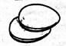
- Clean boys and girls wash their .................... after visiting the toilet.
(face, legs, hands)
- Kapu has dirty hands. His hands contain.........................
(germs, soap, water)
- When we are in the toilet, we should not............................
(speak, breathe, see)
- Mwangi wants to buy meat. He should go to the..........................
(grocery, butchery, dairy)
- ............................can be bought from the bakery.
(Fish, Eggs, Bread)
- Chewing food with the mouth closed is a ...................................habit.
(good, bad, dangerous)
- Write down your favourite food
....................................
- Mostly, we take our breakfast in the ..................................
(morning, evening, afternoon)
- When served with food you should say ................................ (1mk)
(sorry, thank you, please)
- We should eat with our mouth ................................(1mk)
(closed, open)
- We buy meat from a ................................ (1mk)
(butchery, shop, kitchen)
- We buy cooked food from a ................................(1mk)
(hotel, butchery, shop)
- Say places where these foods are sold (4mks)
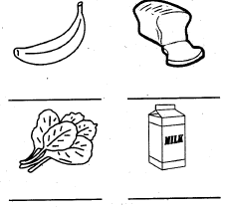
- Colour these fruits (4mks)
