COMPETENCY BASED CURRICULUM ENVIRONMENTAL AND RELIGIOUS ACTIVITIES - GRADE 2 EXAMS TERM 1 2023
ENVIRONMENTAL ACTIVITIES
- Name the animals drawn below.
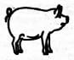
- 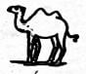
- Colour a source of sound.
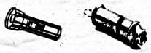
- When cleaning the compound we.......................wear on our feet.
(gloves, slippers, gumboots)
- Dry leaves lying around can make our compound...............................
(neat, clean, dirty)
- A teacher drew the cleaning items drawn below on the board.
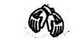
The teacher drew...............................
(hands, gloves, shoes)
- A cat feeds on...............................................
(maize, milk, rice)
- Tick the animal that alerts us on danger
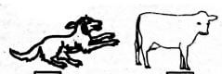
- We should water our flowers in the..........................................
(evening, afternoon, morning)
- The item drawn below is found at home.
It is a .......................................
(radio, phone, television)
- Colour the equipment used for watering chicken.
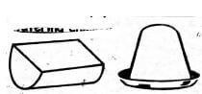
- Cleaning our classrooms is the use of water..........................................
(at home, in school, in the farm)
- Draw and colour a cat in the space provided below.
- Below is a source of water.
Name it...........................
- We can keep our homes clean using.................................
(leaves, brooms, nails)
CHRISTIAN RELIGIOUS EDUCATION
- The story of the little boy with two fish and five loaves of bread teaches Christians to....................................
(eat, fast, share)
- The earthly father of Jesus Christ was called..............................
(God, Peter, Joseph)
- Jesus was baptised by........................................
(God, John, Joseph)
- In the Bible,..........................................was hated by his brothers.
(David, Joseph, Moses)
- The Bible is divided into Old and New.........................................
(Testaments, books, sections)
ISLAMIC RELIGIOUS EDUCATION
- Before swalah, Muslims must take ......................................
(water, wudhu, Qur'an)
- Prophet Muhammad (SAW) was born in.........................
(Makka, Madina, Saudia)
- When eating our food, it is sunna to use our..............................
(hands, spoons, forks)
- Belief in angels is a pillar of..............................
(Iman, Islam, Muslims)
- Complete the following greetings: As salaam alaykum, alaykum.............................
(karim, salaam, rahim)
ANSWERS
- pig
- camel
- the whistle coloured any colour
- gumboots
- dirty
- gloves
- milk
- the dog coloured in any colour
- evening
- television
- the one on the right
- in school

- rain/clouds
- brooms
- share
- Joseph
- John
- Joseph
- Testaments

