COMPETENCY BASED CURICULUM ENGLISH LANGUAGE ACTIVITIES - GRADE 2 TERM 1 EXAMS 2023

QUESTIONS
Dictation
- _________________________________
- __________________________________
- ____________________________________
- ____________________________________
- ____________________________________
Name the following pictures
- 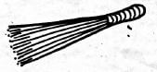
__________________________________
- ___________________________________
- 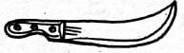
___________________________________
- 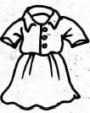
________________________________
- 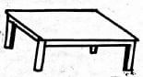
____________________________________
Fill in the missing letters
- S__ck
- g__m__
- c__rc__e
- sh__p
- tr__p
Use "this" or "these" to complete sentences
- __________________________________are our books.
- Fill in ______________________________ gap.
- _______________________________is my school.
- _______________________________are my brothers.
- ______________________________pet belongs to Tom.
Use the letters below to make correct words
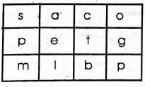
- ________________________________
- ______________________________
- ________________________________
- _______________________________
- _________________________________
Read the following story and answers questions.
Jim is a boy. Lena is a girl. they like playing outside the house. Jim has a tin and Lena has a jug. They fill them with sand.
- ___________________________is a boy.
- __________________________is a girl.
- Where do Jim and Lena play?________________________________
- Lena has a _______________________________________
- Draw a tin

Marking Scheme

- broom
- bottle
- hatchet
- dress
- desk
- sick
- game
- circle
- ship/shop
- trap
- These
- this
- This
- These
- This
- pet / met / bet / set
- mice / ice
- got / pot
- cat / tap / pat
- sac
- Jim
- Lena
- outside the house
- jug
- ...

