COMPETENCY BASED CURICULUM ART & CRAFT / MUSIC ACTIVITIES- GRADE 2 TERM 1 EXAMS 2023

QUESTIONS
ART & Craft / Music Activities
ART & CRAFT
Draw the following lines
- Curved line

- Straight line

- Wavy line

- Zigzag line

- Diagonal line

Music Activities
- "oh God is good" x 2 is a __________________________song.
- "Ee _________________nguvu yetu."
- This is a musical instrument. It is called a___________________________
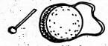
- This is a ___________________________costume.
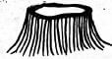
- Draw a shaker.

