COMPETENCY BASE CURICULUM INTEGRATED LEARNING AREAS - GRADE 2 TERM 1 EXAMS 2023

QUESTIONS
ART AND CRAFT ACTIVITIES
- We can feel texture by_______________________________
(Touching, tasting, seeing)
- Write two things we use when colouring pictures.
  - _______________________________
  - ______________________________
- Circle the word that does not describe texture____________________________
(Rough, far, smooth)
- ______________________________is used for cutting papers.
(Scissors, pencils, rubber)
- We decorate fabrics to make them_______________________________
(clean, dull, beautiful)
- Colour the picture below.
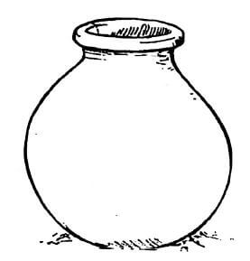
MOVEMENT ACTIVITIES
- Observe
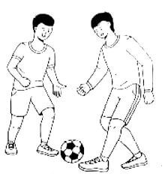
Which game are the boys playing?____________________________________
- Which play item are the boys above using?____________________________ (net, ball, food)
- Which other game can you play by catching?___________________________________
- Bending and curling help us to. _________________________________(Balance, fall, jump)
- Colour the picture below.
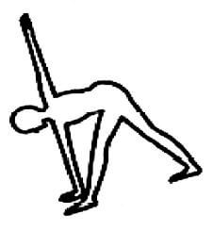
- Practical activity
With the help of your teacher, perform the activity in number 5 above
MUSIC ACTIVITIES
- Name two places where the National Anthem is sung.
  - _________________________________
  - _________________________________
- Draw an instrument played by hitting.
- We play______________________________in a singing game.
(Cartoons, games, station)
- We show that we can_______________________________when we improvise rhythms.
(dance, sing, cry)
- Colour the picture below.
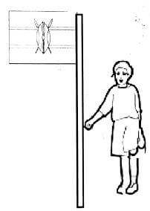

MARKING SCHEME
ART AND CRAFT ACTIVITIES
- touching

  - paper
  - colour pencils
  - pencils
  - crayons
- far
- scissors
- beautiful
MOVEMENT ACTIVITIES
- Soccer / Football
- ball
- rugby
- jump
MUSIC ACTIVITIES
- School assembly
National gatherings
- A drum
- games
- sing

