Kenya Certificate of Secondary Education

451/1 - COMPUTER STUDIES – Paper 1
FORM 4 (THEORY)
2½hrs

MARKING SCHEME
- (a) Computer memory determines the processing power of a computer. State the memory capacities of the following computer generations (1mark)
- First Generation – 2KB
- Third Generation - 2MB
b) State the storage devices used by the generations named in (a) above. (1mark)
- First Generation – Magnetic drum memories.
- Third Generation - Magnetic Disks

- Differentiate between dedicated computers and special purpose computers. (2 marks)
A Dedicated computer is a general-purpose computer that is committed to some processing task; though capable of performing a variety of tasks in different application environments. E.g., the computer can be dedicated to carrying out Word processing tasks only. A special-purpose computer is designed to handle/accomplish a particular specific task only. Such computers cannot perform any other task except the one they were meant to do. Therefore, the programs which are used in a special-purpose computer are fixed (hard-wired) at the time of manufacture.

- a. Explain computer output on microform COM. (1 marks)
This is the process of transforming digital data produced by the computer into human-readable form & recording it in reduced physical size into a photographic film. This method of output provides photographed type of computer output stored as microscopic filmed images into the microform.
b. state two forms/ classes of microforms. (2 marks)
- The Microfilm, which is a film reel of 16mm.
- The Microfiche - a rectangular shaped sheet of film, measuring about 10 x 15 mm.

- a). State one limitation of a parallel port and one limitation of a serial port as used in computer interfacing. (2 marks)
Parallel port – Limited to short distance
-Expensive
Serial port – Limited to transmission rate(slow).
b). State two advantages of using firewire over USB cables. (2 marks)
firewire enables transmission of multimedia type of data
firewire has high transmission rate compare to USB
- Apart from use of carpets, suggest three possible solutions to dust in a computer room.
(3 marks)
- Use of curtains
- Regular cleaning
- Blowing
- Control entry into the lab in shoes
- Explain how the mouse can be used to perform the operations listed below
- Selecting objects and commands
Moving the mouse pointer over the object then pressing the left mouse button once
- Opening files and folders
By double clicking (pressing the left mouse button in two quick successions) over the file/folder
- Invoking context menus
By right clicking (pressing the right mouse button once) over the object/ area

Method @ 1 Mark
Total = 1 Mark X 3
= 3 Marks
- A computer system is composed of several microchips, each having different functions in the operation of a computer.
- BIOS- basic input output devices
- State any one function of the BIOS chip
- POST - Test the computer hardware and make sure no errors exist before loading the operating system. Additional information on the POST is available on our POST and beep codes page.
- Bootstrap Loader - Locate the operating system. If a capable operating system is located, the BIOS will pass control to it.
- BIOS drivers - Low-level drivers that give the computer basic operational control over your computer's hardware.
- BIOS setup or CMOS setup - Configuration program that allows you to configure hardware settings including system settings, such as computer passwords, time, and date.
Or any other correct response
Function @ 1 Mark
- Describe the cold booting process
Cold booting is a situation whereby the computer was originally off and is switched on by pressing the power button on the system unit.
During cold booting, the computer starts by checking all its components to determine whether they are properly connected, functioning correctly and whether they are available for use. This process is called Power – on – self – test (POST).
When the POST is over successfully, the computer loads the operating system which allows the user to start using the computer.
- Due to the risks involved in using the traditional classroom teaching method during this covid-19 period, many schools have embraced online teaching methods. Describe the teaching methods listed below
- Distance learning
This is where the teacher and the learner has no physical contact. The teacher prepares learning materials and sends to the student to download and learn at his own pace and schedule. Exams and certifications are also done online.

Description @ 1 Mark
- Interactive learning
This is whereby the students are in a centralized location while the teacher is at a different location. They are both connected via multimedia devices for interactive communication while seeing each other

Description @ 1 Mark

- In a calculation, the actual result obtained was 0.7649326 but the computer presented it as 0.764.
- With reference to data processing, identify the type of error above and state how it can be minimized

Truncation error
Error @ 1 Mark

- Distinguish between Sequential file organization and indexed Sequential file organization
Sequential file organisation
Sequential file organisation means that records are stored sequentially, one after the other. Records stored using sequential file organisation normally are stored in ascending order or descending order, based on the value in the key field.
Indexed file organisation
Indexed file organisation is a method that uses a separate file, called an index, to record the location of a record on a storage device. An index is a file that consists of a list containing the values of one or more fields and the corresponding disk address for each record in a file.
Difference @ 2 Marks

- State two circumstance which may prompt a teacher to use computer simulations when teaching in a school. (2 marks)
- Teach dangerous content.
- Teach complex content.

- Multiuser Operating System- Operating system which allow CPU to facilitate many users simultaneous.
- State two ways in which operating system manages memory in a computer system.
-Allocate and de-allocate memory spaces to files, programs & processes.
-Ensure that one’s process does not use memory allocated to another process.
-Ensure that each program has enough memory to execute processes.
- State three reasons why system maintenance is necessary in system development life cycle (SDLC).
-Fix and eliminate errors
-Make system better in carrying out its functions
-Enable system to adapt to new changes and circumstances
-To maintain system efficiency.
-To satisfy user expectation
-To accommodate current technological development.

- Table 1 and Table 2 are related tables in a database. Use them to answer the questions that follow.
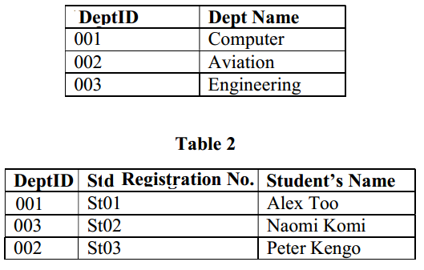
- State the names of the fields shown in table 2 above;
- DeptID - Forein key (1 mark)
- Std Registration No – Primary key (1 mark)

- State two reasons for adding DeptID field in Table 2 above. (2 marks)
- Create relationship between tables
- Easy update of record in different tables- changes made in any table are updates on all the others within the database
- Used to enforce referential integrity
- Prevent users from deleting records in different tables
- Explain the meaning of the term bookmark feature as used in when accessing the internet. (2 marks)
-Saved shortcut that directs a browser to specific web page previously viewed for easy access of favorite location on a web.
- (a) Explain the meaning of the term pseudocode as used in program development.
Set of English statement used to describe an algorithm.
(b)State the function of the following language translators during program development.
(i) Interpreter (1 mark)
Convert each line of high level programming codes to machine codes
(ii) Compiler (1 mark)
Convert the entire source code to HLL at once to machine code before execution.
(c)State the stage of program development in which:
- a flowchart would be drawn (1 mark)
-program design
- the program runs as intended and performs as required. (1 mark)
-program testing
- the user guide would be written (1 mark)
-documentation
- a programmer seeks to better understand the problem. (1 mark)
-problem recognition
(d)A bookshop owner contracted a programmer to design a program that can be used to manage n number of books in his business as follows;
- Enter the book name, publisher and marked price of each book.
- Calculate the discount and new price of each book.
The book shop gives a discount of 13% for purchase of a books worth Ksh.5, 000, 8% for purchase of books worth Ksh.1000 and none for purchase worth Ksh.1,000 and below.
Draw a flowchart to represent the information above, count number of books and output book name, publisher, marked price, discount and new price. (7 marks)
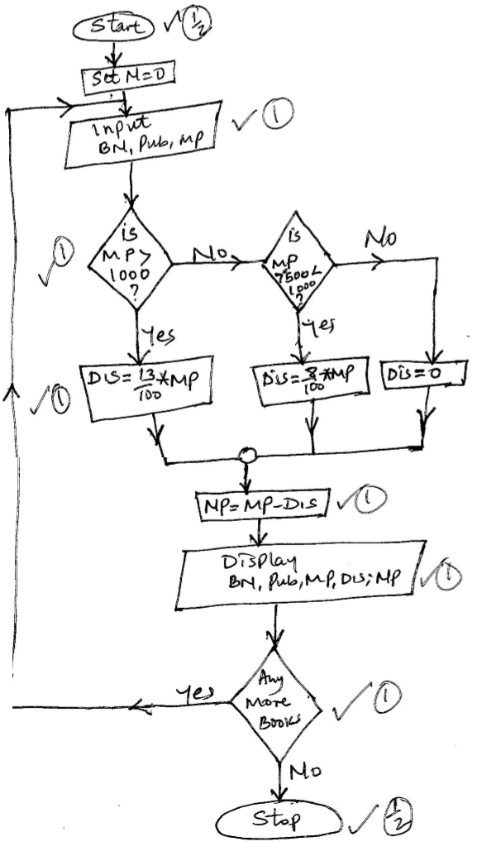
- ( a) XYZ company is facing challenges with their current information system hence need for a new application software that could solve their problems. The management has assigned the ICT department to develop their own software.
- Define the term In-house developed programs
These are programs developed and designed for a specific person/ organisation and therefore they cannot be used by anyone else except the owners of the software who have all the rights over the software.

Definition @ 1 Mark
- State any two advantages and one disadvantage of In-house developed programs
Advantage
- The solutions it offers give the greatest depth, and flexibility possible in meeting the needs of an organisation.
- The software developer delivers and installs the software and trains the end users in the use of the new software.
- They perform tasks that the general purpose software cannot perform.
- This kind of software can be quickly changed when the needs of the organisation change, since the source code belongs to the company.
Disadvantages
- The costs of developing the software, on-site installation, support and training are often high.
- It takes time to acquire the information necessary and to write the code of the new software.
- High possibility of undetected errors;
Or any other correct response
Advantage/ Disadvantage @ 1 Mark
Total = 1 Mark X 3
= 3 Marks
- Data communication is known to have greatly changed the way people exchange and access information around the world.
- Define the term topology as used in data communication
Topology refers to how the computers are connected together. This can also be referred to as the network configuration.

Definition @ 1 Mark

- Distinguish between the terms listed below
Data switching and packet switching

Packet switching
This is a data transmission technique which involves transmitting and routing of data as packet segments sent rapidly and sequentially over a communication channel.

Circuit switching
A method of communicating in which a dedicated communications path referred to as a circuit or channel is established between two devices through one or more intermediate switching nodes before communication between the devices takes place.
Difference @ 2 Marks
Half duplex and full duplex mode of data transmission
- Half-Duplex: Each device can both transmit and receive, but not at the same time. When one device is sending, the other can only receive, and vice versa

- Full-Duplex (Duplex): Both devices can transmit and receive simultaneously. Signals going in either direction share the capacity of the link.

Difference @ 2 Marks

- Identify the ICT personnel responsible for each of the following duties in an organization.

- Ensuring up-to-date maintenance of ICT records (1 mark)
Computer operator
- Identify and fixing security loopholes (1 mark)
Data security analyst/network administrator
- Testing and debugging program (1 mark)
Computer programmer
(d)State the function of each of the following keyboard keys in a keyboard.
(i) tab key – move cursor at set intervals in a document
(ii)Space bar (1 mark)
Use to create space between words and characters when typing
(iii)Delete key (1 mark)
Erase characters from left to right one by one

18. (a)(i) Distinguish between real time and online data processing. (2 marks)
A Real-time system is capable of processing data so quickly such that the results (output) produced are able to influence, control, or affect the outcome of the activity or process currently taking place. In a Real-time data processing system, the computer receives & processes the incoming data as soon as it occurs, updates the transaction file, and gives an immediate response that would affect the events as they happen.
In online processing, data or the input transactions are processed immediately they are received to produce the information required. Online processing occurs when the transactions are processed to update (or make any change in) a computer file immediately after the transactions occur. In online processing, all the Input/output facilities, and communication equipment are under direct influence of the central Processor.
(ii). Explain the significance of the following types of files to a business (3 marks)
- Backup – for security purposes
- Master – permanent storage of records
- Archive – keeping historical records for future reference
(b)Explain two benefits of displaying information in a computer system using a monitor.
- Display information almost instantaneous.
- Reduce cost
- Screen can be adjusted (Zoom)
- User verify work before producing hard copy
(c) Explain the purpose of each of the following in system implementation stage.
(i) file conversion (2 marks)
Changing data from its current format to the one that can be operated with the new system. Data is copied from the old system to the new system.
(ii)Staff training (2 marks)
Teaching the staff how to operate the system in order to familiarize themselves on how to operate the new system.
(d)State how data in a computer system is secured using;
- Antivirus (1 mark)
Clean, delete quarantine and block malicious programs in a computer system.

- Password (1 mark)
Restrict access into a computer system
19. a. Describe any three human computer interfaces (3 marks)
-GUI – Graphical user interface
This is an interaction between the user & computer that involves issuing of commands to the computer by activating certain small graphic images displayed on the screen called Icons. To issue a command, the icons can be selected using a pointing device like a Mouse. GUI is mostly found on Workstations or PCs fitted with graphic adapters able to support high-resolution graphics.
-MDI – Menu Driven Interface
-This type of interface provides the user with a list of program commands displayed on the screen to choose from & a simple means of selecting between them. To activate a choice in the menu, one can use the Enter key, or move the cursor until it is positioned at the desired choice & then press the activation key so that the system can start acting upon the information given.
-CLI/CDI – Command Line Interface/ Command Driven Interface
This is an interaction between the user & the computer that requires the use of commands. The user types a command at the prompt found on a command line. The computer then reads instructions from the command line and executes them.
b. Explain four uses of computers in land survey. (4 marks)
- Keeping a database of land maps
- Computer assisted graphical drawings of land maps
- Expert systems to determine land topology
- Online Identification of land numbers, ownership and titles
- Explain the following types of errors as found in ms excel. (2 marks)
- #NUM!

This occurs when a problem occurs with a number in a formula or function. E.g., Entering a formula that produces a number to a number that is too large or too small to be represented in Ms-Excel.

Suggested action
- Change the formula so that its result is between – 1*10³⁰⁷ and 1*10³⁰⁷.

- #VALUE!

The #VALUE error value occurs when the wrong type of argument or operand is used.

ii. Outline four cell referencing methods giving examples. (3 marks)
- label cell referencing e.g. HOME
- mixed cell referencing e.g. D$4
- relative cell referencing e.g. D4
- absolute cell referencing e.g. $D$4
(d)State a situation when each of the following Desktop Publishing program features may be used when creating a publication.
- Layout guides ; (1 mark)
Used when positioning an object accurately on a page
- Layering; (1 mark)
Technique used to tie together many parts of a page creating a sense of page harmony.
- Bring Forward; (1 mark)
Bring the selected object forward so that it is hidden by fewer objects that are in front of it.
- (a)Bob was advised to format a hard disk for a computer. Explain two circumstances which may prompt a technician to format a hard disk in the computer room. (4 marks)
-when it contains unwanted files
-when files are corrupted by viruses
To enable the operating system recognize and access the disk
When the disk is full and a user would want to store new data
(b)Explain a situation when each of the following Word Processing program may be used when creating a document.
(i) Wrap text (2 marks)
Used when surrounding a graphic with text and pacing a graphic behind of in front of text.
(ii)Watermark (2 marks)
User to insert a text behind a document on a page and use to indicate that a document is to be treated in a certain way.

(c)Perform the binary arithmetic:
1101₂ + 101₂ - 1001₂ and convert the answer to decimal notation (3 marks)
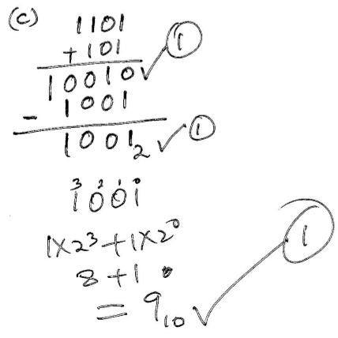………………………………………………………………………………
(d)Using 6- bit ones complement perform the arithmetic operation; (4 marks)
11011₂ -23₁₀
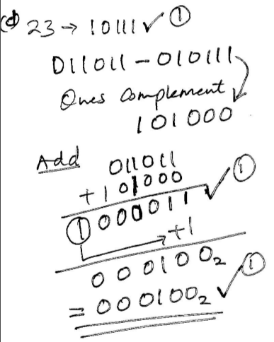………………………………………………………………………………………………………
THIS IS THE LAST PRINTED PAGE

