Term 1 - 2023
COMPUTER STUDIES
(MARKING SCHEME )
FORM TWO
Name: …………………………………………………………. Adm No: ……………….
Class: …………………..
Signature: …………………………………………………….. Date: ……………………
- Using a diagram to describe the following
- Digital data
- Digital data is discrete in nature
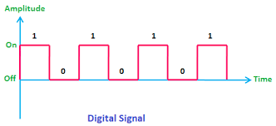

- Analog data
- Analog data is continuous in nature
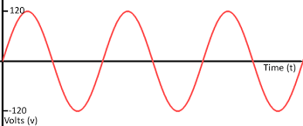
Award 1 for description and 1 mark for the diagram max 4
- The line of text in the box was created using Word processor. The cursor position is between the words “so” and “as”
Ensure that cables in the computer laboratory are properly insulated so as to eliminate the dangers of electric shock to the user

Describe what happen to the text in the box above when each of the following keyboard keys are pressed
- Enter
- All the line of text from the word “as” will move to the next line
- Tab
- All the line of text from the word “as” will be pushed forward creating a wide space between the word “so” and “as”
- End
- The line of text will remain the same
Award 1mark each max 3

- What is a warranty
- Warranty is an agreement the buyer and the seller that spells out terms and condition of after selling a product in case of failure or malfunction
Award 1 mark each max 1
- Give three content of a good warranty
- Scope of coverage
- Callout response and liability agreement
- Preventative maintenance
Award 1 mark each max 3
- State the standard unit for measuring computer speed, memory and monitors size
- Speed - Hertz
- Memory- Byte
- Monitor Size- Inches
Award 1 mark each max 3

- With reference to speed, size, cost and charge leakage compare static RAM and Dynamic RAM
Features | SRAM | DRAM
Speed | Faster | Slower
Size | Smaller | Larger
Cost | Expensive | Cheap
Charge leakage | Charge leakage property absent therefore does not require refreshing | Charge leakage property present therefore require refreshing
Award 1 mark each max 4
- Mention four characteristics of Gas plasma Display monitor
- Has high resolution
- Light, hence portable
- Expensive
- Produces a low amount of radiation
- Occupies less space
Award 1 mark each max 4
- List four ways in which ICT can be used to enhance security in a supermarket
- Install alarming system for warnings and notifications
- Biometric systems to restrict entry
- Use swipe card to grant access to restricted rooms
- Install CCTV camera for monitoring and surveillance
Award 1 mark each max 4
- State four health issues that could arise from prolonged use of computers or use of unsuitable furniture
- Repetitive Strain Injuries
- Headache
- Backache
- Eye strain
Award 1 mark each max 4

- Identify the device shown below
- Magnetic stripe Recognition/Reader

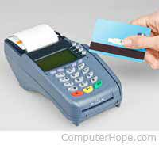
Award 1 mark max 1
Figure 1
- Give four areas where the technology in 9(a) above is mostly used
- In Bank at the ATM for cash deposit and withdrawal
- Used in Supermarkets for settling bills at the EPOS
- Used at the parking lots to raise the barriers
- Used to open doors of restricted rooms
Award 1 mark each max 4
- State four output devices found in an ATM machine
- Monitor
- Speaker
- Printer
- Cash dispenser tray
Award 1 mark each max 4
- Use the table below to classify the devices in the table as input or output devices
 | Devices | Category (Input/Output)
1 | Touchscreen | Input
2 | Projector | Output
3 | Interactive Whiteboard | Input
4 | Digital Camera | Input
5 | Microphone | Input
Table 1
Award 1 mark each max 5

- State four ways in which computers could be used in each of the following sectors other than ensuring maximum security
- Transport sector
- Computer based system are used to control traffic lights
- Navigation softwares are use drivers to locate places
- Computerized systems support booking and reservation
- Computer programs are used to prepare transport schedules
- Tracking system is used a tool of management
Award 1 mark each max 4
- Retail shops
- Advertisement using the internet or smart displays
- E-commerce
- Keeping records or books of accounts using computer programs
- Communication to the customers via whattapps, email and sms
- Computer support electronic payment platforms
Award 1 mark each max 4

- List four softcopy output devices
- Light Emitting Diodes
- Projector
- Monitor
- Speaker
Award 1 mark each max 4
- Identify the most appropriate output devices for the production of each of the following
- Receipts and Invoices
- Dot Matrix/Daisy wheel
- Architectural and Engineering drawings
- Plotter
- Output for visually impaired person
- Braille Output
- Letters, memos and notices
- Laser printer/inkjet
Award 1 mark each max 4

Award 1 mark each max 3

