ASUMBI GIRLS HIGH SCHOOL
POST -MOCK 1
AUGUST/SEPTEMBER
2022

CHEMISTRY PP3 MS

Table 1
 | 1 | 2 | 3
Final burette reading(cm³) | 24.5 | 24.5 | 24.5
Initial burette reading (cm³) | 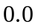
Volume of acid used (cm³) | 24.5 | 24.5 | 24.5

Marking
- Complete table award; ✓
- Decimal consistency; ✓
- Accuracy 0.1;✓
- School value; ✓
Principles of averaging:
Average volume = 24.5 + 24.5 + 24.5 = 24.5; ✓ (½ mark)
3
= 24.5 cm³; ✓(½ mark)

(a) Moles of sodium hydroxide used
Molarity of solution:
Moles = Mass /litre
RMM
= 4 = 0.1molar
40
If 1000 cm³ → 0.1mole
Then 25 cm³ → 25 x 0.1 = 0.0025 moles;
1000

(ii) Moles of hydrochloric acid
NaOH_{(aq)} + HCl_{(aq)} → NaCl_{(aq)} + H₂O_{(l)}
Mole ratio = 1:1;
Thus moles of acid = 0.0025 moles;

(iii) Molarity of acid.
Volume of acid reacting = average titre in (a) e.g. 24.5 cm³
If 24.5 cm³ → 0.0025 moles
Then 1000 cm³ → 1000 x 0.0025 = 0.1020 molar;
24.5

Table II
Marking:
Complete table ✓ - 1mark
Decimal consistency ✓- 1 mark
Accuracy ✓ - 1mark
School value ✓- 1mark
Expected titre = 28.3 cm³

(c) Average volume
28.3 + 28.3 + 28.3 = 28.3 cm³
3
All 3 values within 0.1 of each other and used – 1mark
Only 2 within 0.1 of each other and used – ½ mark
Inconsistent value used – 0 mark

(d) Answer in (b) (iii) x average volume
1000
Example:
Molarity of the acid calculated in (b) (iii) = 0.102 molar.
Thus 1000 cm³ → 0.102 moles
28.3 cm³ → 28.3 x 0.102 = 0.0028866 moles;
1000

(e) (i) Moles of carbonate that reacted:
Using mole ratio, 2 moles of acid reacts with 1 mole of carbonate
Thus moles of carbonate reacting = answer in (d) x 1
2
Example:
2 moles of acid → 1 mole of carbonate
Thus 0.0028866 moles of acid → 0.0028866 x 1
2
= 0.0014433 moles;

(ii) Molarity of carbonate
25 cm³ of carbonate → 0.0014433
Then 1000 cm³ → 1000 x 0.001443 = 0.057732 molar
25

(f) Mass of the salt mixture in gdm-3
250 cm³ → 2.5g
1000 cm³ → 1000 x 2.5 = 10g;
250

(g) Percentage of XCl in the mixture
Mass of X₂CO₃ in 1 litre
Molarity = 0.057732 molar / answer in (e) (ii).
Mass = 0.057732 x 106 = 6.119592g;
Mass of XCl = 10 – 6.119592
= 3.880408;
Percentage = 3.880408 x 100
10
= 30.80408%
Note: Use school based values.

Question 2
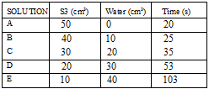

Marking:
- Complete table✓
- Decimal consistency ✓
- Trend (increasing time) ✓
- School value ✓

Graph Trend:
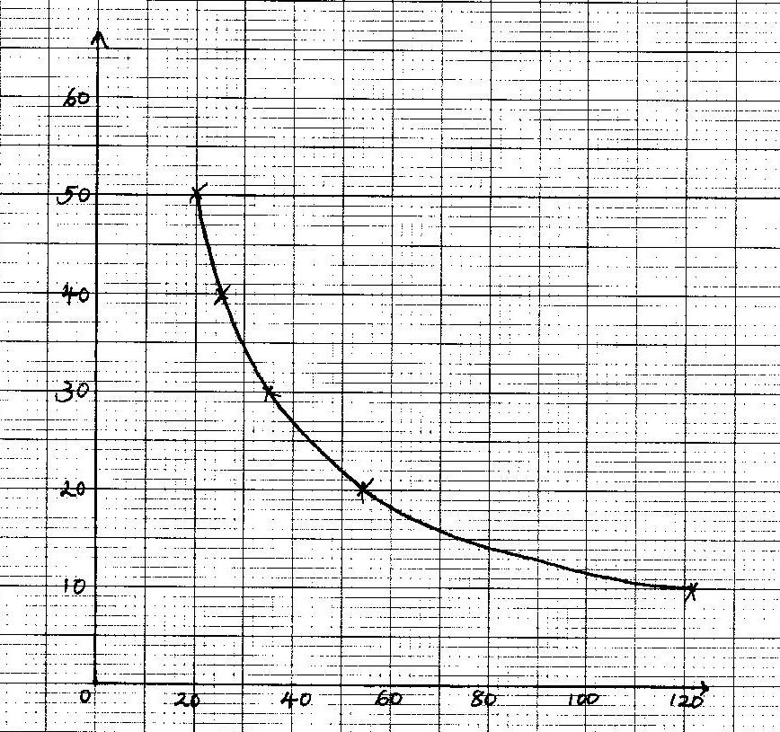
Marking:
Scale – ½ mark
Axes – ½ mark
Plotting – 1mark
Curve – 1mark

(b) As the concentration decreases ,the time increases ✓

(c) To keep the column of solution constant through the experiment ✓

Question 3 (a)
 | Observations | Inferences
(a) | Colourless gas with a pungent smell;  Gas changes moist red litmus paper blue, moist blue litmus paper remains blue | NH₄⁺ present;
(b) | Dissolves to form a colourless solution; | - Soluble salt present;  Coloured ions absent // Fe²⁺, Fe³⁺, Cu²⁺ absent;
(c) (i) | White precipitate formed | SO₄²⁻ present;
(ii) | White precipitate that persists on warming; | Cl- absent;
(iii) | - White precipitate that dissolves in excess;  - Colourless gas with a pungent smell on warming;  Colourless gas changes moist red litmus paper to blue, blue litmus paper remains blue; | Zn²⁺  NH₄⁺ present;
(e) (i) | Dissolves to forma colourless solution | Polar substance;  R – OH present;
(ii) | No effervescence | R – COOH, H⁺, H₃O⁺ absent;
(iii) | Colour of acidified potassium dichromate (VI) changes from orange to green; | R – OH present;

