Name: ……………………………………………………………………………………….Class: ………… Adm. No. ……………
School: ………………………………………………………………………………………Index No. ………………………………..
Date: ……………………………………… Sign:………………………………………..

233/2
CHEMISTRY
Paper 2
SEPTEMBER 2022
Time: 2 hours

M O K A S A II J O I N T E X A M I N A T I O N
Kenya Certificate to Secondary Education
CHEMISTRY PAPER 2
TIME: 2 HOURS

INSTRUCTIONS TO CANDIDATES
- Write your name, admission number, date and school in the spaces provided.
- Answer all the questions in the spaces provided.
- All working must be clearly shown where necessary.
- Scientific calculators may be used.

FOR EXAMINERS’ USE ONLY

Question | Maximum Score | Student’s Score
1 | 11
2 | 10
3 | 10
4 | 11
5 | 10
6 | 9
7 | 7
8 | 11
 | 80

This paper consists of 12 printed pages. Students should check to ascertain that all the pages are printed.

- Below is part of the periodic table grid. The letters do represent elements but not the real chemical symbols. Use it to answer the question that follow.

B | A |  |  |  |  |  |  | C
 | D |  |  |  | J
H | G

- Give one physical property of the elements found in the shaded area. (1 mark)
……………………………………………………………………………………………………………………………...
……………………………………………………………………………………………………………………………...
- Select an element with the lowest first ionization energy. Give a reason for your answer. (2 marks)
……………………………………………………………………………………………………………………………...
……………………………………………………………………………………………………………………………...
……………………………………………………………………………………………………………………………...
- Explain how the atomic radii of D and J compare. (2 marks)
……………………………………………………………………………………………………………………………...
……………………………………………………………………………………………………………………………...
……………………………………………………………………………………………………………………………...
- Name and explain the type of structure of the compound that would be formed when element J and B react. (2 marks)
……………………………………………………………………………………………………………………………...
……………………………………………………………………………………………………………………………...
……………………………………………………………………………………………………………………………...
- Explain how the molar heat of fusion of element B compares with that of C. (2 marks)
……………………………………………………………………………………………………………………………...
……………………………………………………………………………………………………………………………...
……………………………………………………………………………………………………………………………...
……………………………………………………………………………………………………………………………...
- Which of the ions of G, G²⁺ and G²⁻ is the most stable? Explain. (2 marks)
……………………………………………………………………………………………………………………………...
……………………………………………………………………………………………………………………………...
……………………………………………………………………………………………………………………………...
- (I) (a) The diagram below represents a set-up for the laboratory preparation of oxygen gas.
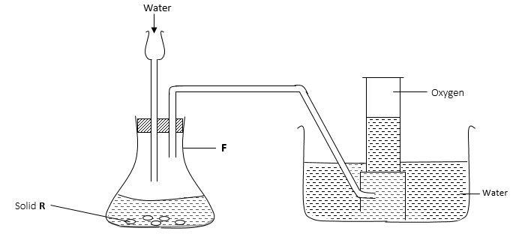
- Identify one mistake in the above set up. (1 mark)
………………………………………………………………………………………………………………………
………………………………………………………………………………………………………………………
- Write a chemical equation for the reaction taking place. (1 mark)
………………………………………………………………………………………………………………………
………………………………………………………………………………………………………………………
- State one industrial use of the product left in the conical flask F.(1 mark)
………………………………………………………………………………………………………………………
………………………………………………………………………………………………………………………
(b) Mr. Hassan had a container made up of iron in which he kept some important documents. List three precautions Hassan could have done to ensure that the container did not corrode. (3 marks)
…………………………………………………………………………………………………………………………………
…………………………………………………………………………………………………………………………………
…………………………………………………………………………………………………………………………………
…………………………………………………………………………………………………………………………………
(II) Study the reaction below and answer the questions that follow.

${Zn}_{(s)}+ {CuO}_{(s)}$ ${ZnO}_{(s)} +{Cu}_{(s)}$

- State the property of zinc that makes the above reaction possible. (1 mark)
.....................................................................................................................................................................................
.....................................................................................................................................................................................
- Give one expected evidence from the above reaction that will prove your answer. (1 mark)
.....................................................................................................................................................................................
.....................................................................................................................................................................................
- Give one application based on the above reaction. (1 mark)
.....................................................................................................................................................................................
.....................................................................................................................................................................................
- Give one reason why air is a mixture and not a compound. (1 mark)
.....................................................................................................................................................................................
.....................................................................................................................................................................................
- The diagram below is used in the manufacture of Hydrochloric acid. Use it to answer the questions that follow:
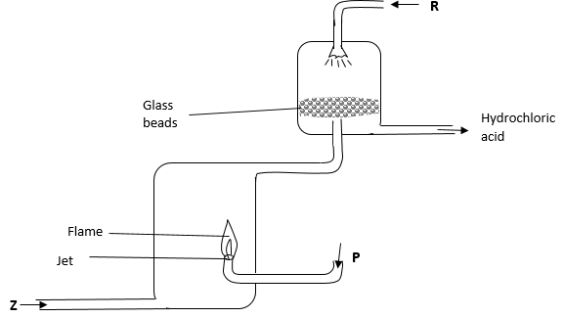

- Identify substances; (3 marks)
R ……………………………………………………………………………………………………………………
P ……………………………………………………………………………………………………………………
Z ……………………………………………………………………………………………………………………
- Why is the jet used in the set up above? (1 mark)
.....................................................................................................................................................................................
.....................................................................................................................................................................................
- Write a chemical equation to show how substance Z can be prepared in laboratory. (1 mark)
.....................................................................................................................................................................................
- State one large scale source of gas P. (1 mark)
.....................................................................................................................................................................................
.....................................................................................................................................................................................
- Write an ionic equation for the reaction that will occur if hydrochloric acid is reacted with silver nitrate solution. (1 mark)
.....................................................................................................................................................................................
.....................................................................................................................................................................................
- State the following in full. (2 marks)
(i) DDT
……………………………………………………………………………………………………………………….
(ii) CFC’s
……………………………………………………………………………………………………………………….
- Describe a test that can be carried out to identify hydrogen chloride gas.
(2 marks)
.....................................................................................................................................................................................
.....................................................................................................................................................................................
.....................................................................................................................................................................................
.....................................................................................................................................................................................
- (a) Give the IUPAC names of the following. (2 marks)
(i) ${CH}_{3}{\left({CH}_{2}\right)}_{5}{CH}_{3}$
……………………………………………………………………………………………………………………….
(ii) ${CH}_{3}{ CHClCHBrCH}_{3}$
……………………………………………………………………………………………………………………….
(b) Perspex is a synthetic polymer formed from the monomer below.

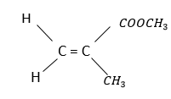

- Draw a polymer with three repeat units. (1 mark)

- A sample of Perspex has a mass of 100,000g. Calculate the number of monomers in the Perspex. (1 marks)

(c) Sodium hexandecanoate commonly known as Sawa soap is manufactured by hydrolysis of palmitic acid using sodium hydroxide as shown.
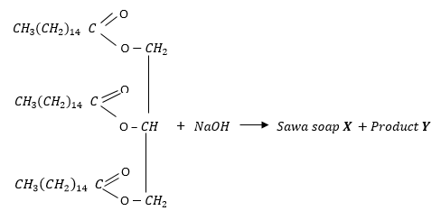
- Write the formula of the Sawa soap X and the product Y. (2 marks)

Sawa soap X | Product Y

- Draw and name two possible isomers of butanoic acid. (2 marks)

Structure
Name

(d) Compounds A and B have the same molecular formula$\left(C_{3}H_{6}O_{2}\right)$. Compound A liberates carbon (IV) oxide on addition of a sodium carbonate solution while B does not. Compound B is formed when an alkanol reacts with an alkanoic acid. Draw the possible structures of A and B. (2 marks)
A | B
- Study the scheme below and use it to answer the questions that follow.
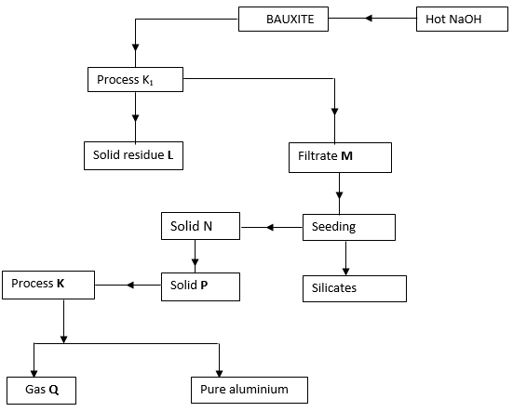

- Identify;
Solid residue L ……………………………………………………………………. (1 mark)
Solid P ……………………………………………………………………. (1 mark)
Gas Q ……………………………………………………………………… (1 mark)
- Write the equation for the reaction taking place in the formation of solid P from solid N. (1 mark)
.....................................................................................................................................................................................
.....................................................................................................................................................................................
- Name the substance added to solid N before process K takes place. (1 mark)
.....................................................................................................................................................................................
- State the negative effect of evolution of gas Q in process K. (1 mark)
.....................................................................................................................................................................................
.....................................................................................................................................................................................

- An aluminium manufacturing factory runs for 24 hours. If the total mass of aluminium produced is 27000kg. Calculate the current used.
(1 Faraday = 96500Cm Al = 27.0) (3 marks)

- State one use of Aluminium. (1 mark)
.....................................................................................................................................................................................
.....................................................................................................................................................................................
- (a) Define the term solubility of a salt. (1 mark)
.....................................................................................................................................................................................
.....................................................................................................................................................................................
.....................................................................................................................................................................................
(b) The table below shows the solubilities of two salts Q and Pat different temperatures.

Temperature (⁰C) | Type of salt  Q | 10 | 20 | 30 | 40 | 50
 |  | 15.0 | 20.0 | 24.0 | 38.0 | 40.0
Solubility /100g of water | P | 20.0 | 25.0 | 26.0 | 36.0 | 35.0

- Name the method that can be used to separate the two salts. (1 mark)
......................................................................................................................................................................
......................................................................................................................................................................
(ii) Plot on the same axes a graph of solubilities of Q and P against temperature. (4 marks)

(iii) From the graph, determine;
I. The temperatures at which solubilities are equal. (1 mark)
......................................................................................................................................................................
II. The solubility at the temperature mentioned above. (1 mark)
......................................................................................................................................................................
III. If the relative formula mass of P is 132, determine the concentration of P in moles per litre in (ii) above. (2 marks)

- (I) The diagram below shows an experiment set to investigate the properties of a flame.
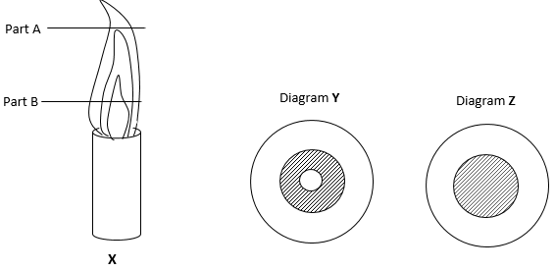
During the experiment a filter paper was placed horizontally over the flame at each of the parts A and B as shown on the diagram X. The results obtained were as shown in diagram Y and Z.

- Match the part and diagrams above. (2 marks)
Diagram | Part
Y
Z

- Name the type of flamed labelled X. (1 mark)
.....................................................................................................................................................................................

(II) A certain indicator was added to solution and a pH value of 6.5 was read.
- Name the indicator. (1 mark)
.....................................................................................................................................................................................
- State the nature of the solution. (1 mark)
.....................................................................................................................................................................................
- Why is the above indicator better than any other indicator? (1 mark)
.....................................................................................................................................................................................
.....................................................................................................................................................................................

(III) A customer defrauded a local Sacco in Kisumu and three suspects John (J), Mark (M) and Luke (L) were immediately arrested. The ink (A) in the withdrawal signature and suspects ink gave the following results.
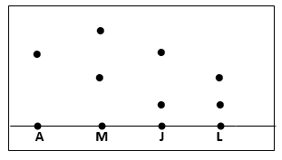
(a) Show the solvent front and base line. (2 marks)
(b) Which suspect defrauded the Sacco? (1 mark)
………………………………………………………………………………………………………………………
- The chromatography was carried out in an air tight container. Give a reason.
(1 mark)
……………………………………………………………………………………………………………………….
……………………………………………………………………………………………………………………….
- (a) Use the standard electrode potentials for elements A, B, C, D and F given below to answer the questions that follow. The letters do not represent the actual symbols of the elements.
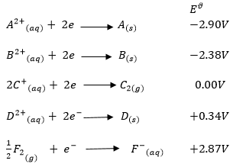
- Identify the strongest oxidizing agent. Give a reason. (2 marks)
…………………………………………………………………………………………………………………………
…………………………………………………………………………………………………………………………

- Which element is likely to be hydrogen? Give a reason for your answer.
(2 marks)
…………………………………………………………………………………………………………………………
…………………………………………………………………………………………………………………………
- Identify two half cells which when connected will produce the highest $E^{ϑ}$ value. (1 mark)
……………………………………………………………………………………………………………………………………………………………………………………………………………………………………………………
- Calculate the $E^{ϑ}$value of the electrochemical cell obtained when the half-cells of elements B and D are combined. (2 marks)

(b) Draw a fully labelled diagram to show how you can electroplate a copper coin with silver. (3 marks)

THIS IS THE LAST PRINTED PAGE

