WESTLANDS JOINT
MARKING SCHEME
CHEM PAPER 2 DECEMBER 2021
- a) The grid below represents part of a periodic table. Study it and answer the questions that follow. The letters do not represent the actual symbols of elements.
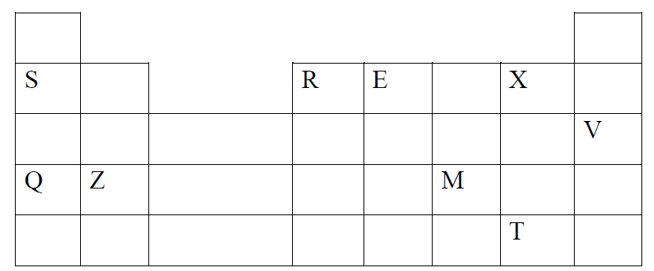
- Identify the most reactive non-metal 1mark
X

- Which of the metal sis the most reactive? Explain. 1mark

Q. has largest atomic radius, outermost electrons are loosely held hence lost easily.

- What name is given to the family of elements to which X and T belong? 1mark

Halogens

- Give reasons for the following
Ionic radius of Q is smaller than that of M 1mark

Q forms ion by losing electron hence remaining electrons are pulled more close to nucleus, M forms ion by gaining electron, the gained electron is repelled by existing electrons hence repulsive effect increases ionic radius

Atomic radius of Q is greater than that of S 1mark
Q has many energy levels than S hence a greater atomic radius than S
- Give an element that does not form compounds under ideal conditions.
Explain. 2marks
V, already is in the stable octet configuration hence does not lose or gain electron

- Give formula of compound formed between E and Z 1mark
ZE₂
b) Study the table below and answer the questions that follow.
Substance | A | B | C | D | E | F
Melting point (°C) | 801 | 113  119 | -39 | 5 | -101 | 1356
Boiling point(°C) | 1410 | 445 | 457 | 54 | -36 | 2860
Electrical Conductivity (Solid) | Poor | Poor | Good | Poor | Poor | poor
Electrical Conductivity (Liquid) | Good | Poor | Good | Poor | Poor | Poor
- Identify a substance with:
- Giant metallic structure 1mark
C
- Has a molecular structure and exists in gaseous state at room temperature
and pressure 1mark
E
- Suggest a reason why substance B has two melting points. 1mark
Its allotropic // exhibit allotropy
- Substances A and C conduct electric current in the liquid state. State how the two substances differ as conductors of electric current. 2marks
A is an ionic compound conduct in liquid state as ions are free .in solid they’re fixed. C is a metal, conduct in all states using free electrons.

- Study the flow chart below and answer the questions that follow.
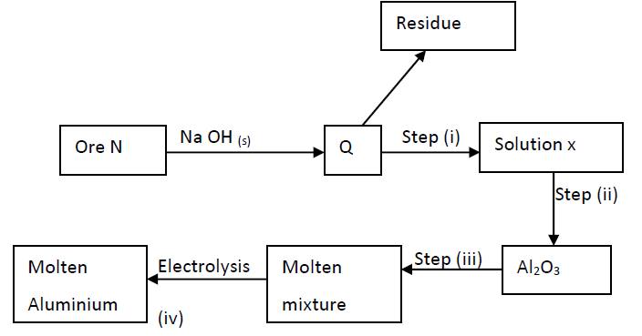
- Name ore N 1mark
bauxite
- Explain why the ore is first dissolved in excess sodium hydroxide solution. 1mark
To remove impurities of silica and iron iii oxide.
- Name the major compound present in the residue. 1mark
Iron (iii) oxide.
- Give the formula of the aluminium compound present in solution 1mark
[Al(OH)₄]²⁺

- i) Explain how to obtain aluminium hydroxide from solution X 1mark
By seeding with pure aluminium hydroxide crystals // bubbling carbon (iv) oxide into it
ii) Write equation for reaction that takes place in (e) above 1mark
2[Al(OH)₄]⁻ + CO_{2(g)} 2 Al(OH)₃ + CO₃²⁻_{(aq)} + H₂O(l)

2[Al(OH)₄] ⁻_{(aq)} Al(OH)₃ Al(OH)_{3(s)} + OH⁻_{(aq)}
iii) What is the role of cryolite in the extraction of aluminium. 1mark
added as impurity to lower melting point of aluminium oxide for electrolysis process
- Aluminium is a good conductor of electricity. State two uses of aluminium based
on this property. 2marks
used make overhead cables

- If sodium carbonate is added to aluminium nitrate solution, effervescence occurs. Explain. 2marks
Aluminium compounds easily hydrolyse releasing hydrogen ions that react with carbonate releasing carbon(iv) oxide causing effervescence.

3. Study the flow chart below and answer the questions that 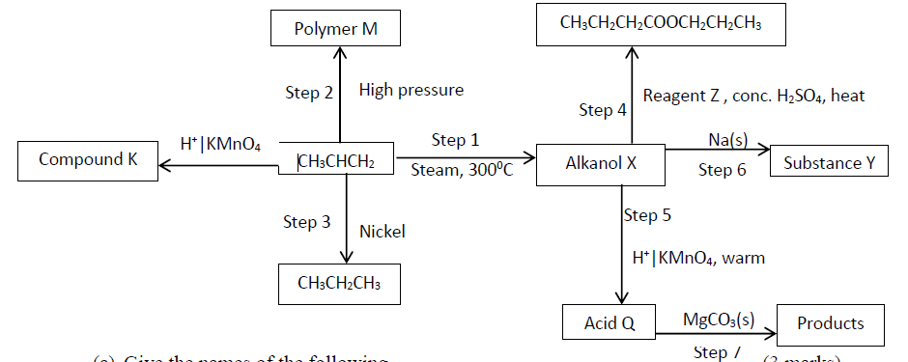follow.
- Give the names of the following
- Compound K (1mark)
…………………ethan – 1,2 -diol…………………………………
- Substance Y (1mark)
…………………sodium propoxide…………………………………………
- Product obtained in step 4 (1mark)
………………propylbutanoate…………………………………
(b) Identify the type of reaction that takes place in step 1 and give one other condition necessary for the reaction other than the temperature indicated.
Type of reaction…hydration………………………. (1mark)
Condition……pressure of 60 – 70 atm and phosphoric (V) acid as catalyst…………………. (1mark)

c)Draw the structural formula of the following
i) Polymer M (1mark)

ii) Acid Q (1mark)

d) Give the industrial application for the reaction in step 3 (1mark)
…………Hardening of liquid oil into solids in manufacture of margarine…………………
e) Write chemical equations for the reactions in step 6 and step 7 . (2marks)
Step 6 …… Na + C₃H₇OH C₃H₇ONa + H₂
Step 7
……… C₃H₆O₂ + MgCO₃ (CH₃CH₂COO)₂Mg + CO₂ +H₂O
f) The following are structures of two cleansing agents.

R SO${- \atop 3}$ Na⁺
In the table below, give one advantage and one disadvantage of each of them. (2marks)

Cleansing Agent | Advantage | Disadvantage
R-COO-Na⁺ | Biodegradable thus non – pollutant | Wastes soap, since does not lather readily with hard water forms scum
R-OSO3-Na⁺ | Does not form scum, since readily lather with hard water | Non - biodegradable thus pollutant

4. The flow chart below illustrates two industrial processes. Harber process and the contact process.
Air
D
B
Nitrogen
Haber process

Oxygen
water
Hydrogen

H₂S0₄(I)

Sulphur(VI) acid
C
Contact process
Sulphur (IV) oxide
A

(a).Name the process of obtaining nitrogen from atmospheric air. ( 1 mark)
Fractional distillation of liquid air
(b). List TWO sources of obtaining large volumes of hydrogen for industrial use.
(i) Electrolysis of acidified water ( ½ mk)
(ii)Cracking of hydrocarbons ( ½ mk)
Steam over carbon \hydrocarbon
(c) Write equation for Haber process. ( 1 mark )
N₂(g) +3H_{2(g)} 2NH_{3(g)}

Fe
(d) Name the catalysts for:
(i) Haber process Finely divided iron ( ½mk)
(ii) Contact process Vanadium (IV) oxide\platinised astestos ( ½ mk)
(e) Identify substances:
(i) D Ammonium sulphate /( NH₄)₂SO₄ ( ½ mk)

(ii) C oleum, /H₂S₂O₇ ( ½ mk)
(f) Give ONE major use of compound D ( 1 mark )
Fertilizers
(g) Write an equation for dilution of C with water. (1 mark)
H₂S₂O₇(I)+H₂O(I) 2H₂SO₄(I)
h) A farmer has three plots each measuring 0.25 acres. He applied nitrogenous fertilizers as follows.
-plot A 250 kg of ammonium phosphate
-plot B 250 kg of urea CO(NH₂)₂
- Plot C 250kg of ammonium nitrate
Which plot received the highest nitrogen content? (3 marks)
H = 1, N = 14, 0 = 16. P = 31, C = 12.
42/149*100=28.19
CO(NH₂)₂
28/60*100=46.67
28/80*100=35
CO(NH₂)₂-has a highest % of Nitrogen

5. h) A farmer has three plots each measuring 0.25 acres. He applied nitrogenous fertilizers as follows.
- Plot A 250 kg of ammonium phosphate - Plot B 250 kg of urea CO(NH₂)₂
- Plot C 250kg of ammonium nitrate -(H = 1, N = 14,O = 16, P = 31,C = 12).
Which plot received the highest nitrogen content? (3mks)
Ammonium phosphate
42 ×100% = 28.19%
149
Urea 28 ×100% = 46.67%
60
Ammonium nitrate
28 × 100% = 35%
80

Plot B Accept if kg are used instead of %.

6. Study the diagram below and answer the questions which follow.
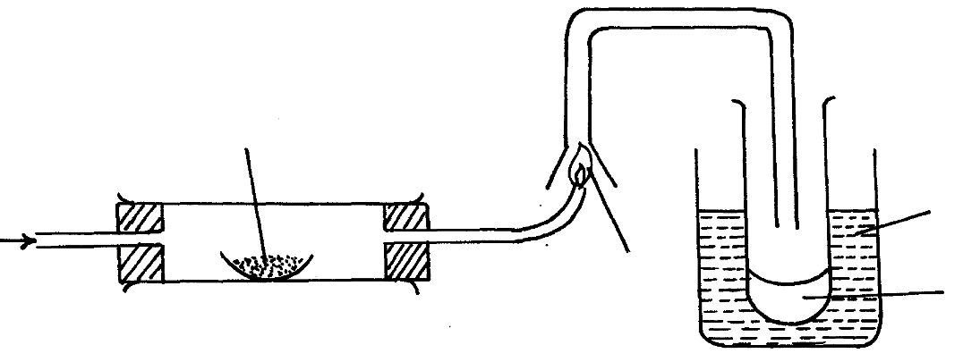
Lead II Oxide

Ice cold water
Flame
H₂

Liquid M
- State two observations made when dry hydrogen gas pass over hot Lead (II) oxide. (2marks)
- Lead (II) oxide changes colour from orange to grey.
- Droplets of a colourless liquid form on cool sides of the combustion tube.
- Write the equation for the reaction which occurs in the combustion tube. (1mark)
PbO _{(s)} + H₂ _{(g)} → Pb _{(s)} + H₂O _{(l)}
- What property of hydrogen is shown in the experiment above (1mark)
Reducing property.
(iv) Identify liquid M and describe the test for its purity (2marks)
Water, Heat liguid M to boiling while measuring the temperature. B.P of
100⁰C indicates that M is pure
- What would be observed if MgO was used instead of Lead II Oxide: Explain (2marks)
No change on MgO because H2 can not reduce MgO
(vi) What is the colour of the flame (1mark)
Blue
(vii) Write a chemical equation of the reaction producing the flame. (1mark)
H_{2(g)} +O_{2(g)} H₂O_{(l)}
(vii) Apart from hydrogen peroxide, state two other reagents that can be used to prepare oxygen gas. (1mark)
Sodium peroxide and water.
(viii) Write an equation to show how hydrogen gas is formed from the reagents chosen in (vii) above (1mark)
2Na₂O_{2 (l)} + 2H₂O _{(l)} → 4NaOH _{(aq)} + O_{2 (g)}
7.I. Use the data below to calculate the enthalpy change for the reaction below
CH_{4(g)} + 2O_{2(g)} CO_{2(g)} + 2H₂0 _{(l)} (3marks)
Bond Energy (KJ)
C – H 314
O = O 296
C = O 149
H – O 283
Ans = -418kJ/mol
II. Given the following Standard Molar enthalpies of combustion. Calculate the standard heat of formation of butane (C₄H₈). (3marks)
ΔH${θ \atop c}$ Carbon (Graphite) = -393.5KJ/mol (well drawn energy cycle - 2marks)
ΔH${θ \atop c}$ Hydrogen = -285.8KJ/mol
ΔH${θ \atop c}$ butene = -2877KJ/mol
Ans = +159.8kJ/mol
III. Use the following information to answer the questions that follow
ΔH _{lattice} MgCl₂ = -2489 kJ/ mol⁻¹
ΔH _{hydration} Mg²⁺ = - 1891 kJ/ mol
ΔH _{hydration}Cl ⁻ = -384 kJ/ mol
b) Using energy level diagram calculate the molar heat of solution of magnesium chloride. (4marks)
(well drawn energy level diagram - 3marks) Ans = - 175kJ/mol

