Name …………………………….………...…………………. Index No………….….……….……
School ……………………………………………..................... Candidate’s Signature ……...……… Date ……………..........................
233/2
CHEMISTRY
PAPER 2
DECEMBER, 2021
(THEORY)
TIME: 2 HOURS

@West practice papers-2021

Kenya Certificate of Secondary Education (K.C.S.E)
CHEMISTRY
PAPER 2
(THEORY)

INSTRUCTIONS
- Write your name and the Index Number in the spaces provided above.
- Answer ALL the questions in the spaces provided after each question.
- Use of Mathematical sets and silent calculators may be used.
- All working should be clearly shown.

FOR OFFICIAL USE ONLY
QUESTIONS | MAXIMUM SCORE | CANDIDATES SCORE
1 | 13
2 | 11
3 | 12
4 | 12
5 | 10
6 | 12
7 | 10
TOTAL | 80

This paper consists of 12 printed pages.
Candidates should check to ensure that all pages are printed as indicated and no questions are missing.
- a) The grid below represents part of a periodic table. Study it and answer the questions that follow. The letters do not represent the actual symbols of elements.
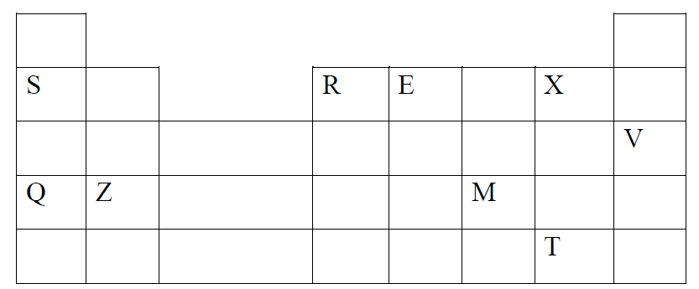
- Identify the most reactive non-metal (1mark)
……………………………………………………………………………………………………………….

- Which of the metal is the most reactive? Explain. (1mark)
……………………………………………………………………………………………………………………………………………………………………………………………………………………………………
- What name is given to the family of elements to which X and T belong? (1mark)
……………………………………………………………………………………………………………….
- Give reasons for the following
Ionic radius of Q is smaller than that of M 1mark
……………………………………………………………………………………………………………………………………………………………………………………………………………………………………
Atomic radius of Q is greater than that of S (1mark)
……………………………………………………………………………………………………………………………………………………………………………………………………………………………………
- Give an element that does not form compounds under ideal conditions.
Explain. (2marks)
……………………………………………………………………………………………………………………………………………………………………………………………………………………………………
- Give formula of compound formed between E and Z (1mark)
……………………………………………………………………………………………………………...
b) Study the table below and answer the questions that follow.
Substance | A | B | C | D | E | F
Melting point (°C) | 801 | 113  119 | -39 | 5 | -101 | 1356
Boiling point(°C) | 1410 | 445 | 457 | 54 | -36 | 2860
Electrical Conductivity (Solid) | Poor | Poor | Good | Poor | Poor | poor
Electrical Conductivity (Liquid) | Good | Poor | Good | Poor | Poor | Poor
- Identify a substance with:
- Giant metallic structure (1mark)
……………………………………………………………………………………………….
- Has a molecular structure and exists in gaseous state at room temperature?
and pressure (1mark)
………………………………………………………………………………………………….
- Suggest a reason why substance B has two melting points. (1mark)
……………………………………………………………………………………………………………..
- Substances A and C conduct electric current in the liquid state. State how the two substances differ as conductors of electric current. (2marks)
……………………………………………………………………………………………………………………………………………………………………………………………………………………………………

- Study the flow chart below and answer the questions that follow.
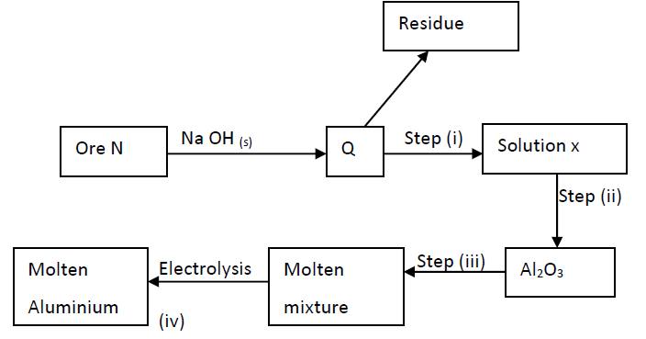
- Name ore N (1mark)
……………………………………………………………………………………………………….
- Explain why the ore is first dissolved in excess sodium hydroxide solution. (1mark)
……………………………………………………………………………………………………………………………………………………………………………………………………………………………………
- Name the major compound present in the residue. (1mark)
…………………………………………………………………………………………………………………
- Give the formula of the aluminium compound present in solution (1mark)
…………………………………………………………………………………………………………………
- i) Explain how to obtain aluminium hydroxide from solution X (1mark)
…………………………………………………………………………………………………………………
ii) Write equation for reaction that takes place in (e) above (1mark)
………………………………………………………………………………………………………………
iii) What is the role of cryolite in the extraction of aluminium. (1mark)
…………………………………………………………………………………………………………………

- Aluminium is a good conductor of electricity. State two uses of aluminium based
on this property. (2marks)
……………………………………………………………………………………………………………….
- If sodium carbonate is added to aluminium nitrate solution, effervescence occurs. Explain. (2marks)
……………………………………………………………………………………………………………………………………………………………………………………………………………………………………
3. Study the flow chart below and answer the questions that 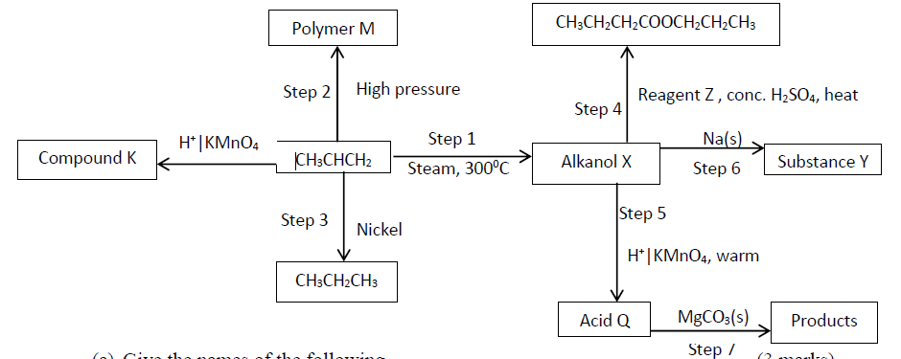follow.
- Give the names of the following
- Compound K (1mark)
………………………………………………………………………………………
- Substance Y (1mark)
………………………………………………………………………………………
- Product obtained in step 4 (1mark)
………………………………………………………………………………………
(b) Identify the type of reaction that takes place in step 1 and give one other condition necessary for the reaction other than the temperature indicated.
Type of reaction……………………………………………………………………. (1mark)
Condition………………………………………………………………………………. (1mark)
c)Draw the structural formula of the following
i) Polymer M (1mark)

ii) Acid Q (1mark)

d) Give the industrial application for the reaction in step 3 (1mark)
…………………………………………………………………………………………………………………
e) Write chemical equations for the reactions in step 6 and step 7 . (2marks)
Step 6 ……………………………………………………………………………………………………………
Step 7
…………………………………………………………………………………………………………………
f) The following are structures of two cleansing agents.

R SO${- \atop 3}$ Na⁺
In the table below, give one advantage and one disadvantage of each of them. (2marks)

Cleansing Agent | Advantage | Disadvantage
R-COO-Na⁺
R-OSO3-Na⁺

4. The standard reduction potentials for five half cells are shown in the table below. Study it and answer the questions that follow. (The letters do not represent the actual symbol of elements).
Elements E^{θ} (Volts)
(i)
(ii)
(iii)
(iv)
(v)
I (a) With a reason, identify the strongest reducing agent. (1mark)
…………………………………………………………………………………………………………..
(b) Which half-cell is likely to be hydrogen? (1mark)
…………………………………………………………………………………………………………….
(c)Write an equation for the reaction between two half cells in (ii) and (IV). (1mark)
…………………………………………………………………………………………………………….
(d) Calculate the e.m.f of the cell in (c) above. (2mark)
…………………………………………………………………………………………………………….

II The diagram below represents a mercury cell that can be used in the industrial manufacture of sodium hydroxide. Study it and answer the questions that follow:-
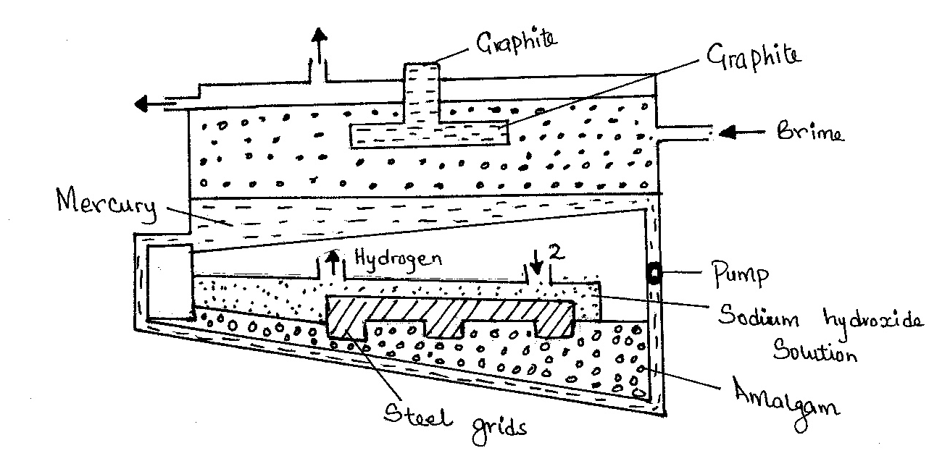

- Name:
(i)Raw material introduced at 2. (½ mark)
…………………………………………………………………………………………………………………
ii)Another substance that can be used in the cell instead of graphite. (½ mark)
…………………………………………………………………………………………………………………
(b)Identify the by-product that comes out at I. (1 mark)
…………………………………………………………………………………………………………………
(c)Write an equation for the reaction: -
(i)That occurred at the anode. (1 mark)
………………………………………………………………………………………………………………..
(ii)In which sodium hydroxide was produced. (1 mark)
……………………………………………………………………………………………………………….
(d)Give two reasons why mercury is recycled. (2 marks)
……………………………………………………………………………………………………………….
( e) State one use of sodium hydroxide ( 1mark)
………………………………………………………………………………………………………………..

5. The flow chart below illustrates two industrial processes. Harber process and the contact process.
Air
D
B
Nitrogen
Haber process

Oxygen
water
Hydrogen

H₂S0₄ (I)
C
Contact process
Sulphur (IV) oxide
Sulphur (VI) acid
A

(a). Name the process of obtaining nitrogen from atmospheric air. (1mark)
..........................................................................................................................................................
(b). List TWO sources of obtaining large volumes of hydrogen for industrial use.
(i) ………………………………………………………………………………….. (1mark)
(ii)…………………………………………………………………………………. (1mark)
(c) Write equation for Haber process. (1mark)
………………………………………………………………………………………………………………
(d) Name the catalysts for: (1mark)
(i) Haber process ………………………………………………………………………………………………….
(ii) Contact process …………………………………………………………………………………………………

(e) Identify substances: (1mark )
(i) D……………………………………………………………………………………….
(ii) C …………………………………………………………………………………….
(f) Give ONE major use of compound D (1mark)
…………………………………………………………………………………………………………………
(g) Write an equation for dilution of C with water. (1mark)
…………………………………………………………………………………………………………………
h) A farmer has three plots each measuring 0.25 acres. He applied nitrogenous fertilizers as follows.
-plot A 250 kg of ammonium phosphate
-plot B 250 kg of urea CO(NH₂)₂
- Plot C 250kg of ammonium nitrate
Which plot received the highest nitrogen content? (3marks)
H = 1, N = 14, 0 = 16. P = 31, C = 12.

6. Study the diagram below and answer the questions which follow.
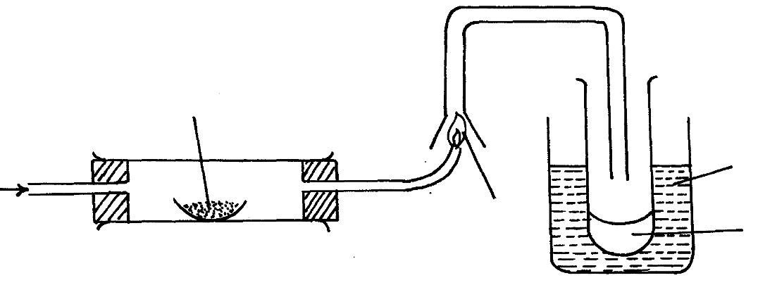
Lead II Oxide

Ice cold water
H₂
Flame
L
Liquid M

(i) State two observations made when hydrogen gas pass over hot Lead (II) oxide. (2marks)
…………………………………………………………………………………………………..….
…………………………………………………………………………………………………..…..
(ii) Write the equation for the reaction which occurs in the combustion tube. (1mark)
…………………………………………………………………………………………………..…..
(iii) What property of hydrogen is shown in the experiment above. (1mark)
…………………………………………………………………………………………………..…..
(iv) Identify liquid M and describe the test for its purity (2marks)
….……………………………………………………………………………………………………
…………………………………………………………………………………………………..…..
(v) What would be observed if MgO was used instead of Lead II Oxide: Explain (2marks)
….…………………………………………………………………………………………………….
…………………………………………………………………………………………………..…..
(vi) What is the colour of the flame (1mark)
…………………………………………………………………………………………………..…..
(vii) Write a chemical equation of the reaction producing the flame. (1mark)
….……………………………………………………………………………………………………
(vii) Apart from hydrogen peroxide, state two other reagents that can be used to prepare oxygen gas. (1mark)
…………………………………………………………………………………………………..….
(viii) Write an equation to show how hydrogen gas is formed from the reagents chosen in (vii) above. (1mark)
…………………………………………………………………………………………………..…..
7.I. Use the data below to calculate the enthalpy change for the reaction below
CH_{4(g)} + 2O_{2(g)} CO_{2(g)} + 2H₂0 _{(l)} (3marks)
Bond Energy (KJ)
C – H 314
O = O 296
C = O 149
H – O 283

II. Given the following Standard Molar enthalpies of combustion. Calculate the standard heat of formation of butane (C₄H₈). (3marks)
ΔH${θ \atop c}$ Carbon (Graphite) = -393.5KJ/mol
ΔH${θ \atop c}$ Hydrogen = 285.8KJ/mol
ΔH${θ \atop c}$ butene = -2877KJ/mol

III. Use the following information to answer the questions that follow
ΔH _{lattice} Mgcl₂ = -2489 kJ/ mol⁻¹
ΔH _{hydration} Mg²⁺ = - 1891 kJ/ mol
ΔH _{hydration}Cl ⁻ = -384 kJ/ mol
b) Using energy level diagram calculate the molar heat of solution of magnesium chloride. (4marks)

