Name ………………………..……………………………Index No…..………………..…….
School ……………………...Candidate’s Signature……....…..….Date:……………………

233/1

CHEMISTRY THEORY

Paper 1
June – 2022

Time: 2 Hours

MUMIAS WEST SUB-COUNTY JOINT EVALUATION
EXAMINATION - 2022
Kenya Certificate of Secondary Education (K.C.S.E)

INSTRUCTION TO CANDIDATES
- Write your name, school and index number in the spaces provided.
- Sign and write the date in the spaces provided.
- Answer all the questions in the spaces provided.
- Mathematical tables and electronic calculators may be used.
- All working must be clearly shown.

FOR EXAMINER’S USE ONLY
Question | Maximum Score | Candidate’s Score
1 – 27 | 80

This paper consists of 10 printed pages.
Candidates should check the question paper to ensure that all the
Pages are printed as indicated and no questions are missing.

- Bronze is an alloy of Tin and Copper. Give one use of Bronze (1mk)

- The following setup was used to investigate some properties of two gases G and H
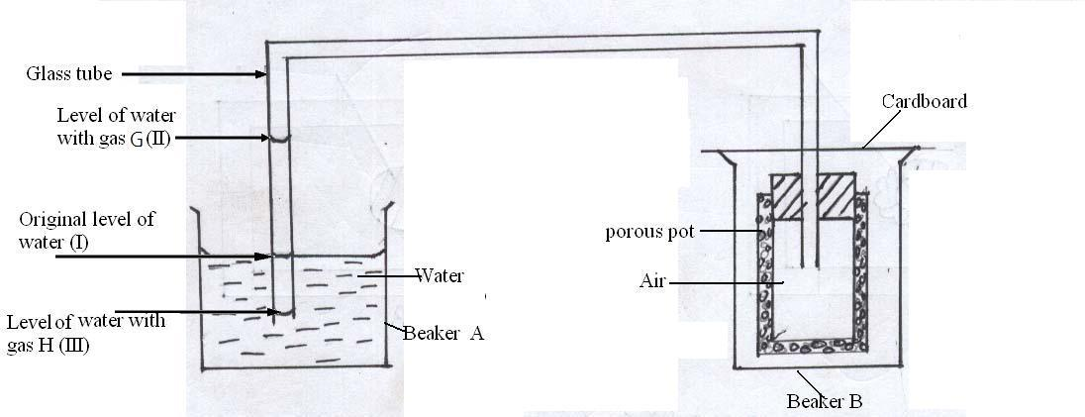
When beaker B was filled with gas G the level of water in the glass tube rose to point II. When the experiment was repeated using gas H, the level of water dropped to point III. Explain these observations (3mks)

- State the oxidation number of Manganese in
- MnO₂ (1mk)
- MnO⁻₄ (1mk)

- Chlorine can be prepared by using the following three reagents; Solid Sodium Chloride, Concentrated Sulphuric (VI) acid and Potassium Manganate (VII).
What is the role of each of the following in the reaction?

- Concentrated Sulphuric (IV) acid (1mk)

- Potassium Manganate (VII) (1mk)

- Which other reagent can be used instead of solid Sodium Chloride? (1mk)

- The set up below was used to electroplate a metallic door handle. Study it and answer the questions that follows.
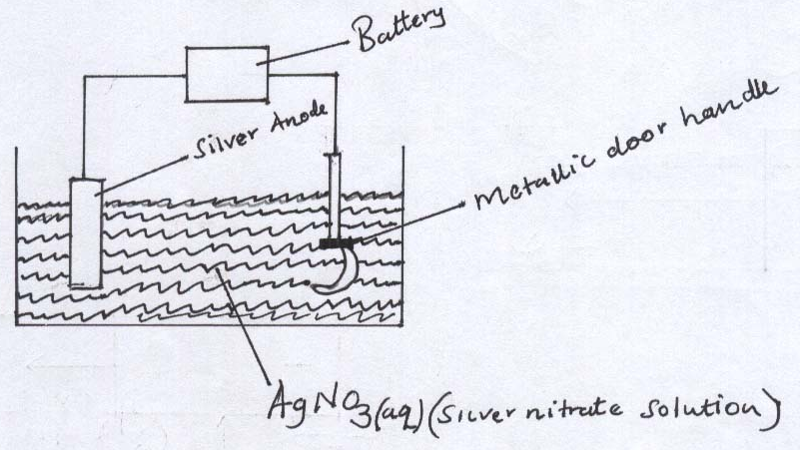
- Write an ionic equation for the reaction that occurred at the cathode. (1mk)

- State and explain what happens to the anode. (2mks)

- Patience Masafu of form II at Mumias Muslims Girls high school set up the following experiment with the help of the two laboratory assistants. Metal rods S, T, U and V were cleaned with sand paper and placed in a beaker containing water. A second set was put in a container of steam and a third set was placed in a beaker containing a dilute acid. Bubbles of gas and reactions were observed around some of the rods as shown in the diagrams below.
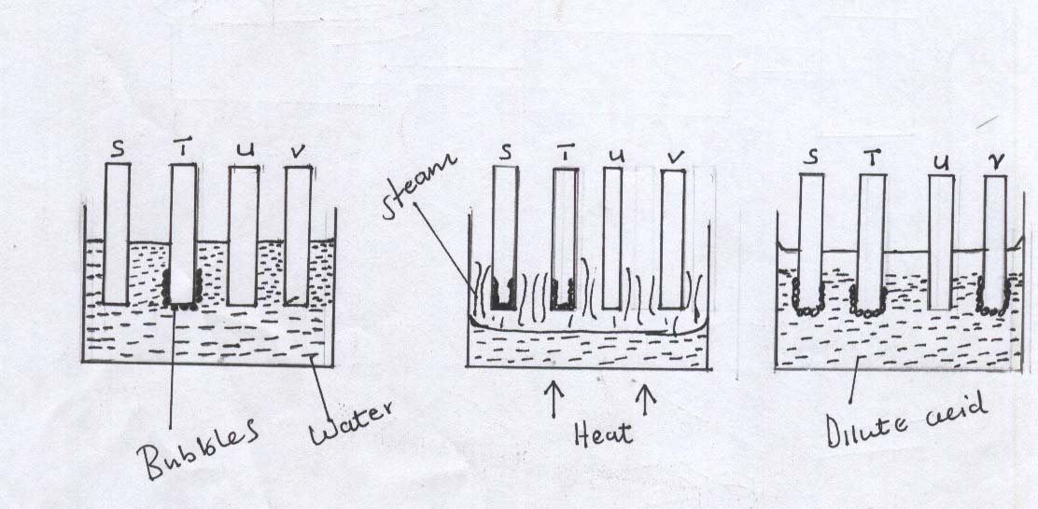
- It was very necessary to clean the rods with sand paper before dipping them. Explain.
(2mks)

- Arrange the four metals in order of their reactivity starting with the most reactive.
(2mks)

- Describe how a solid sample of Lead (II) Chloride can be prepared using the following reagents:
Dilute Nitric Acid, Dilute hydrochloric acid and Lead Carbonate. (3mks)

- Using Bronsted and Lowry theory, define the terms:
- A base (1mk)

- An acid (1mk)

- How is this different from Arrhenius definition? (2mks)

- Study the energy level diagram below and answer the questions that follow
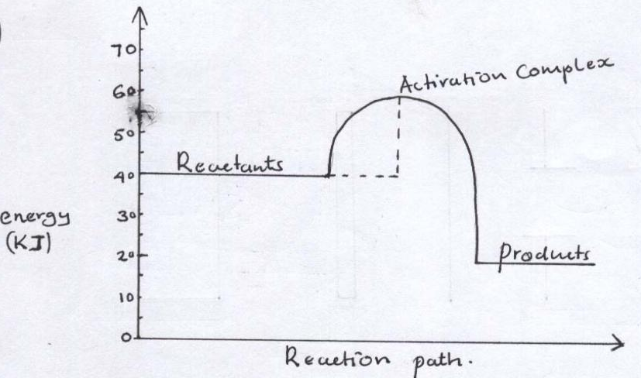
- State and explain whether the reaction represented in the diagram is endothermic or exothermic. (2mks)
- From the diagram, determine
- The activation energy. (1mk)

- Enthalpy of reaction (1mk)

- Explain why the reaction between 1.0g of Calcium Carbonate and 1M Hydrochloric acid is faster than the reaction between 1.0g Calcium Carbonate and 1M at Butanoic acid. (3mks)

- Hopson, a form four student at Mwitoti high School wanted to determine the solubility of Potassium Nitrate. He obtained the following results as shown below.
Mass of evaporating dish 15.13g
Mass of evaporating dish and solution 36.51g
Mass of evaporating dish and salt 19.41g
Use the information above to calculate the solubility of Potassium Nitrate. (3mks)

- State three factors that should be considered when choosing fuel for cooking. (3mks)

- A sealed glass tube containing air at s.t.p was immersed in water at 80⁰c. Assuming there was no increase in the volume of the glass tube due to expansion of the glass, calculate the pressure of the air inside the tube. (3mks)
(Standard pressure = 760mmHg, Standard Temperature = 273k)

- During electrolysis of aqueous Zinc Sulphate solution, a current of 0.64 A was passed through the electrolyte for 18 minutes. Calculate the volume of gas produced at the anode. (1 Faraday = 96500 coulombs, Molar gas volume is 24000cm³ at room temperature) (3mks)

- The elements shown in the table belong to a certain metallic group in the periodic table. Study the information and answer the questions that follow.
Element | Atomic size (nm)
S | 0.160
T | 0.180
V | 0.193
Define the term
- Ionization energy. (1mk)

- Which element is likely to have most ionization energy? Explain (2mks)

- Complete the diagram below to show how Alpha and Beta particles from radioactive source can be distinguished from each other. Label your diagram clearly. (2mks)
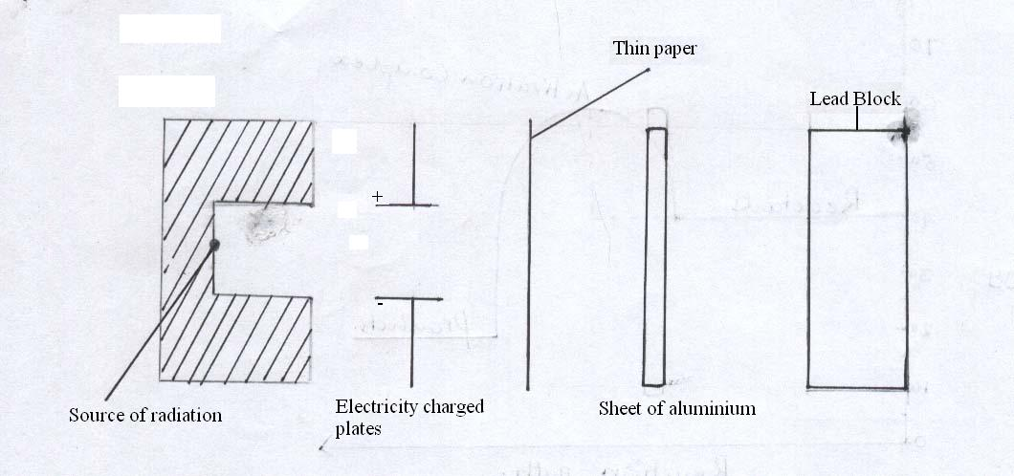
(b) The following are nuclear equations
(i)
(ii)
Identify the nuclear fission reaction. (1mk)

17. Painting, Oiling, galvanizing and or tin plating are methods of rust prevention.

a) Explain the similarity of these methods in the ways they prevent rusting. (1mk)

b) Explain why galvanized iron objects are better protected even when scratched. (1mk)

c) Write down the chemical formula for rust. (1mk)

18. a) State and explain Boyle’s law on the behaviour of gases. (2mks)

- State two conditions under which real or natural gases are likely to behave like ideal or perfect gases. (1mk)

- (a) Name the following compounds.
O
(i) CH₃CH₂CH₂C OH ……………………………………………………..(1mk)
(ii) CH₃COOCH₂CH₂CH₃ ……………………………………………………(1mk)
- Complete the following equation.
H H
C = C + O Cold dilute ……………………(1mk)
H H H⁺, KMnO₄

20. Study the diagram below and answer the questions that follow. The diagram shows the method used to separate components of mixture Q
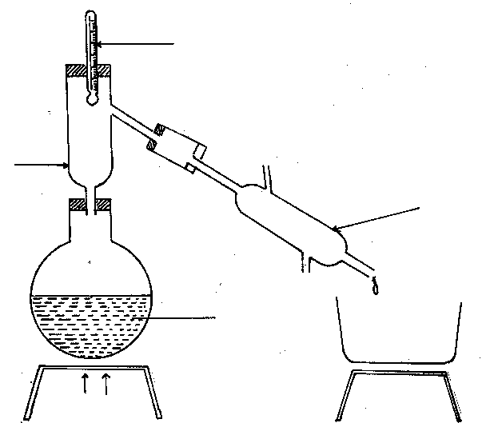
X
Y
Liquid mixture Q

Heat
Thermometer
a) Name X and Y (1mk)
X ……………………………………………………..
Y ……………………………………………………..
b) What is the purpose of apparatus X? (½ mk)

- Show the direction of flow of cold water used for cooling the vapour formed. (½ mk)

d) What name is given to the above method of separating mixtures? (1mk)

21. Explain the following observations.
a) Alkaline earth metals are generally less reactive than alkali metals. (1mk)

b) The order of reactivity increases down group I, but decreases down group VII. (2mks)

22. Describe briefly a simple test which would be used to distinguish between the following ions in the solution. Give the result of the test in each case.
a) Zn²⁺_{(aq)} and Fe²⁺_{(aq)} (1½mks)

b) CO₃²⁻_{(aq)} and SO₃²⁻_{(aq)} (1½mks)

23. The flow chart below shows laboratory preparation of chlorine gas. Study it and answer the questions that follow.

MnO₂ + W Cl_{2(g)} Water Y
[Heat]

Dry chlorine gas
a) Name substances. (1mk)
W ……………………………………..
Y ………………………………………
b) Explain whether heating would be necessary if Potassium Manganate (VII) was used instead of Manganese (IV) Oxide (MnO₂) (1mk)

c) What is the function of water in the above set up? (1mk)

24. a) What condition is necessary for chemical equilibrium to be established? (1mk)

- The production of ammonia gas involves a reversible reaction as shown
N_{2(g)} + 3H_{2(g)} 2NH_{3(g)} ΔH = - ve
Suggest two conditions that are likely to shift the equilibrium from right to left. (2mks)

25. An unknown mass of anhydrous potassium carbonate was dissolved in water and the solution made upto 200cm³. 25cm³ of this solution neutralized 18.0cm³ of 0.22M nitric (v) acid. Calculate the unknown mass of potassium carbonate (K=39, C=12, O = 16) (3mks)

26. When magnesium ribbon is burnt in air and the product dissolved in water, a colourless solution is formed and a colourless gas is evolved.
(ii) Name the compound responsible for the production of the colourless gas. (1mk)

(iii) Write down a balanced chemical equation for the reaction producing the colourless gas. (1mk)

27. The following are some half-cell electrode potentials with respect to copper.
E/V
K⁺_{(aq)} + e⁻ K_{(s)} -2.99
Na⁺_{(aq)} + e⁻ Na_{(s)} -2.75
Ca²⁺_{(aq)} + 2e⁻ Ca_{(s)} - 2.86
Cu²⁺_{(aq)} + 2e⁻ Cu_{(s)} 0.00
Hg²⁺_{(aq)} + 2e⁻ Hg_{(l)} +0.87
Ag⁺_{(ag)} + e Ag_{(s)} + 0.79

(a) Explain why electrode potential of copper is zero. (1mk)

(b) Identify the weakest oxidizing agent and weakest reducing agent. (1mk)
- Weakest oxidizing ……………………………………………………
- Weakest reducing …………………………………………………….

- Work out the e.m.f of a cell represented by
Na_{(s)} Na⁺_{(aq)} Ag⁺_{(aq)} Ag_{(s)} (1mk)

This is the last printed page

