Name …………………………….………...…………… Index No………….….……….………
School ……………………………………………............Candidate’s Signature ……...……… Date ……………........................…..
233/1
CHEMISTRY
PAPER 1 MARKING SCHEME
DECEMBER, 2021
(THEORY)
TIME: 2 HOURS

WESTLANDS JOINT EVALUATION TEST - 2021
Kenya Certificate of Secondary Education (K.C.S.E)
CHEMISTRY
PAPER 1 MARKING SCHEME
(THEORY)

INSTRUCTIONS
- Write your name and the Index Number in the spaces provided above.
- Answer ALL the questions in the spaces provided after each question.
- Use of Mathematical sets and silent calculators may be used.
- All working should be clearly shown.

FOR OFFICIAL USE ONLY
QUESTIONS | MAXIMUM SCORE | CANDIDATE’S SCORE
1-29 | 80

This paper consists of 11 printed pages.
Candidates should check to ensure that all pages are printed as indicated and no questions are missing.

- Element X and Y have atomic numbers 12 and 8 respectively.
(i) Write down the electron arrangement of the ions.

(a) X⁺ 2.8 1……………………………………………………….. (1mk)

(b) Y ⁻ 2.7……………………………………………………………… (1mk)

(ii) Write down the formula of the compound formed between X and Y. (1mk)

XY₂
2. (a) when the air hole is open, the Bunsen burner produces a non-luminous flame. Explain
(1mk)
Excess air hence complete combustion

(b) Give a reason why a luminous flame is yellow and sooty. (1mk)

Contains unburnt carbon particles which glows yellow

3.Describe how you can separate a mixture of solid Copper (II) Oxide and solid Copper (II) Nitrate (3mks)

Add water to the mixture, stir, copper (II)( nitrate dissolves . filter, dry the residue to obtain copper (II) oxide. Evaporate the filtrate to get copper (II) nitrate

4.A compound X is made of carbon, hydrogen and oxygen whose percentage composition by mass are 62.1%, 10.3% and the rest oxygen respectively. The relative molecular mass of X is 58. Determine the molecular formula of the compound.. (H = 1, O = 16, C = 12) (3 mks)
element C H O
%mass 62.1 10.3 27.6
Moles 5.175 10.3 1.725
Mole ratio 3 6 1

Empirical formula C₃H₆O
(12×3 +1×6 + 16×1)n = 58
n =1
molecular formula C₃H₆O

5. Identify the acid and base in the forward reaction using the equation below (2mks)
H₂O_{2(l)} + H₂O_{(l)} ⇌ H₃O⁺_{(aq)} + HO₂⁻_{(aq)}
Hydrogen peroxide is acid has donated hydrogen ion while water is base has accepted hydrogen ion.
…………………………………………………………………………………………………

- A hydrocarbon, compound Z, decolourises bromine liquid in presence of light but does not decolourise acidified potassium manganate(VII).

(i) Name and draw the structural formula of the 5th member of the homologous series to which Z belongs. (2 mks)

H H H H H
I I I I I
H- C - C - C - C - C - H
I I I I I
H H H H H pentane

(ii) Draw and name an isomer of Z. (1mk)

H H H H H
I I I I I
H- C - C - C - C - H or H H - C-H H
I I I I I I I
H H H - C-H H H- C - C - C -H
I I I I
H H H- C –H H
I
H
2-methylbutane 2,2-dimethyl propane

- (a) State Gay Lussac’s law (1mk)
Gay – lussac’s law states that when gases combine they do so in volumes that bear simple ratio to one another and to that of product if gaseous if pressure and temperature remaining constant

(b) 15.0cm³ of ethene were mixed with 50.0cm³ of oxygen and the mixture was sparked to complete the reaction. If all volumes were measured at a pressure of one atmosphere and 25°C, calculate the volume of the resulting gaseous mixture. (2mks)

C₂H_{4(g)} + 3O_{2(g)} 2CO_{2(g)} + 2H₂O_{(l)}
1v 3v 2v
15.0cm³ 45.0cm³ 30.0cm³
Resulting Oxygen =5cm³ Resulting CO₂ = 30cm³ Total=35cm³

- The set up below can be used to prepare Sulphur IV Oxide. Study it and answer the questions that follow

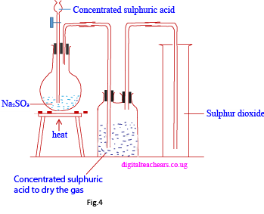
- N is Sodium Sulphite. Name M (1mk)
Concentrated Sulphuric (VI) acid
(b) Complete the diagram to show how dry Sulphur IV Oxide can be collected. (2mks)

9. The graph below is a cooling curve of a substance from gaseous state to solid state.
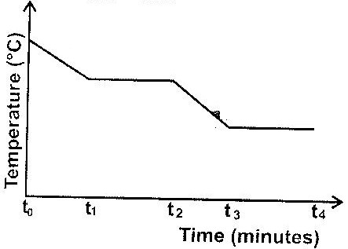

Give the name of the: (2mks)
- Process taking place between t₀ and t₁
Condensation
- Energy change that occurs between t₃ and t₄
Enthalpy of Fusion
10.Element J has two isotopes namely J-39 and J-40. Its relative atomic mass (RAM) is 39.07. Calculate the percentage abundance of each isotope. (3mks)

Let percentage of J-39 be k%, J-40 will have (100-k)%
$\frac{\left(39×k\right)+ 40(100-k)}{100}$= 39.07. $\left(39×k\right)+ 40\left(100-k\right)=3907$
39k+4000-40k=3907. – k = 3907-4000. – k = - 93.
Hence k=93%. J-39 has 93% abundance, J-40 has 7% abundance.

11. Starting with copper metal describe how crystals of copper (II) chloride can be prepared.
(3mks)
Heat CU in air to form CUO. Add excess CUO to dil HCL to form CUCl_{2.} Filter to remove CUO. Heat the filtrate to saturate. Leave it to cool to crystallize, filter and collect the crystals.

12. The diagram below shows the apparatus used to investigate one of properties of carbon.
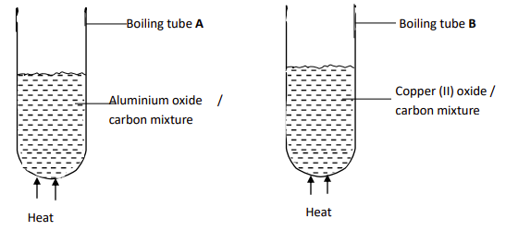
State and explain the observations in each boiling tube. (2mks)
In boiling tube A, no observable change (ignore nothing was seen) as aluminium is higher in reactivity series than carbon hence cannot be reduced by carbon
In boiling tube B, a brown metal of copper was formed. Copper is below carbon in reactivity series hence reduced from its oxide.

13. 3.1g of copper (II) carbonate reacted with 100 cm³ of 0.2 M hydrochloric acid.
a) Determine the reagent that was excess.( Cu =63.5, C= 12, O=16) (1 mk)

CUCO₃ +2HCl_{(aq)} CUCl₂ +C0₂
100/1000*0.2=0.02moles
Moles of CuCO₃ 3.1/123.5 = 0.0251
Excess was CuCO3 by 0.0251-0.02 = 0.0051 moles

b) Calculate the volume of carbon(IV) oxide that was liberated at r.t.p. (2 mks)
(MGV=24.0dm³)

Ratio HCl : CO₂
2 : 1 Moles of CuCO₃ 3.1/123.5 = 0.0251
Excess was CuCO3 by 0.0251-0.02 = 0.0051 moles

0.02: 0.01
0.01*24.0=0.24dm³
- Consider the following equilibrium reaction.

Cr₂O₇²⁻_{(aq)} + 2OH⁻ _{(aq)} 2CrO₄⁻_{(aq)}+H₂O_{(l)}
Orange Yellow
State and explain what would be observed when dilute hydrochloric acid is added into equilibrium mixture. (2 mks)

The solution becomes more orange/yellow colour fades: Backward reaction if favoured to produce more hydroxide ions to replace the ones used up by the acid

- a) Draw a well labelled diagram to show the penetrating power of the three types of nuclear radiation (2 mks)

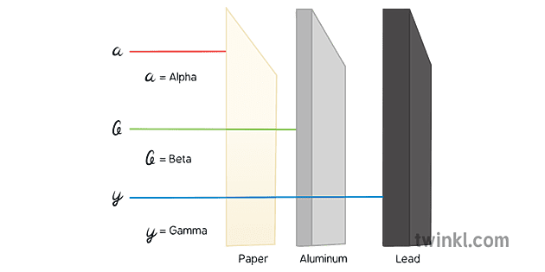
¹/₂ mk for source of radiations and each radiation labelled correctly

b) Which radiation causes more harm to human cells. Explain. (1mk)

Alpha particles: they are highly charged and travels at slowest speed hence longer time of contact with the target atoms
- Perspex is a synthetic polymer of formula;

CH₃

CH₂ C

COOCH₃
n

- Write the structural formula of the monomer of Perspex. (1mk)
CH₃

CH₂ C

COOCH₃

- State the type of polymerization involved in the formation of Perspex (1mk)
Addition polymerisation
- Give one use of Perspex. (1mk)
Substitute for glass

- (a)The ability of hard water to conduct electricity reduces when water is boiled but is not much affected when the water hardness is removed by addition of washing soda (Sodium carbonate). Explain. (1¹/₂mks)
Boiling precipitates calcium ions and magnesium ions in hard water reducing their concentration. Adding washing soda leads to ion exchange hence ions are used in conductivity
(b)Explain how dilute hydrochloric acid can be used to differentiate between permanent and temporary hardness of water (1¹/₂mks)
temporary hardness is caused by hydrogen carbonate ions that lead to effervescence when HCl is added. No effervescence in permanent hardness as the water has sulphate ions that would not react lead to effervescence with acid.
18. Determine the oxidation state of manganese in the following; (3mks)
(i) MnO₂
Mn+(2x-2)=0
Mn= +4
(ii) KMnO₄
+1+Mn+(-2x4)=0
Mn= +7
(iii)Mn₂O₃
2Mn+(-2x3)=0
Mn= ⁺⁶/₂=+3

19. Electrolysis is performed for copper (II) sulphate solution using copper electrodes.
(a) State the observation made on the electrolyte. (1mk)
The blue colour remains
(b) Write the equations at the anode and cathode. (2 mks)
Anode: CU_{(s)} CU²⁺_{aq} +2e-
Cathode: CU²⁺_{aq}+2e- CU_{(s)}

20. Briefly explain how concentration would affect the rate of reaction. (2mks)

Higher concentration means more particles involved in the collision hence higher rate of reaction. Lower concentration means less number of particles involved in collision hence low rate of reaction
21. (a) In an experiment to electroplate an iron watch with silver, a current of 0.5A was passed
for 48minutes. Calculate the amount of silver deposited on the watch. (1F=96500C, Ag=108 )Silver needs one mole of electron to deposit it hence 1F=96500C.
Charge = 0.5×48×60=1440C.
Moles to deposit Ag= 1440÷96500=0.0149
Mass= moles × r.a.m
0.0149×108=1.6116grams (2mks)
- State two reasons why electroplating is important. (1mk)
Improve appearance and protect from rusting.
22. Show using dot (.) and cross (x) diagram to represent bonding in (2mks)
- Lithium fluoride (Li=3, F=9)

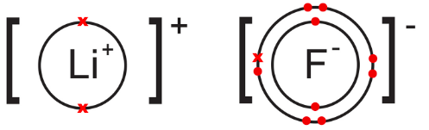
- Carbon (iv) chloride (C=6,Cl=17)

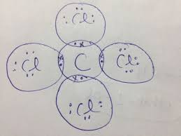

23.The set-up below was used to prepare Nitric(V)acid.
Glass stopper
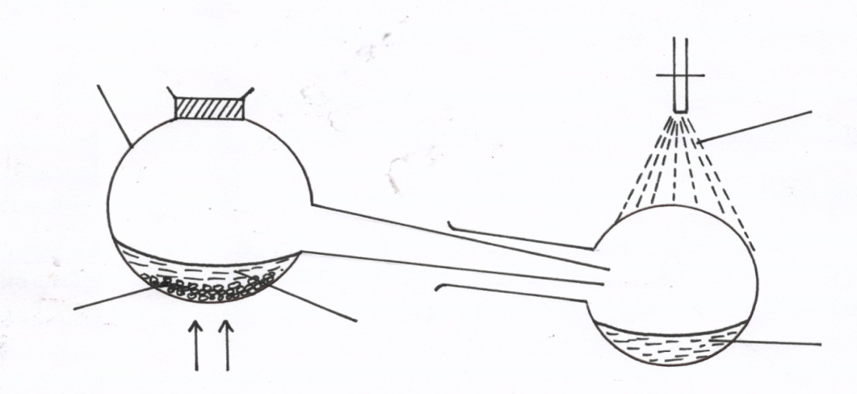
Glass retort
Tap water

Liquid R
Sodium nitrate
Nitric acid
Heat

(i) Give the name of liquid R. ( 1mk)
Concentrated sulphuric (vi) acid
(ii) Write an equation for the reaction which takes place in the retort flask (1mk)
2NaNO_{3(s)} + H₂SO_{4(l)} 2 HNO_{3(aq)} + Na₂SO_{4(aq)}
iii) State the role of tap water. (1mk)
To condense the nitric(v) acid fumes

24. Chlorine dissolves in water to form two products.
(i). Name the two products. (1 mk)
Chloric (I) acid
Hydrochloric acid
(ii).State and explain the observations made when the mixture of the products is exposed to sunlight. (2 mks)
Bubbles of a colourless gas, Hg yellow colour fades away. HOCl is reduced to HCl and 0₂

25. (a) State the observations made when concentrated Sulphuric (VI) acid is added to the following substances. (2 mks)
(i) Sugar crystals
Black solid
(ii) Copper (II) sulphate crystals
Blue crystals turn white
(b) Explain why the volume of concentrated sulphuric (VI) acid tend to increase when it is left in an open place for sometimes. (1 mk)
Conc H₂SO₄ is hygroscopic therefore it absorbs water/moisture from the atmosphere hence increasing in volume

26.Study the table below showing the solubility of a salt at various temperatures.
Temperature(degrees celcius) | Solubility(g/100g of H₂O)
0 | 30
30 | 24
70 | 19
100 | 14
325g of a saturated solution at 0⁰C was heated to a temperature of 100⁰C Calculate the mass of the salt that crystallized out. (3 mks)
Mass of solution at 0⁰C=130
Mass of solution at 100⁰C= 114
Mass of salt : 130-114=16g
³²⁵/₁₃₀ * 16=40g
27. Explain the difference in melting point of magnesium oxide (3080°C) and phosphorus (V)
Chloride (563°C). (3mks)
Magnesium oxide has ionic bonding with giant ionic structure, ionic bonds are strong hence need much heat to break them. Phosphorus (v) chloride has covalent bond, simple molecular structure and weak van der waals forces as intermolecular forces which require less heat to break
- Classify the following salts according to their types: (3mks)
- Na₂CO₃.NaHCO₃.2H₂O Double salt
- CuSO₄……………… Normal salt
- NaHCO₃………………Acid salt
29. Study the diagram below and answer the questions that follow.
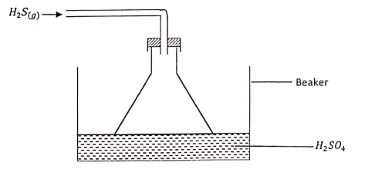
- Give the observation made in the beaker. (¹/₂mk)
A yellow solid was formed. (ignore yellow solution)
- Write an equation for the reaction that took place in the beaker. (1mk)
3H₂S _{(g)}+ H₂SO_{4(l)} 4S _{(s)} + 4H₂O_{(L)}
(c) Give one reason why the gas is directed into the beaker using the inverted funnel
as above? (¹/₂mk)

Avoid sucking back of acid // increase surface area for reaction.

