Name …………………………….………...…………… Index No………….….……….……,…
School ……………………………………………............Candidate’s Signature ……...……… Date ……………........................…..
233/1
CHEMISTRY
PAPER 1
DECEMBER, 2021
(THEORY)
TIME: 2 HOURS

@West Practice papers- 2021

Kenya Certificate of Secondary Education (K.C.S.E)
CHEMISTRY
PAPER 1
(THEORY)

INSTRUCTIONS
- Write your name and the Index Number in the spaces provided above.
- Answer ALL the questions in the spaces provided after each question.
- Use of Mathematical sets and silent calculators may be used.
- All working should be clearly shown.

FOR OFFICIAL USE ONLY
QUESTIONS | MAXIMUM SCORE | CANDIDATE’S SCORE
1-29 | 80

This paper consists of 11 printed pages.
Candidates should check to ensure that all pages are printed as indicated and no questions are missing.

- Element X and Y have atomic numbers 12 and 8 respectively.
(i) Write down the electron arrangement of the ions.

(a) X⁺ ……………………………………………………………………..(1mk)

(b) Y⁻ …………………………………………………………………….. (1mk)

(ii) Write down the formula of the compound formed between X and Y. (1mk)

………………………………………………………………………..
2. (a) when the air hole is open, the Bunsen burner produces a non-luminous flame. Explain
(1mk)
……………………………………………………………………………………………

……………………………………………………………………………………………

(b) Give a reason why a luminous flame is yellow and sooty. (1mk)

……………………………………………………………………………………………

……………………………………………………………………………………………

3.Describe how you can separate a mixture of solid Copper (II) Oxide and solid Copper (II) Nitrate (3mks)

………………………………………………………………………………………………

………………………………………………………………………………………………

………………………………………………………………………………………………

………………………………………………………………………………………………

………………………………………………………………………………………………
4.A compound X is made of carbon, hydrogen and oxygen whose percentage composition by mass are 62.1%, 10.3% and the rest oxygen respectively. The relative molecular mass of X is 58. Determine the molecular formula of the compound.. (H = 1, O = 16, C = 12) (3 mks)

…………………………………………………………………………………………………
…………………………………………………………………………………………………
…………………………………………………………………………………………………
……………………………………………………………………………………………………………………………………………………………………………………………………

5. Identify the acid and base in the forward reaction using the equation below (2mks)
H₂O_{2(l)} + H₂O_{(l)} ⇌ H₃O⁺_{(aq)} + HO₂⁻_{(aq)}

….…………………………………………………………………………………………………

……………………………………………………………………………………………………..
- A hydrocarbon, compound Z, decolourises bromine liquid in presence of light but does not decolourise acidified potassium manganate(VII).

(i) Name and draw the structural formula of the 5th member of the homologous series to which Z belongs. (2 mks)

….…………………………………………………………………………………………………

………………………………………………………………………………………………………

………………………………………………………………………………………………………

………………………………………………………………………………………………………

(ii) Draw and name an isomer of Z. (1mk)

…... …………………………………………………………………………………………………

………………………………………………………………………………………………………

………………………………………………………………………………………………………

………………………………………………………………………………………………………

- (a) State Gay Lussac’s law (1mk)

….…………………………………………………………………………………………………

…………………………………………………………………………………………………….

(b) 15.0cm³ of ethene were mixed with 50.0cm³ of oxygen and the mixture was sparked to complete the reaction. If all volumes were measured at a pressure of one atmosphere and 25°C, calculate the volume of the resulting gaseous mixture. (2mks)

………………………………………………………………………………………………………

………………………………………………………………………………………………………

………………………………………………………………………………………………………
- The set up below can be used to prepare Sulphur IV Oxide. Study it and answer the questions that follow
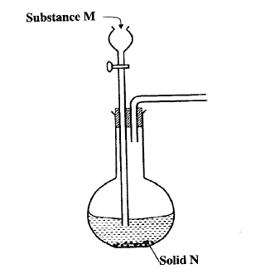
- N is Sodium Sulphite. Name M (1mk)

….………………………………………………………………………………………………
(b) Complete the diagram to show how dry Sulphur IV Oxide can be collected. (2mks)

9. The graph below is a cooling curve of a substance from gaseous state to solid state.
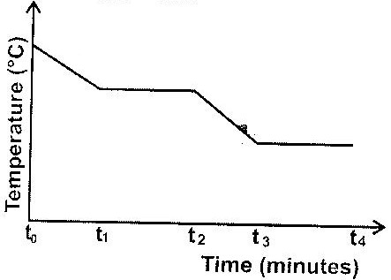

Give the name of the: (2mks)
- Process taking place between t₀ and t₁

….………………………………………………………………………………………………….
- Energy change that occurs between t₃ and t₄

….………………………………………………………………………………………………….
10.Element J has two isotopes namely J-39 and J-40. Its relative atomic mass (RAM) is 39.07. Calculate the percentage abundance of each isotope. (3mks)

….…………………………………………………………………………………………………

………………………………………………………………………………………………………

……………………………………………………………………………………………………..

….………………………………………………………………………………………………….
11. Starting with copper metal describe how crystals of copper (II) chloride can be prepared.
(3mks)
….…………………………………………………………………………………………………,

………………………………………………………………………………………………………

………………………………………………………………………………………………………

….…………………………………………………………………………………………………..

12. The diagram below shows the apparatus used to investigate one of properties of carbon.
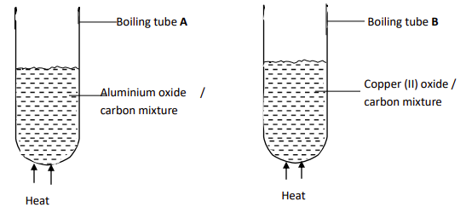
State and explain the observations in each boiling tube. (2mks)

….…………………………………………………………………………………………………..

………………………………………………………………………………………………………

………………………………………………………………………………………………………
13. 3.1g of copper (II) carbonate reacted with 100 cm³ of 0.2 M hydrochloric acid.
a) Determine the reagent that was excess.( Cu =63.5, C= 12, O=16) (1 mk)

….…………………………………………………………………………………………………

…………………………………………………………………………………………………….

….…………………………………………………………………………………………………
b) Calculate the volume of carbon(IV) oxide that was liberated at r.t.p. (2 mks)
(MGV=24.0dm³)

….………………………………………………………………………………………………….

………………………………………………………………………………………………………

………………………………………………………………………………………………………
- Consider the following equilibrium reaction.

Cr₂O₇²⁻_{(aq)} + 2OH⁻ _{(aq)} 2CrO₄⁻_{(aq)}+H₂O_{(l)}
Orange Yellow
State and explain what would be observed when dilute hydrochloric acid is added into equilibrium mixture. (2 mks)

………………………………………………………………………………………………………

………………………………………………………………………………………………………

………………………………………………………………………………………………………

- a) Draw a well labelled diagram to show the penetrating power of the three types of nuclear radiation (2 mks)

….…………………………………………………………………………………………………

………………………………………………………………………………………………………

………………………………………………………………………………………………………

b) Which radiation causes more harm to human cells. Explain. (1mk)

………………………………………………………………………………………………………

………………………………………………………………………………………………………

- Perspex is a synthetic polymer of formula;

CH₃

CH₂ C

COOCH₃
n

- Write the structural formula of the monomer of Perspex. (1mk)
………………………………………………………………………………………………

………………………………………………………………………………………………

………………………………………………………………………………………………

- State the type of polymerization involved in the formation of Perspex (1mk)

….…………………………………………………………………………………………..
(c) Give one use of Perspex. (1mk)

………………………………………………………………………………………………

- (a)The ability of hard water to conduct electricity reduces when water is boiled but is not much affected when the water hardness is removed by addition of washing soda (Sodium carbonate). Explain. (1¹/₂mks)

………………………………………………………………………………………………………

………………………………………………………………………………………………………

……………………………………………………………………………………………………
(b)Explain how dilute hydrochloric acid can be used to differentiate between permanent and temporary hardness of water (1¹/₂mks)
….………………………………………………………………………………………………………………………………………………………………………………………………………………………………………………………………………………………………………………
18. Determine the oxidation state of manganese in the following; (3mks)
(i) MnO₂
……………………………………………………………………………………………………

….…………………………………………………………………………………………………
(ii) KMnO₄
……………………………………………………………………………………………………

….…………………………………………………………………………………………………
(iii)Mn₂O₃
……………………………………………………………………………………………………

….………….……………………………………………………………………………………..
19. Electrolysis is performed for copper (II) sulphate solution using copper electrodes.
(a) State the observation made on the electrolyte. (1mk)
….…………………………………………………………………………………………………
(b) Write the equations at the anode and cathode. (2 mks)

Anode:…………………………………………………………………………………………….

Cathode:…………………………………………………………………………………………..

20. Briefly explain how concentration would affect the rate of reaction. (2mks)

………………………………………………………………………………………………………

………………………………………………………………………………………………………

21. (a) In an experiment to electroplate an iron watch with silver, a current of 0.5A was passed
for 48minutes. Calculate the amount of silver deposited on the watch. (1F=96500C, Ag=108 ) (2mks)
….…………………………………………………………………………………………………

………………………………………………………………………………………………………

………………………………………………………………………………………………………

- State two reasons why electroplating is important. (1mk)
….………………………………………………………………………………………………………………………………………………………………………………………………….
22. Show using dot (.) and cross (x) diagram to represent bonding in (2mks)
- Lithium fluoride (Li=3, F=9)

….………………………………………………………………………………………………

…………………………………………………………………………………………………

………………………………………………………………………………………………….

….………………………………………………………………………………………………

- Carbon (iv) chloride (C=6,Cl=17)

….………………………………………………………………………………………………

…………………………………………………………………………………………………

…………………………………………………………………………………………………

…………………………………………………………………………………………………

23.The set-up below was used to prepare Nitric(V)acid.
Glass stopper
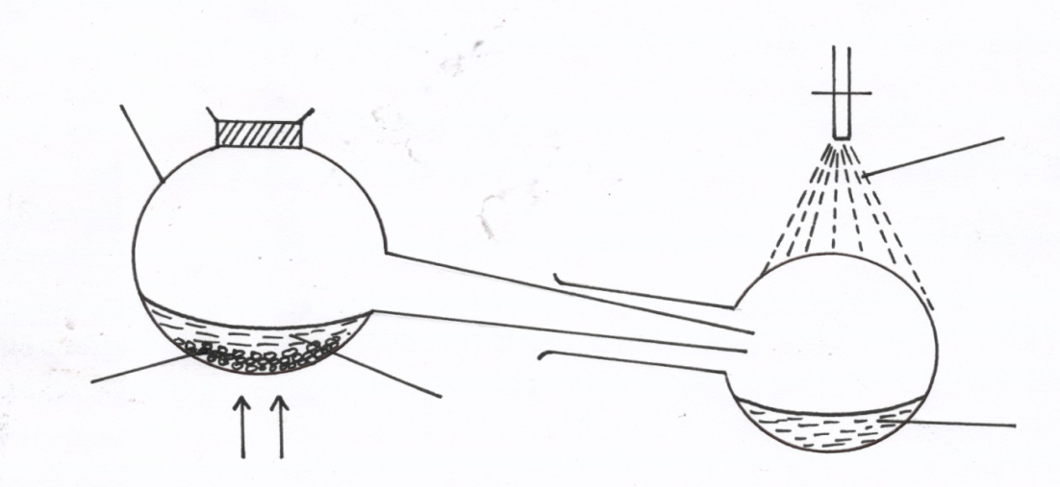
Glass retort
Tap water

Liquid R
Sodium nitrate
Nitric acid
Heat

(i) Give the name of liquid R. ( 1mk)
……………………………………………………………………………………………………..
(ii) Write an equation for the reaction which takes place in the retort flask (1mk)
……………………………………………………………………………………………………
iii) State the role of tap water. (1mk)
…………………………………………………………………………………………………….
24. Chlorine dissolves in water to form two products.
(i). Name the two products. (1 mk)
….…………………………………………………………………………………………………
…………………………………………………………………………………………………….
(ii).State and explain the observations made when the mixture of the products is exposed to sunlight. (2 mks)
….…………………………………………………………………………………………………

………………………………………………………………………………………………………

……………………………………………………………………………………………………….
25. (a) State the observations made when concentrated Sulphuric (VI) acid is added to the following substances. (2 mks)
(i) Sugar crystals
………………………………………………………………………………………………………
(ii) Copper (II) sulphate crystals
………………………………………………………………………………………………………
(b) Explain why the volume of concentrated sulphuric (VI) acid tend to increase when it is left in an open place for sometimes. (1 mk)
………………………………………………………………………………………………………

…………………………………………………………………………………………………
26.Study the table below showing the solubility of a salt at various temperatures.
Temperature(degrees celcius) | Solubility(g/100g of H₂O)
0 | 30
30 | 24
70 | 19
100 | 14
325g of a saturated solution at 0⁰C was heated to a temperature of 100⁰C Calculate the mass of the salt that crystallized out. (3 mks)
………………………………………………………………………………………………………

………………………………………………………………………………………………………

….…………………………………………………………………………………………………..
27. Explain the difference in melting point of magnesium oxide (3080°C) and phosphorus (V)
Chloride (563°C). (3mks)
….…………………………………………………………………………………………………..
….…………………………………………………………………………………………………..
….…………………………………………………………………………………………………..
- Classify the following salts according to their types: (3mks)
- Na₂CO₃.NaHCO₃.2H₂O………………………………………………………………….
- CuSO₄……………………………………………………………………………………
- NaHCO₃………………………………………………………………………………….
29. Study the diagram below and answer the questions that follow.
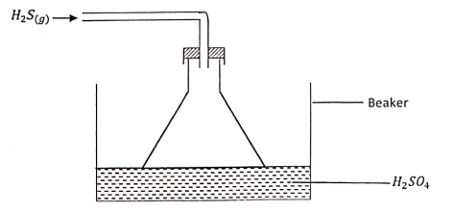
- Give the observation made in the beaker. (¹/₂mk)
….…………………………………………………………………………………………………
- Write an equation for the reaction that took place in the beaker. (1mk)

….…………………………………………………………………………………………………
(c) Give one reason why the gas is directed into the beaker using the inverted funnel
as above? (¹/₂mk)
….…………………………………………………………………………………………………..

