FORM FOUR PAPER 2
CHEMISTRY MARKING SCHEME

- (a) (i) period 2. It has two energy levels.

(ii) R has more protons, than Q hence stronger nuclear charge than Q which attracts electrons strongly towards the center.

(iii)T form ions by gaining an electron, which is repelled by the already existing electrons thus increasing ionic radius.

X
Q
X
+
_
Charge
Labeling
e- Distribution
T
X

(b) (i) giant atomic structure – F

(ii) E
It is a metal since it conducts electricity both in solid and molten state

- The enthalpy change when one mole of a substance is completely burnt in oxygen. (1 mk)

(b) (i)86.66-86.20

= 0.46g
- DH=MCDT
= $\frac{200}{1000}X 4.2 X 15$
= 12.6kJ

- RMM C2H5O4 = 46
Moles = $\frac{0.46}{46}$ = 0.01

- 0.01 moles = 12.6kJ
1 mole = $\frac{1x12.6}{0.01}$
= -1260kJ/mol

C. C₂H₅OH+30₂ 2C0₂ +3H₂0 DH = ⁻1260kJ/Mol
(l) (g) (g) (c)
(d)
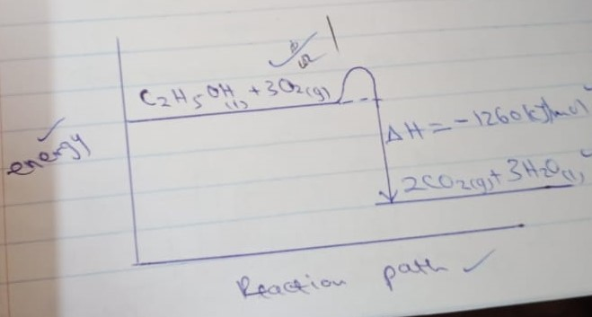

- (a) (i) butanoic acid

- Propyl ethanoate
(b) Propane, butane
(c) Thermal cracking occur in absence of catalyst at 7000c
Catalytic occurs in presence of aluminum oxide catalyst at 4000c 14500c
(d) (i)W- fermentation
X-fractional distillation
(ii) B – Ethane
C- Sodium ethanoate
(iii)CH₃CH₂OH C₂H₄ + H₂O
(g) (g) (l)
(iv) 2CH₃CH₃ +50₂ 2 CO₂ + 6H₂O
(g) (g) (g) (l)
(v) Orange bromine turns to colourless substance. A substitution reaction occurs between bromine and ethane.
(vi) C₂H₄ = 28, no of monomers = $\frac{11200}{28}$ = 4000
- (a)
- Brightness recues, the concentration of the ions reduces since they are discharged at the electrons,.
- On the diagram
- 2cl- Cl2 + Ze-
- Graphite/carbon (or platinum)

(b)
(i) Zn, it loses electrons most readily.
(ii) Half cells of Zn and Ag.
(iii)E^{Ø}_{cell} = 0.80 – (-0.076)
= +1.56V
(iv) E^{Ø} _{cell} = - 0.76 –(0.34)
=M-1.10V
The reaction cannot occur since E^{Ø} is negative.

- 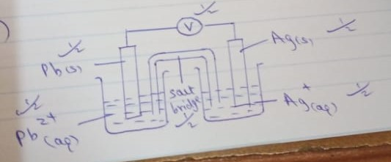

- a (i)
8cm
6cm
4 cm
2 cm
A
B
C
D

Baseline

(ii) Substance A and B

(b) Heat the mixture. Ammonium chloride will sublime and deposit on the cooler part of the boiling tube. Calcium nitrate will remain at the bottom of the boiling tube.

(c )(i) Fractional distillation

- Pour both liquids in separating funnel and allow it to settle, the denser liquid will settle down and less dense, liquid will form the top layer. Open the tap and run the liquid in the bottom layer leaving the liquid in the second layer.

- A (i) bauxite
(ii) Iron (iii) oxide
(or silicon (iv) oxide)
(iii) Cryolite
- Cathode
Al³⁺ + 3e⁻ Al
(l) (l)
Anode
2O²⁻ O₂ + 4e⁻
(l) (g)

(b)
(i) Froth floatation
(ii) Iron pyrites
(iii)- Its poisonous causing respiratory diseases
- Causes acid rain which corrodes building etc.
(iv) Making nails
- Making construction beams.

C
- Zinc blende
- 2ZnS + 30₂ 2ZnO +2 SO₂
(s) (g) (s) (g)
(iii) – galvanizing iron sheets
- Manufacture of dry cells. etc.

