NAME……………………………………… INDEX NO.……………………………….…
SCHOOL…………………………………………………DATE ………………………….…..
CANDIDATE’S SIGNATURE……………………………

233/1
CHEMISTRY
PAPER 1
THEORY
SEPTEMBER 2022
TIME: 2 HRS

KIJISET EXAMINATION 2022
Kenya certificate of secondary education (K.C.S.E)

233/1
CHEMISTRY
PAPER 1
THEORY
SEPTEMBER 2022
TIME: 2 HRS

for examiner’s use only
QUESTIONS | MAXIMUM SCORE | CANDIDATE’S SCORE
1 - 29 | 80

This paper consists of 12 printed pages.
Candidates should check the question paper to ensure that all
pages are printed as indicated and no questions are missing

- Element Y has atomic number 17 while X has 12.
  - Write electronic arrangement of X and Y. (1mk)
X……………………

Y………………………

  - Name the type of bond and structure formed when X and Y reacts. (2mks)
…………………………………………………………………………………………………

  - Draw a dot (●) and cross (X) diagram of the compound formed in (ii) above. (1mk)

- The table below indicates the PH value of solutions labelled M, L, N, P and Z.
PH | 4 | 14 | 1 | 10 | 7
solution | M | L | N | P | Z

  - Which solution has the highest concentration of hydrogen ions? (1mk)
…………………………………………………………………………………………………

  - Which solution can be used as an anti-acid? Give a reason for your answer. (2mks)
…………………………………………………………………………………………………
…………………………………………………………………………………………………

- State two reasons why luminous flame is not used for heating purposes in the laboratory (1 mk)
………………………………………………………………………………………………………………………………………………………………………………………………
4. In which homologous series do the following compounds belong?
(i) CH₃ CH CH₂ (2 marks)
………………………………………………………………………………………………
(ii) CH₃ CH₂ CH₂ OH
………………………………………………………………………………………………5. The structures shown below represent two cleansing agent A and B.

(a) Name the type of cleansing agent A. (1 mark)
………………………………………………………………………………………………
(b) Which of the two cleansing agents is more suitable for washing in water containing calcium chloride? Give a reason. (2 marks)
………………………………………………………………………………………………………………………………………………………………………………………………………………………………………………………………………………………………
6. (a) Study the nuclear equation below and answer the questions that follow.

(i) Determine the values of (1mark)
n
………………………………………………………………………………………………
m
………………………………………………………………………………………………

(ii) State one useful application of this type of nuclear reaction. (1mark)
……………………………………………………………………………………………
228
(b) Write an equation to show how thorium nuclide ₉₀ Th
undergoes alpha decay to form another nuclide radium Ra.
(Clearly indicate the mass number and atomic number of radium) (1 mark)
………………………………………………………………………………………………………………………………………………………………………………………………………………………………………………………………………………………………
………………………………………………………………………………………………
7. The apparatus below were used to separate a mixture of liquid A and B.
B
A

State two properties of liquids that make it possible to separate using such apparatus. (1 mark)
………………………………………………………………………………………………………………………………………………………………………………………………………………………………………………………………………………………………………………
8. a) What property of concentrated sulphuric(VI) acid is illustrated by its action on:
(i) Sugar ( ½ mk)
………………………………………………………………………………………………
(ii) Copper metal ( ½ mk)
………………………………………………………………………………………………
b) Write the equation for the reaction of concentrated sulphuric acid with copper metal. (1mk)
………………………………………………………………………………………………
9. Ammonia is manufactured in the Haber process according to the equation:-
  - How would the following affect the yield of ammonia.

    - High pressure. (1mk)
………………………………………………………………………………………………
………………………………………………………………………………………………
    - High temperature. (1mk)
………………………………………………………………………………………………
………………………………………………………………………………………………
  - Name the catalyst used. (1mk)
………………………………………………………………………………………………
- X grams of anhydrous sodium carbonate was dissolved in water to make a 250cm³ solution. 25cm³ of the solution neutralized 20cm³ of 0.25M nitric acid. Determine the value of X. (3mks)

- Study the table below and answer the questions that follow.
Bond type Bond energy KJmol⁻¹
C – C 346
C = C 610
C – H 413
C – Br 280
Br – Br 193
  - Calculate the heat change for the reaction;
C₂H₄ + Br₂ C₂H₄Br₂ (3mks)

  - Name the type of reaction that occurred in (a) above. (1mk)
…………………………………………………………………………………………

- The Solvay process is used to manufacture Sodium Carbonate.
  - Name two raw materials for the process. (1mk)
……………………………………………………………………………………………………………………………………………………………………………………
  - How is Sodium Carbonate obtained from Sodium Hydrogen Carbonate? (1mk)
……………………………………………………………………………………………………………………………………………………………………………………
  - Name two main substances that are recycled. (1mk)
……………………………………………………………………………………………………………………………………………………………………………………
- Starting with copper turning, describe how a solid sample of Copper (II) Carbonate can be prepared. (3mks)
…………………………………………………………………………………………………………………………………………………………………………………………………………………………………………………………………………………………………………………………………………………………………………………………………………
- The diagram below represents the apparatus used to react steam with magnesium.
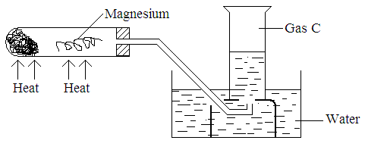
  - State the observation made in the boiling tube. (1mk)
………………………………………………………………………………………………
  - Write an equation for the reaction that takes place in the tube. (1mk)
………………………………………………………………………………………………
  - What property makes it possible for gas C to be collected as shown? (1mk)
- The following diagrams shows the structure of two allotropes of carbon. Study them and answer the questions that follow.

A B

(a) Name the allotropes. (1 mark)

A ……………………………………….

B ………………………………………..

(b) Give one use of A. (½ mark)

……………………………………………………………………………………………..

(c) Which allotrope conducts electricity? Explain. (1½ marks)

…………………………………………………………………………………………………………………………………………………………………………………………………………………………………………………………………………………………………………..…………..
- The diagram below represents an arrangement for preparing and collecting dry hydrogen. Study it and answer the questions that follow.
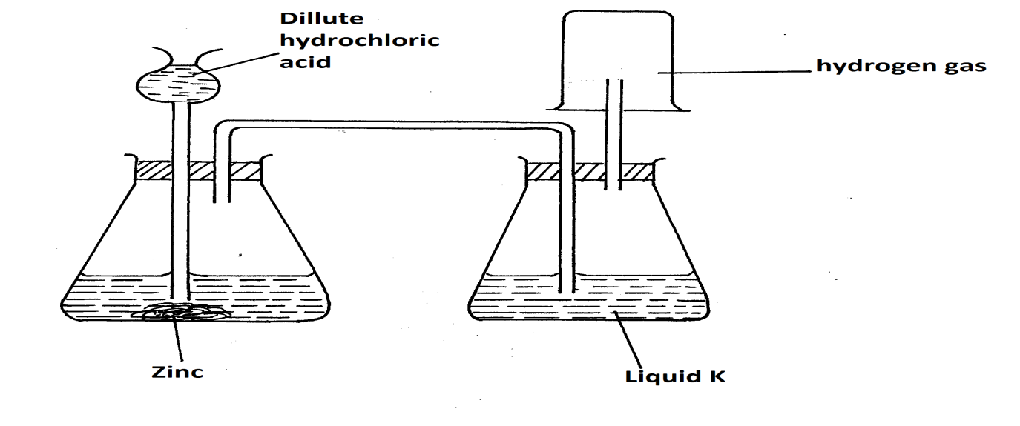

a) Write the equation for the reaction that produces hydrogen gas. (1mk)
…………………………………………………………………………………
b) Name the suitable substance that liquid K is likely to be. (1mk)
…………………………………………………………………………………………
c) Explain why it is not advisable to use nitric (v) acid as an alternative to hydrochloric acid in the preparation experiment. (1mk)
…………………………………………………………………………………………
…………………………………………………………………………………………
- Explain what happens when blue litmus paper is dipped in methylbenzene in which hydrogen chloride is bubbled. (2mks)
…………………………………………………………………………………………
…………………………………………………………………………………………
…………………………………………………………………………………………
………………………………………………………………………………………….
- Using equations only differentiate the bleaching effect of Chlorine and SO₂ (2mks)
…………………………………………………………………………………………………..
…………………………………………………………………………………………………..
…………………………………………………………………………………………………..
…………………………………………………………………………………………………..
- In temperate countries, salt is sprayed on roads to defrost and clear roads but the long term effect on this practice is costly to motorist.
- Explain the role of salt in defrosting the ice. (1mk)
...................................................................................................................................................... ......................................................................................................................................................
- Explain why the long term effect is costing to motorist. (1mk)
......................................................................................................................................................
......................................................................................................................................................
- (a) State Graham’s gas law of diffusion. (1mk)

................................................................................................................................................
................................................................................................................................................

(b) Two containers, one with Nitrogen (IV) oxide and other with bromine simultaneously
develop leaks, after 30 seconds, the smell of Nitrogen (VI) oxide is detected. How much longer will it take before bromine is detected. (N = 14, O = 16, Br = 80) (2mks)

- Study the diagram below and answer the questions given below.

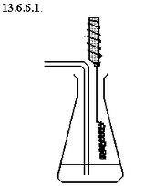
Oxygen
Conc. Ammonia solution
Hot Catalyst X

- The reaction between ammonia and oxygen in the presence of the catalyst continues without further heating. Explain. (1mk)

................................................................................................................................................
................................................................................................................................................
................................................................................................................................................
................................................................................................................................................
- Name catalyst X. (1mk)

................................................................................................................................................

- Write an equation for the reaction which takes place in the flask. (1mk)

................................................................................................................................................
................................................................................................................................................
- A current of 0.4 A was passed through lead (II) nitrate solution for 30 minutes. Determine the mass of lead deposited. (Pb = 207 1F = 96500C ) (3mks)

- The table below shows the tests carried out a sample of water and the results obtained.
Sample | Tests | Observation
A | Addition of sodium hydroxide solution dropwise until in excess | White precipitate which dissolves in excess to form colourless solution
B | Addition of excess aqueous ammonia | White precipitate
C | Addition of dilute nitric (V) acid followed by barium chloride | White precipitate

a) Identify the anion present in the water. (1mk)
………………………………………………………………………………………………
b) Write the ionic equation for the reaction in C. (1mk)
…………………………………………………………………………………….
c) Write the formula for the complex ion in A. (1mk)
…………………………………………………………………………………….
- An ore of iron was found to contain 7g of iron and 3g. of oxygen.
( Fe = 56 O =16)
a) Work out its empirical formula. (2mks)
…………………………………………………………………………………….
…………………………………………………………………………………….
b) Write a balanced equation for reaction of the oxide in (a) with hot carbon. (1mk)
.................................................................................................................................................
- (a) Name the two common ores from which Zinc metal can be extracted. (1mk)
………………………………………………………………………………..…………….
………………………………………………………………………………………..…….
(b) Taking one of the ores named in (a) above, write a chemical equation for the
roasting process to get the required oxide. (1mk)
………………………………………………………………………………………………
(c) Outline any two uses of Zinc metal. (1mk)
………………………………………………………………………………………………………
……………………………………………………………………………………………………..
26. One of the four types of oxides is amphoteric oxide.
(a) What is an amphoteric oxide? (1mk)
………………………………………………………………………………………………………………………………………………………………………………………………
(b) Write the formulae of any two amphoteric oxides. (1mk)
…………………………………………………………………….………………………..
………………………………………………………………………………………………
27. Rusting leads to fast wearing out of farm tools and equipment as well as buildings.
(a) Give the chemical name of rust. (1 mark)
…………………………………………………………………………………………………………………………………………………………………………………………..
(b) What two conditions accelerate rusting process? (2 marks)
………………………………………………………………………………………………………………………………………………………………………………………………

28. The melting point of phosphorous(III)chloride is -91°C while that of sodium chloride
is 801°C. In terms of structure and bonding explain the difference in the melting
point. (3mks)

……………………………………………………………………………………………………………………………………………………………………………………………………………………………………………………………………………………………………………………………………………………………………………………………………………………………………………………………………………………………………………………………………………………………………………………………
29. (a) Define the term molar latent heat of fusion. (1 mark)
……………………………………………………………………………………………………………………………………………………………………………………………………
(b) The molar heat of fusion of ice at O⁰C is 6kJ mol⁻¹. Calculate the heat change when 36g of ice is converted to 36g of water at 10⁰C. (3 marks) (SHC = 4.2Jg⁻¹ K⁻¹, density = 1.0g/cm³, H = 1.0, O = 16.0)

