NAME : ___________________________________________________NDEX: _____________
CANDIDATES SIGNATURE: _______________________ DATE : ___________________

CHEMISTRY PAPER 1 233/1
MARKING SCHEME
TIME: 2HOURS
FORM 4 END OF TERM 2 EXAMINATIONS 2021
INSTRUCTIONS:
- Answer all the questions in the spaces provided.
- Mathematical tables and silent non-programmable electronic calculators may be used.
- All working must be clearly shown where necessary.
- Candidates should answer the questions in English.

For examiners use only
Question | Maximum  score | Candidates  Score
1-29 | 80

- Element Y has atomic number 8 while X has 16 .
- Write electronic arrangement of X and Y (1mk)
X – 2.6
Y- 2.8.6

- Name the type of bond and structure formed when X and Y react. (2mks)
Bond- covalent bond
Structure-simple molecular structure

- Explain why it is not advisable to leave a jiko with a burning charcoal in a closed room where one is sleeping. (2mks)
In insufficient supply of oxygen, carbon (ii) oxide is produced when inhaled it combines with haemoglobin to form a stable compound called carboxy haemoglobin which leads to suffocation.

- The following equation shows a reversible reaction
(i) red-brown colour intensifies reverse molecules does not change.

H_{2(g)} + Br_{2(g}) 2HBr_{g} -74.4KJ
Red Brown Colourless
State and explain the observation that can be made when
- Temperature is increased. (1 ½ mks)
Red-brown colour intensifies reverse reaction is favoured as it is endothermic

- Pressure is reduced. ( 1 ½ mks)
Has no effect since number of molecules does not change.

- A mixture contains zinc oxide, iron (iii) chloride and potassium chloride. Describe how each of the substances can be obtained from the mixture. (3mks)
- Heat the mixture in a beaker covered with watch glass containing cold water. Fecl3 will sublime and deposit below the surface.
- Add water to the remaining mixture for KCL to dissolve.
- Filter the mixture obtain zinc oxide as a residue.
- Heat the filtrate to saturation/for water to evaporate
- Allow it to cool to form pottasioum chloride crystals.

- Using a dot (.) and cross (x) diagram, draw the structure for silicon (iv) chloride. (2mks)
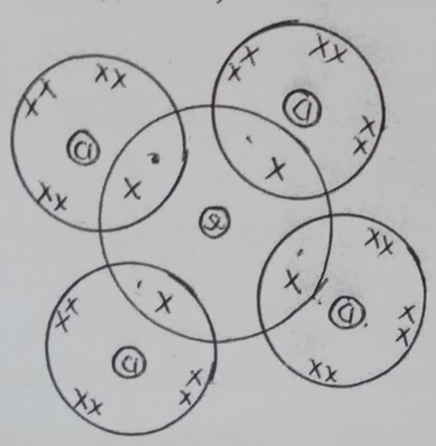
(Atomic numbers Si= 14, Cl=17)

C.A.O
- Must show the nucleus
- Must show electron distribution in the outermost energy.

- Ammonium nitrate was gently heated as shown below.
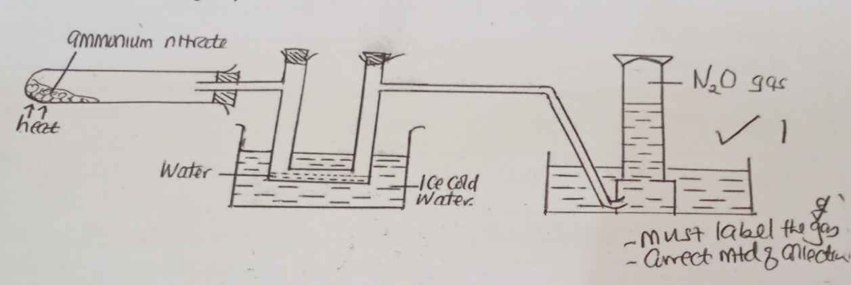

- Complete the diagram to show how the gas is collected. (1mk)
- Write the equation for the reaction occurring in the boiling. (1mk)
NH₄NO_{3(s)} heat N₂O_{(g)} + 2H₂O _{(n)}

- State one chemical test that can be used to identify the gas collected in the above set up. (1mk)
It relights a glowing splint with a pleasant smell.

- (a) What is a saturated solution? (1mk)
It is a solution that cannot dissolve any more solute at a particular temperature.

(b) 115g of a saturated solution at 65ºc is found to contain 65g of potassium nitrate. Calculate the solubility of potassium nitrate at 65ºc. (2mks)
Mass of solvent = 115 – 65 = 50g
65g KN03 50g of water.
100g of water
$$\frac{65 x 100}{50}$$
130g KNO₃/100g of water

- What do you understand by the term prescription in relation to drugs? (1mk)
It’s a written instruction by a qualified physician/doctor on how a given dose of drugs is to be administered. Accept words to that effect.

- Starting with sodium solid, describe how a sample of sodium hydrogen carbonate crystals may be prepared. (3mks)
- Drop or add a small sodium solid in a beaker containing water to form sodium hydrogen solution
- Bubble excess CO2(g) through the solution to form sodium hydrogen carbonate.
- Heat the solution to saturation or leave in the open to crystalise slowly.
- Allow it to cool to form crystals.
- State boyles law. (1mk)
- At constant temperature the volume of a given fixed mass of a gas is inversely proportional to pressure.

b. a gas occupies 500cm³ at 27ºc and 100,000 pa. What will be its volume at 0ºc and 101325 pa. (3mks)
$$\frac{P1V1}{T1}=\frac{P2V2}{T2}$$

$$\frac{100000 X 500}{300}= \frac{101325 X V2}{\begin{aligned}273 \\ \end{aligned}}$$
V2 =$\frac{273X100000 X 500}{\begin{aligned}300 X 101325 \\ \end{aligned}}$
= 449.05CM³
11. Write equations to show the effect of heat on each of the following:
a) Sodium hydrogen carbonate (1mk)
2NaHCO₃ _{(s)} Na₂CO_{3(S)} +CO_{2(g)} + H₂O_{(l)}
heat
b) Silver nitrate (1mk)
2AgNO_{3(s)} 2Ag(s) + 2NO₂ (g) + O₂
heat

c) Anhydrous iron (ii) sulphate (1mk)
2FeSO_{4(s)} Fe₂O_{3(s)} + SO_{2(g)} +SO3_{(g)}

12. (a) A student electroplated a spoon with copper metal. Write an equation for the process that took place at the cathode. (1mk)
(a) CU²⁺_{(aq)}+ 2e CU_{(s)}

b) Calculate the time in minutes required to deposit 1.184g of copper if a current of 2 amperes was used. ( 1 faraday = 96500 coulombs, cu= 63.5). (2mks)
63.5g require 2 x 96500c
1.184g = $\frac{2x9600 x 1.184}{63.5}$
= 3598.6C
Q = It
3598.6 = 2 x t
t=$\frac{35986}{2}=1799.3$
t= $\frac{1799.3}{60}$
29.988 ≈ 30 minutes

13. In the extraction of Sulphur by the frasch process, hot compressed air at 15 atmospheres is forced down the innermost pipe.
a) What is the role of the hot compressed air. (1mk)
- To produce a light froth consisting of molten Sulphur and water.
- High pressure forces the mixture up the middle pipe.

b. which allotrope of sulphur;
i. is stable below the transition temperature at 96⁰c. (1mk)
Rhombic
- has prismatic crystals (1mk)
Monoclinic
14. The graph below shows the radioactive decay for a sample 400g of iodine -131.
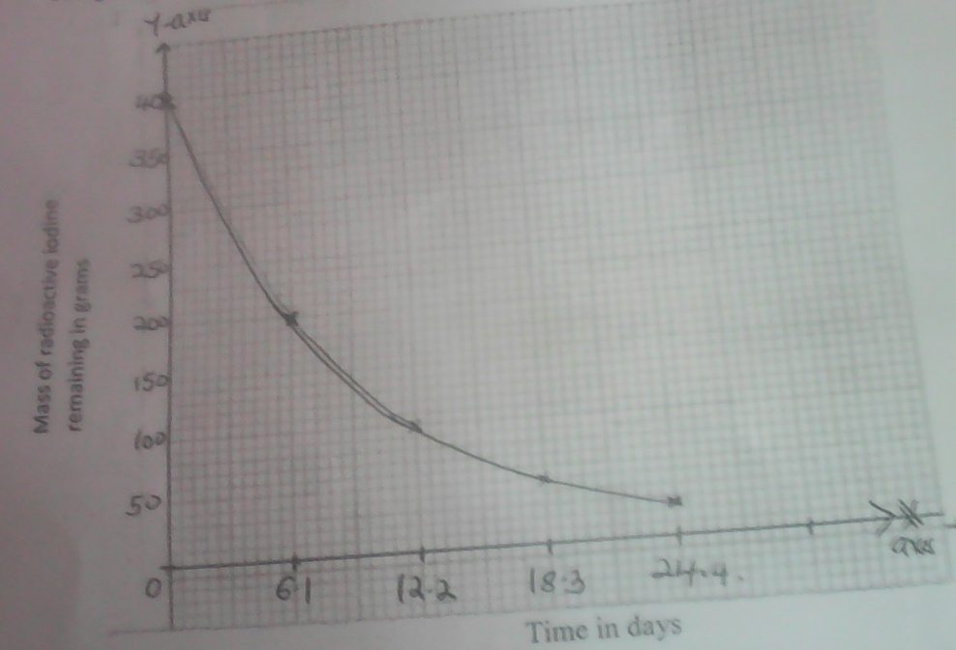

- Define half-life. (1mk)
Time taken for a given mass to decay to half its original mass or w.t.t.e

- From the graph determine the half-life of iodine -131. (1mk)
6.1 days

- Determine the mass of the isotope present after 36.6 days. (1mk)
400 6.1 200 6.1 100 6.1 50 6.1 25 6.1 12.5 6.1 6.25
6.25.

15. A certain salt was found to form a solution when exposed to air. Name the process undergone by the salt. (1mk)
Deliquescence reflect deliquescent

b. give one example of such a salt. (1mk)
NaOH₂, CaCl₂, FeCl₂, KOH, ZnCl₂, FeCl₃

16. State and explain two observations made when a spatula of sodium carbonate solid is added to aluminum chloride solution in a boiling tube. (2mks)
Observation
- Bubble / effectiveness of a colourless gas
- The boiling tube becomes warm
Explanation
- CO(g) is produced
ALCL3 hydrolysis in water forming acidic solution which reacts with sodium carbonate evolving carbon (iv) oxide gas.
- The reaction is exothermic

17. The structure below shows a portion of a polymer

- Draw a repeat unit of the polymer. (1mk)
H H
C C
C₆H₅ H

- Name the polymer. (1mk)
Polyster
18. Give one use and difference between the apparatus below. (3mks)
 | Use | difference
 | Used of delivering liquid substances | Has no tap
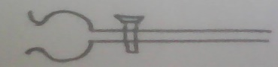 | Used to add controlled amounts of liquids | Has a tap

19. Element R has two isotopes with mass numbers 29.46 and 31. If the relative atomic mass of element R is 30, determine the percentage abundances of each isotope. (3mks

$(\frac{x}{100}{{x 29.46)}^{}}$+$\frac{(100-x)X31}{100}$ =30
29.46x + 3100-31x=3000
-1.54x=-3000-3100
X=64.9351% and
35.0649%

20. When chlorine is bubbled through water, the resulting solution acts as a bleaching agent.
a. write an equation for the reaction between chlorine gas and water. (1mk)

Cl2_{(g)} + H2O_{(l)} HOCl _{(aq)} + HCl _{(aq)}

b. using an equation, explain how the resulting solution acts as a bleaching agent

dye + HOCl_{(aq)} HCl _{(aq)} + (dye + O)
colourless matters

21. In an experiment, dry hydrogen gas was passed over heated lead (ii) oxide as shown in the diagram below.
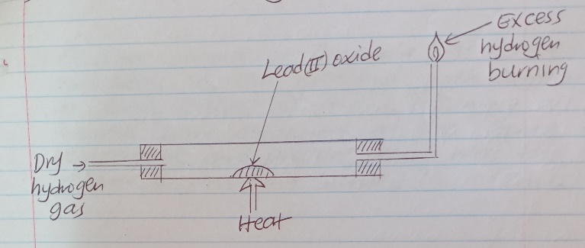

State and explain the observations made in the combustion tube. (3mks)
Grey solid deposited/formed PbO has been reduced to lead metal a colourless liquid condenses/formed on the cooler part of the combustion tube. Hydrogen has been oxidized to water.

22. (a) State gay-lussacs law. (1mk)
At constant temperature and pressure, gasses react in volumes that bear simple whole number ratios to one another and to the volumes of products if gaseous.

b) A given volume of ammonia gas burned completely in air enriched with oxygen to form 300cm³ of steam and nitrogen gas. Assuming all volumes were measured at the same temperature and pressure, what was the volume of ammonia burned. (2mks)

4NH_{3(g)} + 3O_{2(g)} 2N_{2(g)} + 6H₂O)
2V 3V
300cm³
$\frac{300x2 }{3}=200cm$³
or
$\frac{300x4 }{4}=200cm$³

23. The diagram below shows the apparatus for preparation of hydrogen sulphide gas.

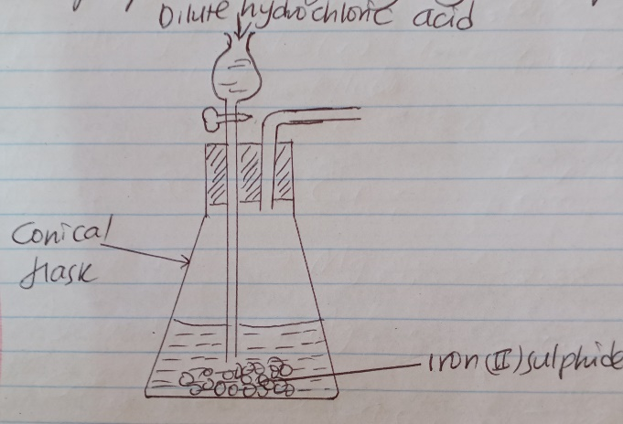

- Complete the diagram to show how hydrogen sulphide gas is collected. (2mks)

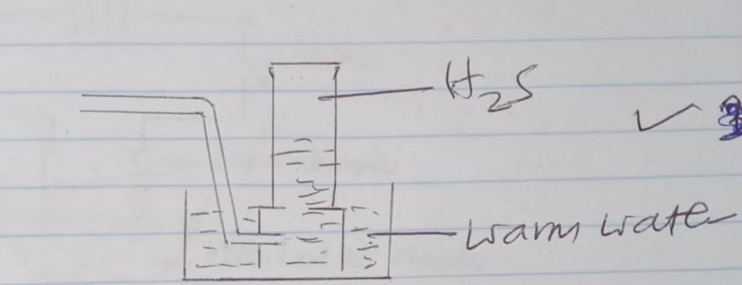

Or
Dry using CaCl₂ then collect by downward delivery.

- Write an equation for the reaction that takes place in the conical flask. (1mk)

2HCl_{(aq)} + FeS_{(s)} FeCl2_{(aq)} + H₂S_{(g)}

- This experiment should only be carried out in fume cupboard. Explain (1mk)
H₂S is highly poisonous/it kills/toxic
24. The table below gives some properties of three elements in group vii of the periodic table. Study it and answer the questions that follow.
element | Atomic  no | Melting  point(ºC) | Boiling  Point (ºC)
Chlorine | 17 | -101 | -34.7
Bromine | 35 | -7 | 58.8
iodine | 53 | 114 | 184

- Which element is in liquid form at room temperature? Give a reason (1mk)
Bromine
At room temperature (250) bromine is liquid since its melting point and boiling point are between -7 and 58.8. //room temperature is between melting pint and boiling point.

- Explain why the boiling point of iodine is much higher than that of chlorine. (2mks)
Atomic /molecular mass of iodine is higher than that of chlorine van-der waals forces are stronger in iodine than in chlorine hence iodine boiling point is higher than that of chlorine.
Accept intermolecular force.
25. Study the set up below and use it to answer the questions that follow.

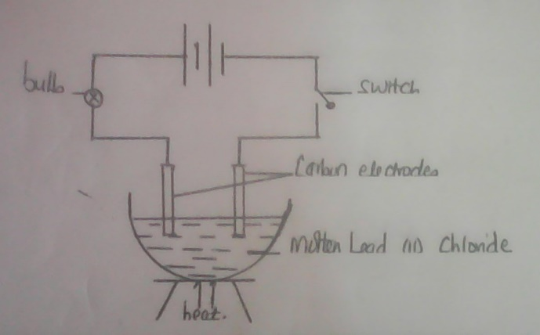

- State and explain an observation that would be make at the anode when the circuit is completed.
Greenish yellow fumes/bubbles of chlorine gas
Cl⁻_{(l)} ions loses electron/gets oxidized to form chlorine gas.

- Write an equation for the reaction at the cathode.

Pb²⁺_{(l)} + 2e⁻ Pb_{(s)}
26. In preparation of ammonia gas 30cm3 of nitrogen gas and 30cm3 of hydrogen gas were exploded in a vacuum
(i) Write an equation for this reaction. (1 mk)

N_{2(g)} + 3H_{2(g)} 2NH_{3(g)}
(ii) Calculate the volume of the residual gases.

N_{2(g)} + 3H_{2(g)} 2NH_{3(g)}
1 2 2 residual gases
10cm³ 30cm³ 20cm³ =20cm³ + 20cm³
= 40cm³

27. juice extracted from a nettle plant were added drop wise into a boiling tube containing 5cm3 potassium hydrogen carbonate solution until there was no further change.
(a) Explain the observation made in the boiling tube when the reaction was going on. (2 mks)
Effervescence due to production of CO₂ methonoic acid from the nettle plant reacts with KHCO_{3(aq)} to produce CO₂
(b) What observation would have been made if the nettle juice were added to silver metal in a boiling tube? Explain
No effervescence, silver is below hydrogen in the reactivity series.
28. The set up below was used to prepare and collect carbon (ii) oxide in the laboratory.
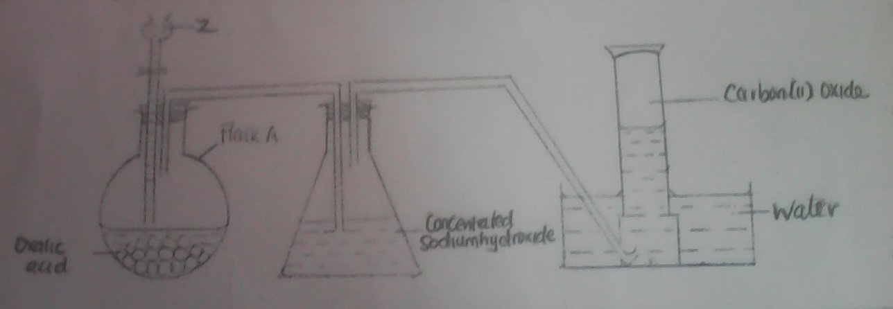

(i) Identify Z and give its role in the reaction. (1 mk)
- Concentrated sulphric (vi) acid / H₂SO_{4(l)}
- Dehydration of oxalic acid
(ii) Write an equation for the reaction in the flask A
ConH₂SO₄
H₂C₂O_{4(S)} CO_{(g)} + CO_{2(g) +} H₂O_{(l)}
(iii)Give one use of carbon (II) oxide.
- Reducing agent in extraction of metals
- Source of fuel
(any one)
29. When 94.5g of hydrated barium hydroxide Ba(OH)₂.nH₂O was heated to a constant mass, 51.3g of anhydrous barium hydroxide was obtained. Determine the empirical formula of the hydrated barium hydroxide (Ba = 137, O=16, H=1) (3 marks)
Compound Ba(OH)₂ H₂O
Mass 51.3 43.2
Moles $\frac{51.3}{17}=0.3$ $\frac{43.2}{18}=2.4$
Mole ratio $\frac{0.3 }{0.3}=1$ $\frac{2.4}{0.3}=8$

EF is Ba(OH)₂ 8H₂O.

